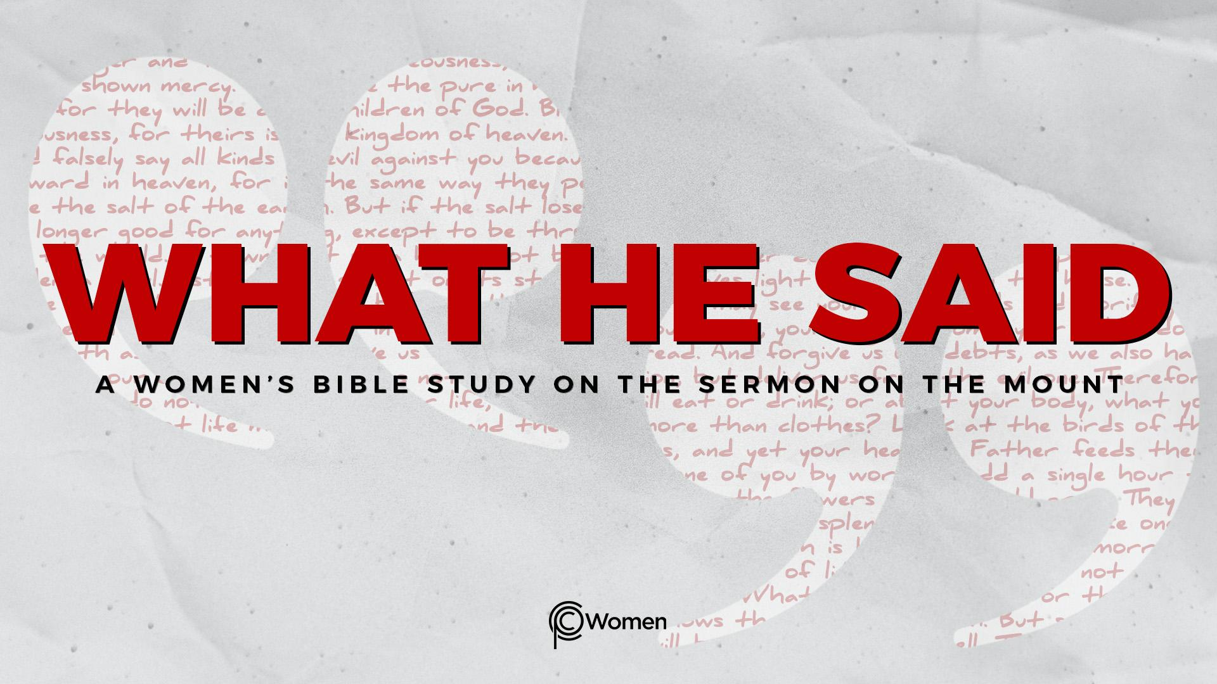
NOTE: Our lesson questions are based on the NIV 2011 edition. Our preference is your first time through the questions, you answer without consulting commentaries - delight in what the Holy Spirit will reveal to you.

Lesson 9
Matthew 5:27-30

1. Where did God meet you after you steeped in His Word in Lesson 8 and what truth or insight convicted or inspired you?

2. Ask the Lord to unveil the consequences of humanity’s distorted desires and other sin before you read through Matthew 5:27-30. In V29-30 (as in V22), Jesus speaks of “hell” as a place of punishment in contrast to the kingdom of God. What are your notions about hell? What have you been taught if anything? What imagery does the word evoke?

3. a) In Matthew 5:27, Jesus again introduces wisdom from the Torah (Exodus 20:14). What is the command He quotes and what is your understanding of the conduct it prohibits?

b) Jesus gets to the heart of the matter in Matthew 5:28. What dynamic does He confront as an evil? What do you think Jesus knows which justifies His assertion?

4. How is “adultery in the heart” a taking of what is not yours and quite unlike a passing glance or sexual desire within a covenantal commitment?

5. a) What is the gist of the provocative statements Jesus makes in V29-30?

b) What are some different ways the eye and the hand might lead a man to give expression to a distorted and low view of sexual desire? How do these expressions devalue the dignity of women?

6. In this passage, Jesus refers to hell as a place that represents divine justice on human and spiritual evil, a place you should take extreme measures to avoid. What else can you conclude about Jesus’ view on hell from the following additional verses:
- Matthew 13:41-42

- Matthew 25:41-43

- John 5:24

- Revelation 21:7-8

- a) How do the verses below reflect God’s point of view on sin and its devastating effects on your personal purity, your relationships with others and your intimacy with Him:

- Isaiah 59:2

- Isaiah 64:6

- Romans 3:23

- Romans 6:23

b) Do you think a commandment has the power to eliminate the sinful condition of a person’s heart? Recognizing that sin is a heart problem, what is the solution prophesied in Ezekiel 36:26 and fulfilled in the new covenant (Hebrews 8:10)?

- JESUS SAID: BE RUTHLESS ABOUT SIN
In Matthew 5:29-30, Jesus said, “If your right eye causes you to stumble, gouge it out and throw it away… If your right hand causes you to stumble, cut it off and throw it away.” “It is better for you to lose one part of your body than for your whole body to be thrown into hell.” Jesus is not asking anyone to mutilate their body. He is using hyperbole to emphasize the serious nature of sin and its consequences. His followers must be ruthless about ridding themselves of sin, not managing or justifying it. Paul would later say, “if by the Spirit you put to death the misdeeds of the body, you will live.” Romans 8:13b.

a) What habit of sin, thought pattern or distorted desire would you like to “put to death” in order to walk in personal purity?

b) Are you willing to make the sacrifices necessary to keep yourself from being pulled into sin? Who will you trust to keep you accountable? Commit to praying for God to equip you to be a person whose eyes, hands and heart are at home in the goodness of the kingdom of God.

MEMORY VERSE: “But your iniquities have separated you from your God; your sins have hidden his face from you, so that he will not hear.” Isaiah 59:2

NAME PRAYER REQUEST

