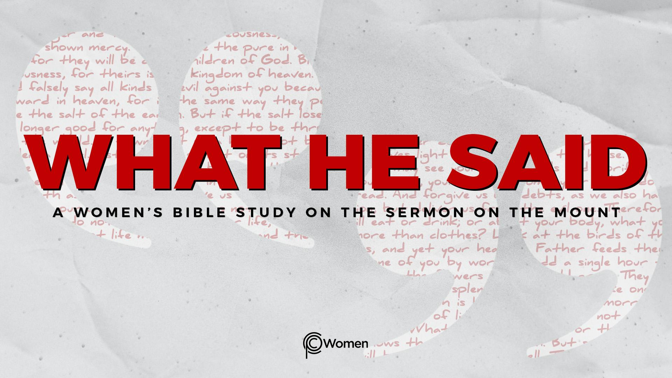
NOTE: Our lesson questions are based on the NIV 2011 edition. Our preference is your first time through the questions, you answer without consulting commentaries - delight in what the Holy Spirit will reveal to you.

Lesson 8
Matthew 5:21-26

1. What truth, verse or insight was food for thought from Lesson 7 and when did God bring it to mind this week?

2. Prayerfully read through the first of six teachings about doing right by other people in Matthew 5:21-26. In each, Jesus quotes the wisdom of the Torah and then interprets the law according to His vision of the kingdom of heaven. In these and other verses, Jesus will sometimes use “hyperbole” to make a point. What is the definition of hyperbole? Where do you find it in this passage and how might the use of hyperbole prompt a disciple to reflect more deeply on what Jesus is saying? NOTE: This technique, rooted in Jewish tradition, highlights the gravity of a bigger spiritual principle over a literal interpretation.

3. In V21, what phrase does Jesus use to introduce the command from the Law? What is the command and the consequence? From what well recognized set of laws is He quoting (Exodus 20:13)?

4. a) What phrase does Jesus use to present His interpretation of the command in Matthew 5:22? Describe each of the offenses he calls out and their respective consequences.

b) How do you make sense of the fact that as the offenses become less egregious, the consequences become more severe? How might murder, anger and name calling stem from the same core disposition of heart? (Hebrews 12:15 and 1 John 3:15 may shed some light.)

5. a) Recount the situation in Matthew 5:23-24. How does Jesus tie a person’s worship of God to a strained relationship to a brother or sister? To better understand the priorities of worship, review Isaiah 1:15-16 and Hosea 6:6.

b) What is the deeper spiritual point Jesus is making through the hyperbole in this passage? Explain your thinking.

6. What do the following verses say about what it takes to be reconciled to a brother or sister who has something against you:

- Matthew 6:12

- Romans 12:17-19

- 2 Corinthians 5:18-19

- Ephesians 4:2-3

- In what ways would a reconciled relationship with a brother or sister have greater priority to the Lord than an actual offering at the altar?

8. Summarize Jesus’s teaching and reasoning from Matthew 5:25-26.

9. Describe a relationship you have with another person that is in need of reconciliation. Examine yourself. What do you think settling with your adversary would require of you?

10. JESUS SAID: BE RECONCILED
“All this is from God, who reconciled us to himself through Christ and gave us the ministry of reconciliation… We are therefore Christ’s ambassadors, as though God were making his appeal through us. We implore you on Christ’s behalf: Be reconciled to God.” 2 Corinthians 5:18, 20.

As you contemplate being reconciled to God through Jesus, how would you characterize the dispute that Jesus settled between you and God? What did God have against you and what difference has reconciliation made in how you are able to relate to God and to fellow believers? Take some time to give thanks to Jesus who by His death brought harmony to your relationship to God and the power to be reconciled with others.

MEMORY VERSE: “See to it that no one falls short of the grace of God and that no bitter root grows up to cause trouble and defile many.” Hebrews 12:15

NAME PRAYER REQUEST

