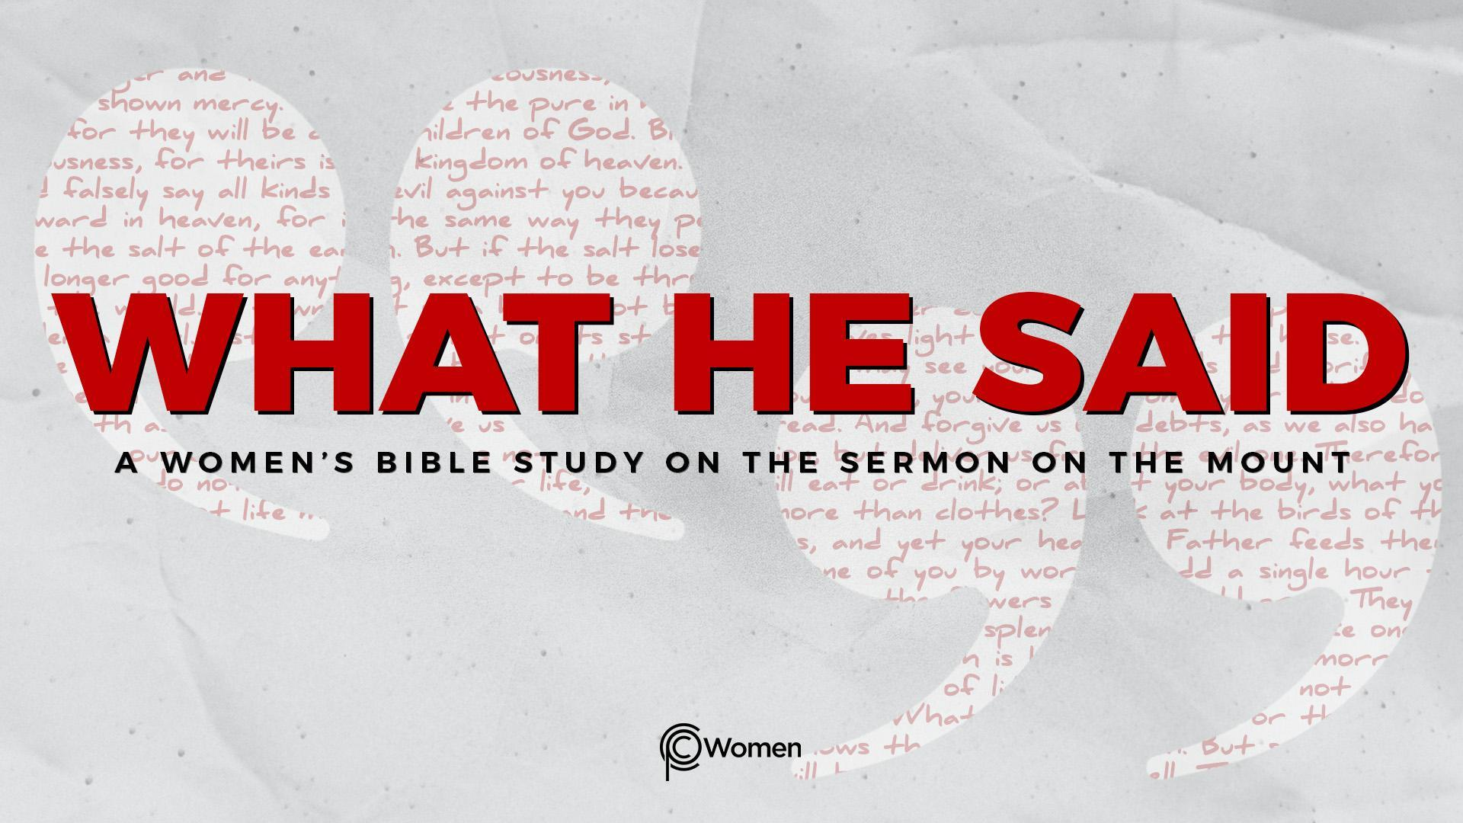
NOTE: Our lesson questions are based on the NIV 2011 edition. Our preference is your first time through the questions, you answer without consulting commentaries - delight in what the Holy Spirit will reveal to you.

Lesson 7
Matthew 5:17-20

1. How did God stir your compassion for the lost this past week and what truth, verse or insight was fuel for you as you sought to live out Jesus’ call to be salt and light?

2. Seek the LORD as we begin the study of Jesus’ view on the role of the Torah and the Prophets in Matthew 5:17-20. Come to this passage willing to hear what Jesus has to say about the heart of God’s commands. In His day, there was much debate about how to interpret God’s will in the Torah. What is your understanding of the relevance/authority of the Old Testament today? How does your initial read of Jesus’ teaching in V17-20 challenge or support your thinking? What questions does it raise?

3. a) What is the contrast Jesus makes in V17 about the role of the Law and the Prophets within the ongoing purpose of God? Describe the gist of the contrast as best you can and share why it might be confusing or concerning to the hearers.

b) Read this sampling of verses and note a few of the ways Jesus fulfilled what the Lord had said in His Word:

- Matthew 1:18, 22-23

- Matthew 4:13-16

- Matthew 8:16-17

- Matthew 13:34-35

- Luke 24:44-47

4. a) What is Jesus saying about the enduring nature and eternal significance of the Law in Matthew 5:18? What do you think He means by the phrase “until everything is accomplished”?

b) Find a simple truth in each of the verses below that relates to the enduring nature of the things of God.

- Psalm 102:25-27

- Isaiah 51:6

- Isaiah 55:10-11

5. a) After elevating the importance of the Torah, what distinctions does Jesus make as He addresses the practice and teaching of its commands in Matthew 5:19? How does His statement shed light on the meaning of the phrases “abolish the Law” and “fulfill the Law” used in V17?

b) What does Jesus say to His disciples that gives insight to the weight of His commands in Matthew 28:18-20?

- How does your view of the commands of the Torah conflict or align with Matthew 5:19? Talk about the tension of this instruction for kingdom-living with a grace mindset of not earning salvation.

- a) What do you think Jesus is teaching His audience in V20? What surprises you, perplexes or even bothers you about what He said?

b) Jesus expounds on His teaching about righteousness, doing what is right by someone, in Matthew 22:35-40. How does Jesus respond to the question, “which is the greatest commandment?” and what is your take away from this exchange?

8. JESUS SAID: PRACTICE AND TEACH THESE THINGS
In Matthew 5:19, Jesus said, “…anyone who sets aside one of the least of these commands and teaches others accordingly will be called least in the kingdom of heaven, but whoever practices and teaches these commands will be called great in the kingdom of heaven.” James cautions that not many should become teachers because they will be judged more strictly (James 3:1).

If the emphasis of Jesus’ words is on those who are called to correctly interpret and “teach” others the Word of God, how would you characterize His lesson? What was He implying about the 1st century Pharisees and teachers of the law (Matthew 23:27-28)? Why does this matter to you today?

MEMORY VERSE: “Do not think that I have come to abolish the Law or the Prophets; I have not come to abolish them but to fulfill them.” Matthew 5:17

NAME PRAYER REQUEST

