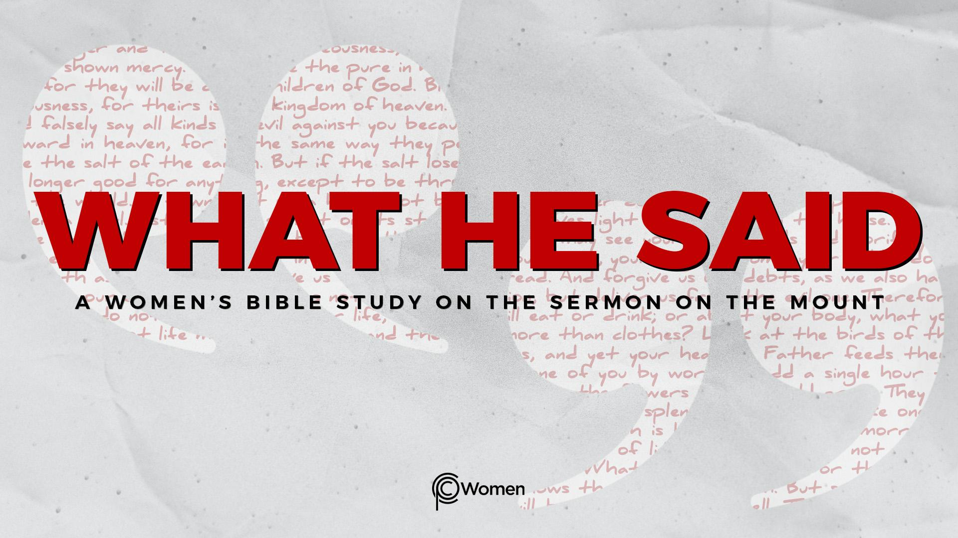
NOTE: Our lesson questions are based on the NIV 2011 edition. Our preference is your first time through the questions, you answer without consulting commentaries - delight in what the Holy Spirit will reveal to you.

Lesson 6
Matthew 5:13-16

1. What truth, verse or insight from Lesson 5 caused you to think differently about what it may mean to live out your faith and how did God adjust your outlook?

2. Pray for understanding before you read what Jesus said about the role and impact of the kingdom community in the world in Matthew 5:13-16. Identify three images or metaphors that He uses to call us into a new kind of life. Share your thoughts on how these verses might be connected to V3-12.

3. Read Matthew 5:13. We use salt for flavoring and as a preservative. Skim these verses to learn the symbolic meaning of salt to Jesus’ audience: Leviticus 2:13, Numbers 18:19 (enduring covenant); 2 Kings 2:19-21 (purifying).

- What do you think Jesus is asking of His followers in Matthew 5:13 and about what is He warning?

- What does the need for salt imply about the condition of the world?

4. a) In V14, Jesus said, “You are the light of the world.” What are some of the essential properties of light and, according to Ephesians 5:8-9, what does living in the light produce?

b) Jesus compares the light to a town or city on a hill. In what ways are they similar based on Matthew 5:14-15? When have you been tempted to hide or cloak your identity as a Christian or the message of the gospel?

5. CHALLENGE:
a) What was Jesus’ call on Paul’s life while on the road to Damascus in Acts 26:16-18 and how was Paul’s mission tied to darkness and light?

b) Now read Paul’s admonition to the Ephesian church in Ephesians 5:8-14. What is Paul saying about how Jesus’ followers are to live?

6. Jesus’ statements in Matthew 5:14-15 are rooted in certain Hebrew Scriptures addressed to Israel, calling it to become a city through which God’s light would shine. What strikes you about the images of light and city from the following verses?

- Isaiah 2:2-5

- Isaiah 49:5-6

- Isaiah 60:1-3

7. In what darkness is God asking you to be light? What could this look like for you?

8. Write a truth about how a believer’s actions can glorify our Father in heaven based on Matthew 5:16.

9. JESUS SAID: LET YOUR LIGHT SHINE
In John 8:12, Jesus said, “I am the light of the world. Whoever follows me will never walk in darkness, but will have the light of life.” As He is the light of the world, His followers reflect His light to those who remain in darkness. He said, “… let your light shine before others, that they may see your good deeds and glorify your Father in heaven.” Matthew 5:16. Our light shines only to make visible the goodness and glory of God.

What is your attitude toward the lost who are without the light of life? For whom are you burdened with sorrow or compassion because they walk in darkness? Ask God to give you opportunities to bring praise to Him through your words and deeds, so that the goodness and light of Jesus might be visible to those who walk in darkness..

MEMORY VERSE: “In the same way, let your light shine before others, that they may see your good deeds and glorify your Father in heaven.” Matthew 5:16

NAME PRAYER REQUEST

