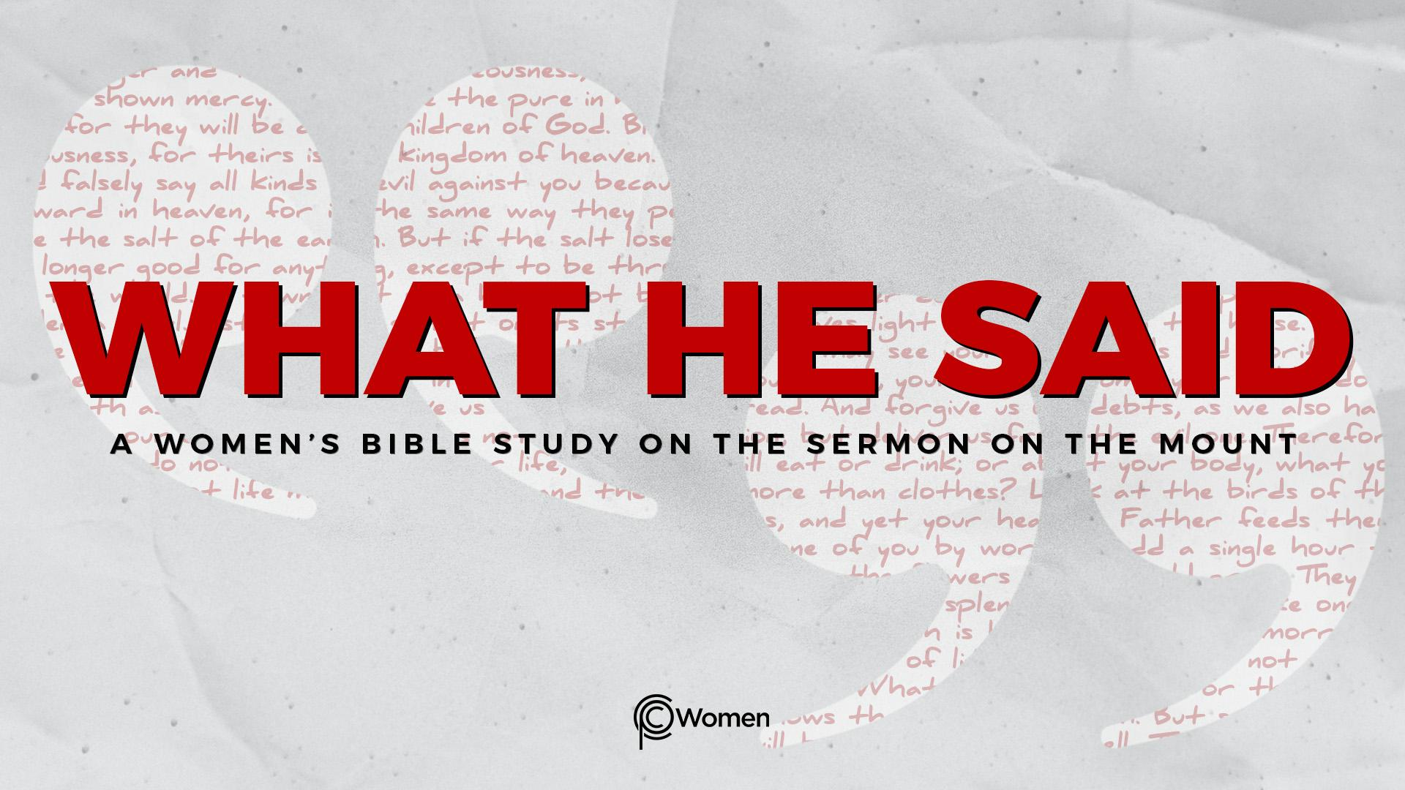
NOTE: Our lesson questions are based on the NIV 2011 edition. Our preference is your first time through the questions, you answer without consulting commentaries - delight in what the Holy Spirit will reveal to you.

Lesson 5
Matthew 5:9-12

1. How did the prior lesson minister to you and what did you learn - or of what were you reminded - about righteousness, mercy or the state of your heart?

2. Before you read the final section of the Beatitudes in Matthew 5:9-12, ask the LORD to help you see Jesus’ words with fresh eyes and a receptive heart. As Jesus dispenses wisdom about the kingdom of heaven, He turns His attention to certain types of conduct, i.e., actions taken by and actions directed toward specific people. From your initial review of these verses, in what aspects are they similar to the prior verses, V3-8, and how do they differ?

3. For V9-12, list the specific actions identified and the results or hopeful responses:

V9

V10

V11-12

4. a) While peace (shalom) is referenced throughout the Bible, the Greek word for “peacemaker” in V9 appears rarely in the New Testament. Describe a peacemaker and how a peacemaker would be unlike others who operate in this world.

b) Read the following verses and share your conclusions about the peace of God or peace with God:

- Proverbs 16:7

- Isaiah 9:6-7

- Colossians 1:19-20

- James 3:17-18

5. a) Jesus said the peacemakers are blessed because they will be called “children of God” (Matthew 5:9). As you think about being a child in your own family, in what ways do you resemble your parents or grandparents, and how have you been influenced by them?

b) As you consider John 1:12-13, Romans 8:14-17, and 1 John 3:1-2, what is the significance of using familial language?

- In Matthew 5:10, Jesus said the blessed are those in the crowd who are persecuted because of righteousness. Recall how you have experienced or witnessed persecution because of righteousness. How has it prepared you for the kingdom of heaven?

7. a) In Matthew 5:11-12, Jesus addresses His disciples as blessed and prepares them for the realities of ministering in His name. What are they to expect according to V11? What would be the normal reaction of someone who has experienced such treatment?

b) In contrast, from V12, what is the response Jesus calls His followers to have and why? Discuss whether you are moved or motivated by the eternal consequences of your words and actions.

8. From the following verses, how is the persecution a legacy of the prophets?

- 2 Kings 17:13-14

- 2 Chronicles 36:15-16

- Matthew 23:34-37

9. JESUS SAID: BE PEACEMAKERS
Read Isaiah 2:3-4 about true peace in the kingdom of heaven in the last days. “He will judge between the nations and will settle disputes for many peoples. They will beat their swords into plowshares and their spears into pruning hooks.” It may be difficult to imagine peace in a broken world in need of reconciliation and restoration. Peace is more than the absence of conflict or mere appeasement. It is a supernatural transcendent peace secured by Jesus resulting in peace with God as well as harmony among people.

In what conflict or disagreement is God calling you to bring harmony? How has the situation revealed the limitations of your ability to be a peacemaker? Examine how your actions or attitudes may have contributed to the lack of peace.

MEMORY VERSE: “See what great love the Father has lavished on us, that we should be called children of God! And that is what we are! The reason the world does not know us is that it did not know him.” 1 John 3:1

NAME PRAYER REQUEST

