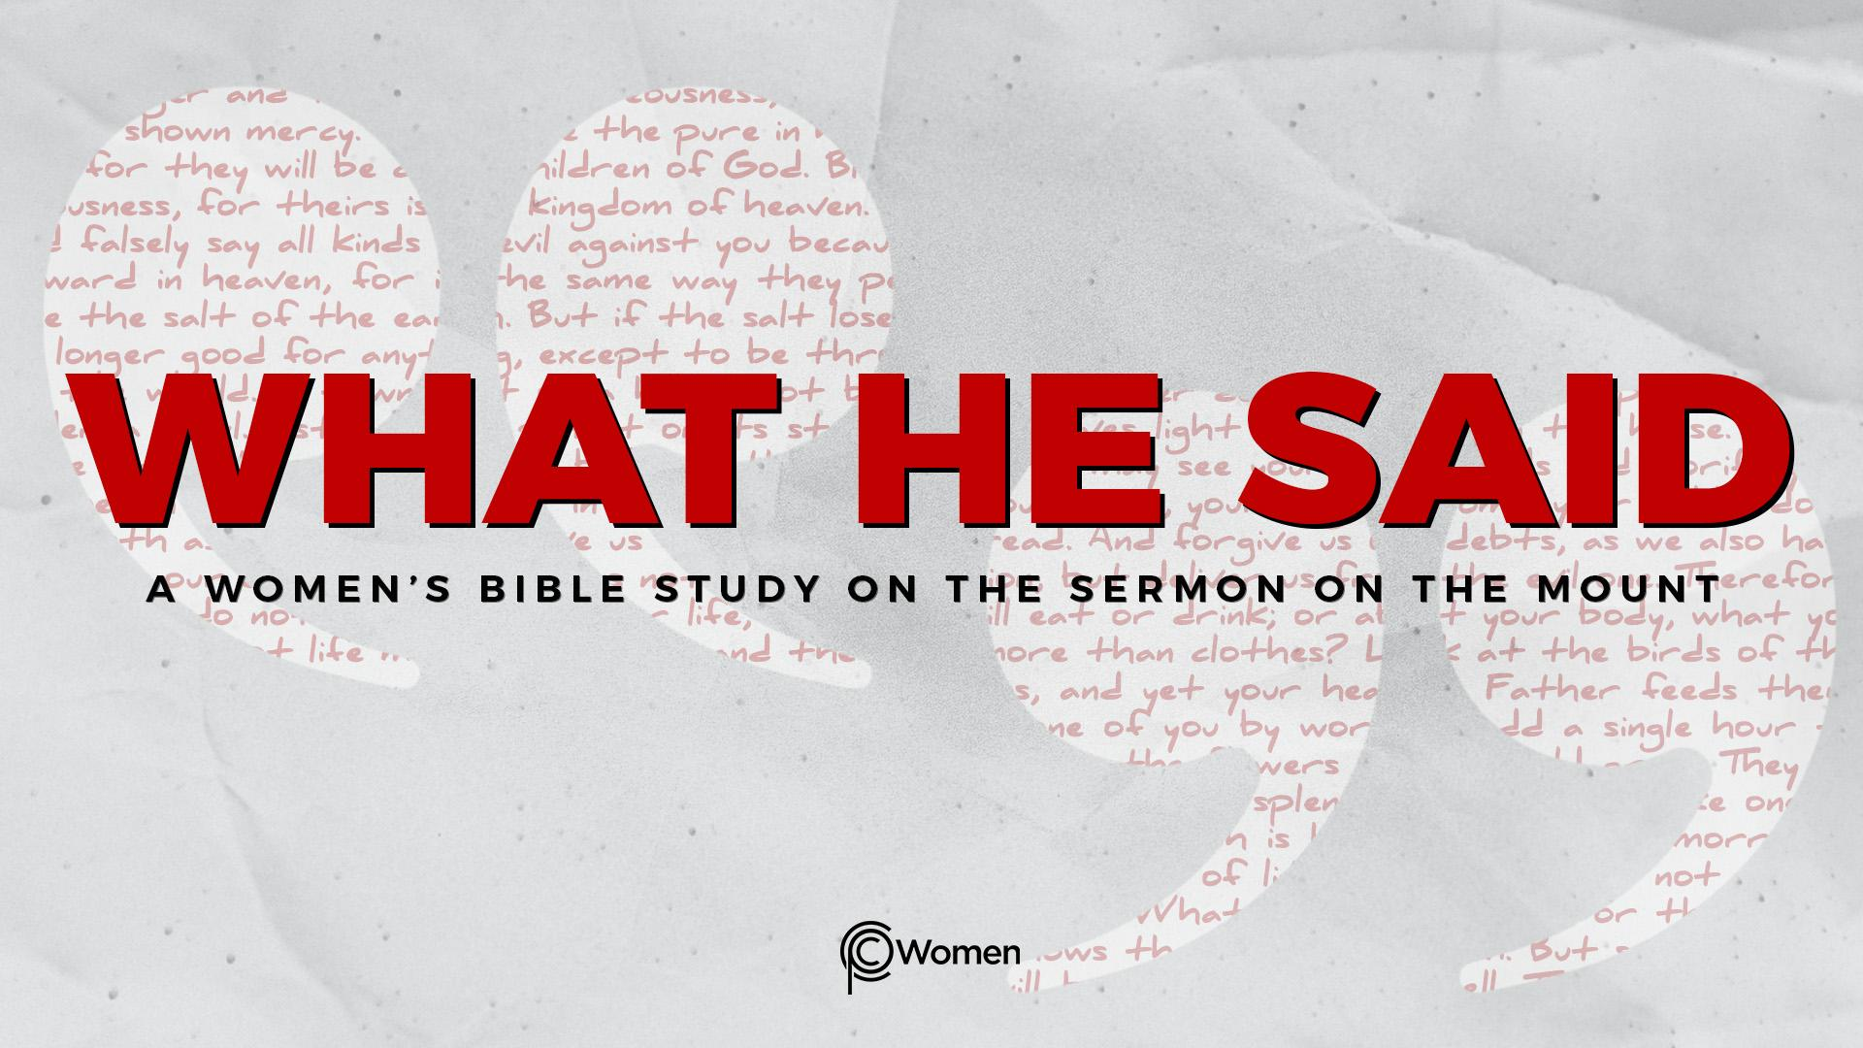
NOTE: Our lesson questions are based on the NIV 2011 edition. Our preference is your first time through the questions, you answer without consulting commentaries - delight in what the Holy Spirit will reveal to you.

Lesson 4
Matthew 5:6-8

1. What truth, verse or insight from last week’s lesson was meaningful to you and when did the Holy Spirit bring it to mind this week?

2. Prayerfully read Matthew 5:6-8 in which Jesus identifies three groups of people displaying unique character traits He sees as being blessed, fortunate, living the good life. As you think about what Jesus said in these verses, which character trait seems most out of reach or unlike you, and why? Which character trait would you like to see God grow in you?

3. As was true for V3-5, there is a logical structure to each of Jesus’ sayings in V6-8. In the first line, He identifies a trait or quality that He sees as blessed and, in the second line, He lets you know why He believes this. With that in mind, for each verse, describe the trait and the blessing:

V6

V7

V8

4. a) How would you define righteousness as used in V6? Why might a person who hungers and thirst for righteousness please God? Take into account the view of righteousness expressed in Romans 3:10-12.

5. a) Reflect on the verses below that describe spiritual hunger and thirst.

- Psalm 42:1-2

- Psalm 63:1-5

- Isaiah 55:1-2, 6-7

- John 7:37-39

b) When have you experienced a similar hunger and how was it satisfied?

- a) Matthew 5:7 focuses on mercy: “Blessed are the merciful for they shall be shown mercy.” Use a dictionary to define mercy, making the distinction between mercy and justice. When have you seen it demonstrated or received it?

b) What do you learn about Jesus through His acts of mercy in the verses below?

- Matthew 20:29-34

- Luke 23:33-34, 42-43

- John 8:3-11

- a) Describe the person who is “pure in heart” from Matthew 5:8, using the following verses for inspiration, Psalm 24:3-6, Proverbs 4:20-23 and
Ezekiel 36:25-26.

b) In Matthew 5:8, Jesus said they will “see God”. What more is revealed about seeing God from these verses?

- Exodus 33:19-20

- John 1:18

- 1 Corinthians 13:12

8. JESUS SAID: BE MERCIFUL
In Exodus 33:19, God says “I will have mercy on whom I will have mercy…” Mercy is not getting what you deserve; its source is the goodness of God. In Jesus, since you have been forgiven of the penalty of sin, you have received God’s mercy and have everything you need to extend mercy to others. “Be merciful, just as your Father is merciful.” Luke 6:36

- Write a truth about how Jesus is an expression of God’s mercy towards those He loves.

b) In what situation are you withholding mercy or hoping to receive mercy? Pray that the LORD overwhelms you with the extent of His mercy towards you and that He supplies the mercy you need or the mercy He is calling you to extend.

MEMORY VERSE: “Above all else, guard your heart, for everything you do flows from it.” Proverbs 4:23

NAME PRAYER REQUEST

