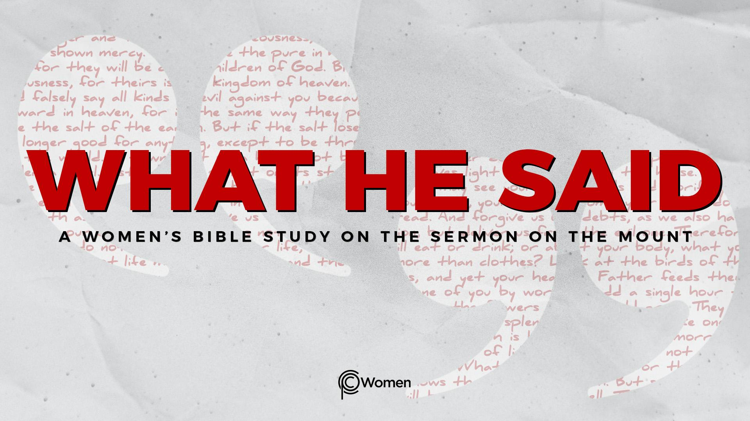
NOTE: Our lesson questions are based on the NIV 2011 edition. Our preference is your first time through the questions, you answer without consulting commentaries - delight in what the Holy Spirit will reveal to you.

Lesson 3
Matthew 5:3-5

1. How did the LORD use last week’s lesson on what it means to be blessed and what truth or insight has adjusted your perspective?

2. Ask God to reveal Himself as you read the first set of Beatitudes in Matthew 5:3-5, in which Jesus identifies three groups of people with differing social status. Jesus is proclaiming the good news of the kingdom of heaven and His instruction is radical to those hearing it for the first time. Why do you think He is calling out these particular groups of people and what do they have in common?

3. There is a logical structure to each of Jesus’ sayings in V3-5. In the first line, He identifies a group who is blessed or possesses the good life and, in the second line, He lets you know what He sees as the blessing. With that in mind, for each verse, identify the group and the blessing:

V3

V4

V5

4. Read the following verses and note the similarities to the message of Jesus in V3-5:

- Isaiah 57:15

- Isaiah 61:1-3

- James 2:5

- Revelation 21:3-4

5. a) What does it mean for someone to be “poor in spirit” (Matthew 5:3)? What is likely their view about themselves in terms of God and their standing before Him? For insight, read Isaiah 6:5, Isaiah 66:2, and Luke 5:8.

- How might the poor in spirit be suited for or ready to receive the kingdom of heaven?

6. a) Discuss what it means to mourn (Matthew 5:4) and what events or circumstances give rise to mourning. See, e.g., Genesis 37:33-35, Nehemiah 1:3-7, Luke 19:41-44.

b) Review the following verses and comment on the comfort God provides.

- Psalm 119:75-77

- Lamentations 3:31-33

- 2 Corinthians 1:3-7

c) When have you experienced deep personal grief and where did you look for/find comfort in your time of mourning?

7. a) In Matthew 5:5, as Jesus addresses the powerless and afflicted in the crowd, He echoes the words of King David who said, “the meek will inherit the land and enjoy peace and prosperity [shalom].” Psalm 37:11. Those considered meek are described in Psalm 147:3, 6, 11. What are some of their characteristics?

b) CHALLENGE: How does Romans 8:14-17 link the inheritance of the meek as children of God to Jesus? Consider whether this is a spiritual inheritance or is there more?

8. JESUS SAID: BE MEEK
Jesus uplifted those who are meek, but do you value meekness? How would you describe someone who is the opposite of meek? As you examine your own life and attitudes, are you striving for power or prestige? Do you demand to have things your way, in your time? Pray that the Spirit would develop in you humility toward God and a willingness to surrender your rights in service of others.

MEMORY VERSE: “These are the ones I look on with favor: those who are humble and contrite in spirit, and who tremble at my word.” Isaiah 66:2b

NAME PRAYER REQUEST

