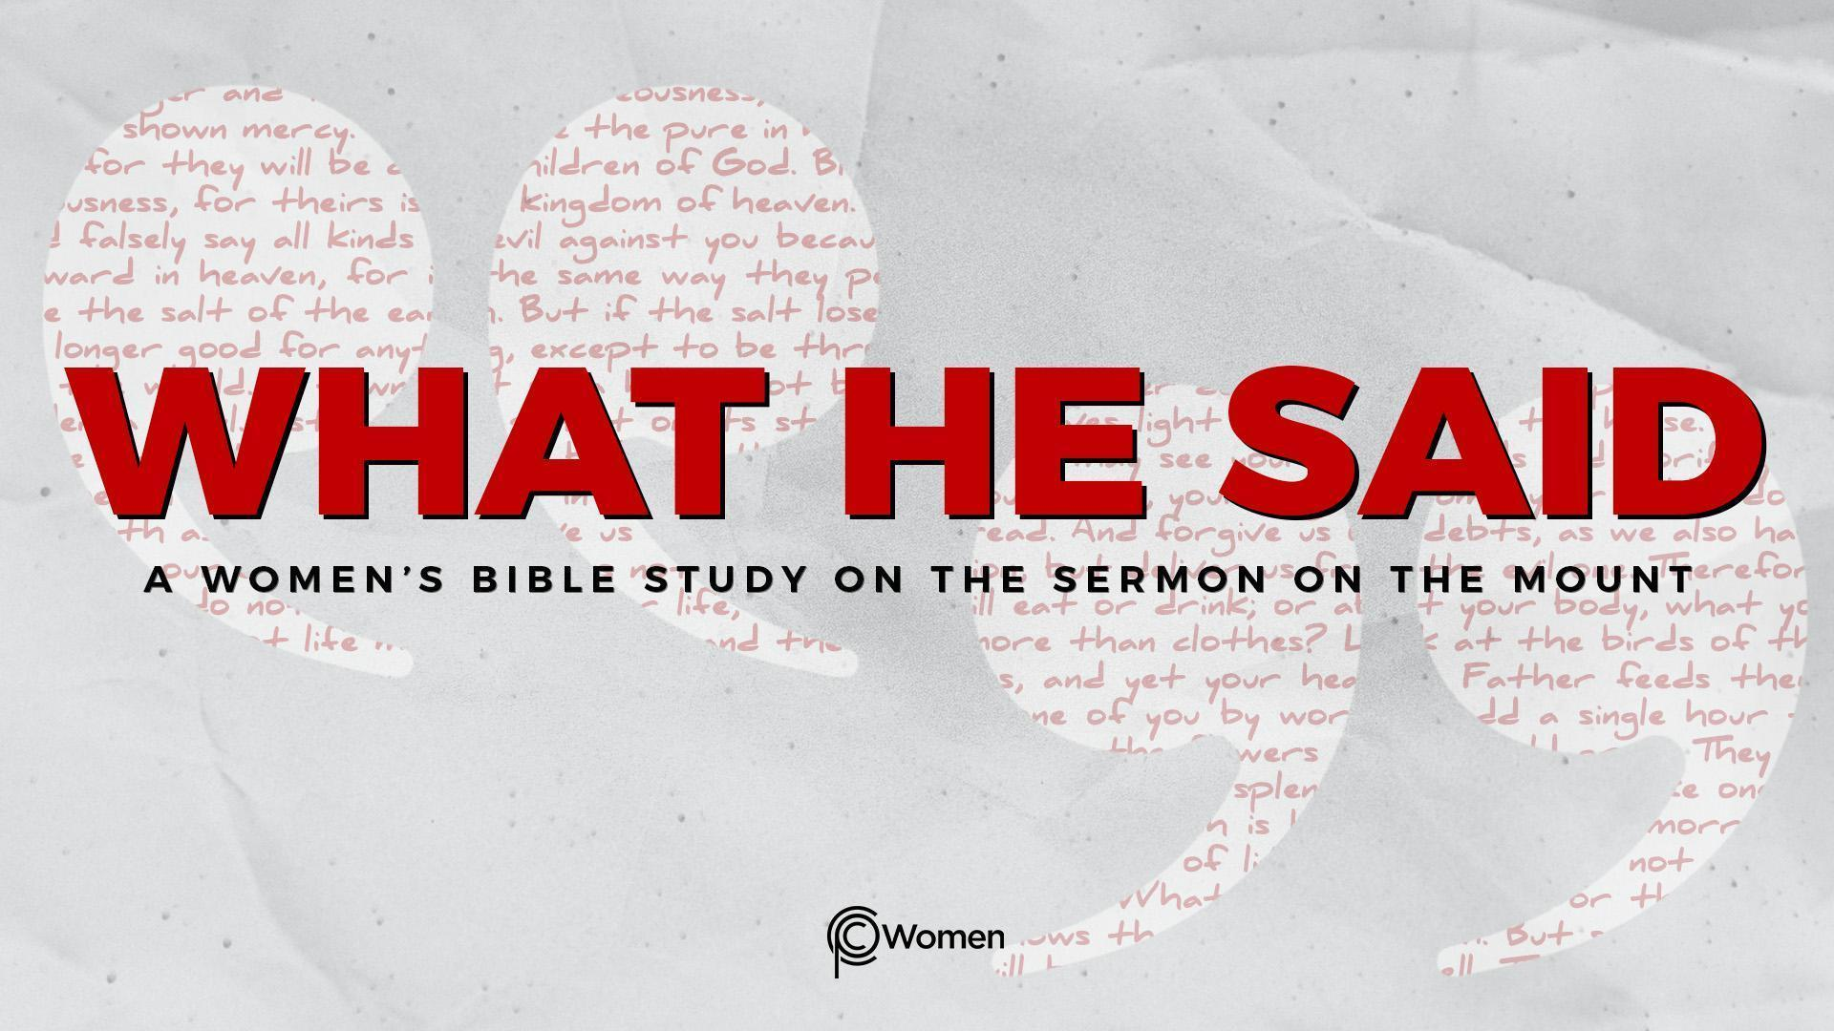

SHARING CLASS
Lesson 25

Sharing Class is a time to look back and celebrate what we’ve learned throughout the year. This Lesson is designed to help you in your time of reflection. You might want to refer to your lessons and lecture notes, the “Memory Verses” or “My Main Thing” document as you answer these questions.

1. From our Sermon on the Mount study which verse (or Suggested Memory Verse) did you love or need the most and why?

2. What truth or quote from a lecture helped you grasp what Jesus said about living in the kingdom of heaven, and in what way?

3. Share how you have seen the Lord answer a personal prayer request this year.

4. How has this study transformed an attitude or a behavior with respect to God, other people, or kingdom life?

5. What is the main thing you will remember that has led you to come closer to Jesus and see His kingdom more clearly from:

- Sermon on the Mount lessons from Matthew’s Gospel

- Reflecting on what Jesus said

