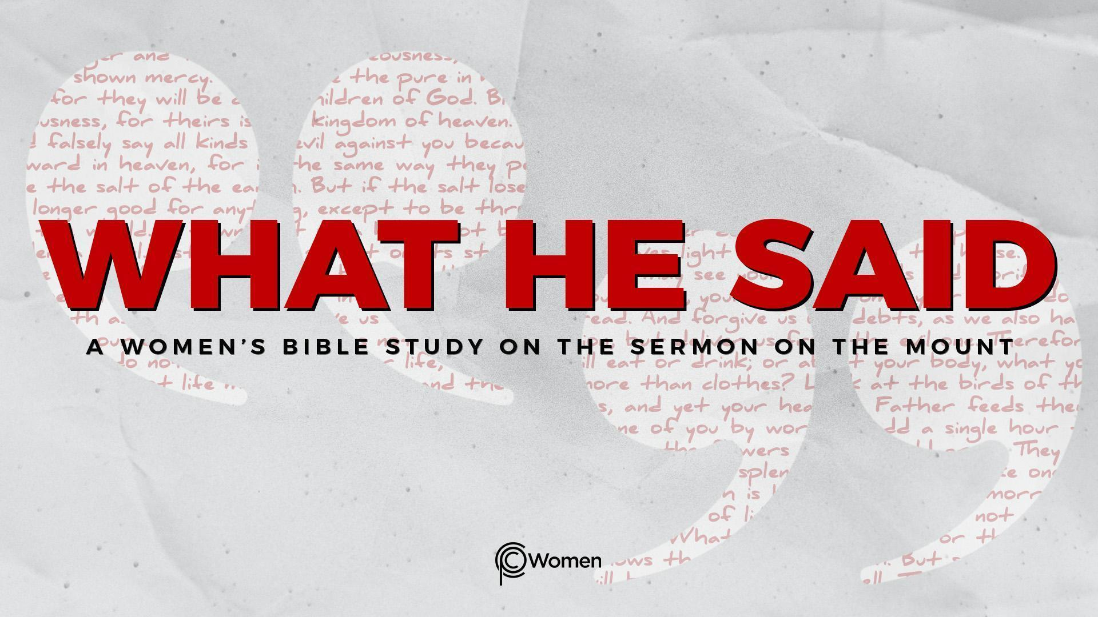
NOTE: Our lesson questions are based on the NIV 2011 edition. Our preference is your first time through the questions, you answer without consulting commentaries - delight in what the Holy Spirit will reveal to you.

Lesson 24
Matthew 7:24-29

1. What truth, verse or insight from Lesson 23 concerning the vetting of prophets and disciples was eye-opening for you and why was clarity on this topic relevant?

2. In these final verses of the Sermon on the Mount, Matthew 7:24-29, Jesus looks at whether those who have heard Him will actually put into practice His astonishing teaching. He has taught about the kingdom of heaven and invited us to live with radical kingdom values. Ask the Spirit for understanding as you read and consider this final parable which portrays the wise person and the fool. Share a wise decision you have made and how you acted upon it, and then share a foolish decision and its ramifications. What did you learn from these experiences?

3. Jesus compares two men and two houses in V24-27. Fill in the chart below with the various differences and similarities you find in the parable.

FIRST MAN (V24-25) SECOND MAN (V26-27)
Hears Jesus’ words | Hears Jesus’ words
Puts them into practice | Does not put them into practice
4. a) As you study the chart above, what conclusions can you draw from the similarities between the two men and the elements that came against each of their houses?

b) What can you learn from the differences between these two men? What made the biggest difference in the ultimate outcomes for the houses according to V25?

5. What can you learn about the foundation of the house that did not fall, or the rock upon which it was built, from the verses below.

- Psalm 62:7

- Isaiah 33:6

- 1 Corinthians 3:11

6. Matthew 7:24 begins with the word “therefore.” Explain how this parable relates to or sums up prior verses.

7. Read the following verses from Proverbs. What are the marks of a wise person in contrast to those of a fool?

- Proverbs 1:5, 7

- Proverbs 13:1, 13

- Proverbs 14:7, 14

8. Write a truth from what Jesus said about the wise man and the foolish man from Matthew 7:24-27. Consider also what He is not saying. For example, is He saying that the wise man is the “real” Christian or that he was saved by putting Jesus’ teaching into practice? Why or why not? Feel free to use Scripture to support your reasoning.

9. a) Describe what the crowd was feeling when Jesus finished speaking according to Matthew 7:28-29. As you reflect on this, why was His teaching so unlike what anyone had heard before? Refer to what Jesus said in John 7:16-18.

b) How do each of the following verses evidence Jesus’ unique claim to authority and how have you seen His authority evidenced in your own life?

- Matthew 28:18-20

- John 10:17-18

- Colossians 2:9-10

10. JESUS SAID: BUILD WISELY
The wise woman builds wisely by putting into practice the words of Jesus. She understands she will be tested; the rain will come, the streams will rise, and the winds will blow. But in the victory secured by Jesus, she proclaims, “Christ is my firm foundation, the rock on which I stand.”

Each of us wants to be wise and to build our lives upon the authoritative teaching of Jesus. What words of Jesus would you most like to put into practice now? How can you begin to build upon Jesus as your firm foundation and stand victorious in the face of forces coming against you?

MEMORY VERSE: “Therefore everyone who hears these words of mine and puts them into practice is like a wise man who built his house on the rock.” Matthew 7:24

NAME PRAYER REQUEST

