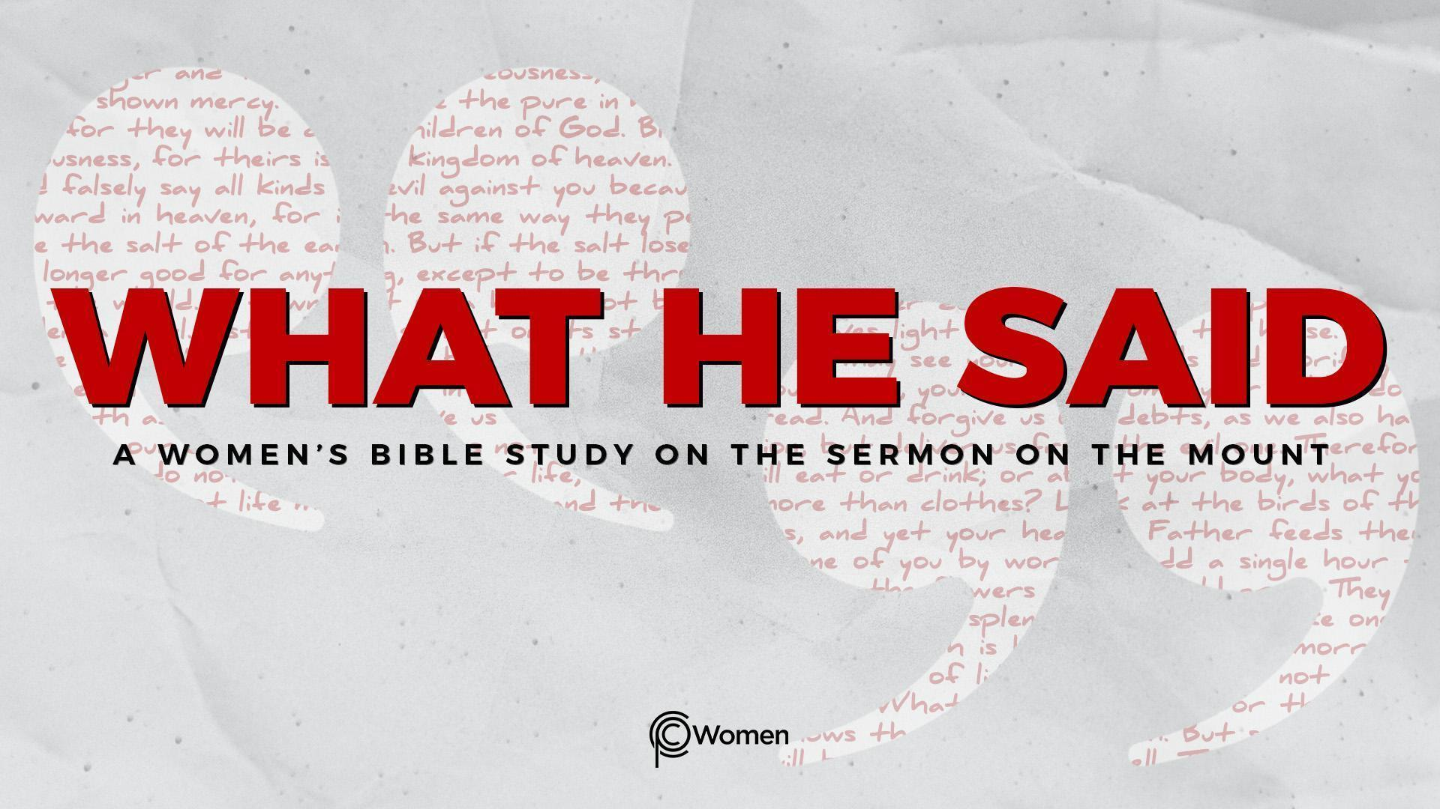
NOTE: Our lesson questions are based on the NIV 2011 edition. Our preference is your first time through the questions, you answer without consulting commentaries - delight in what the Holy Spirit will reveal to you.

Lesson 23
Matthew 7:15-23

1. What truth, insight or verse from Matthew 7:12-14 stood out and how did it help you apply The Golden Rule to your daily life this past week?

2. As you approach Matthew 7:15-23, ask God to reveal His truth of how to judge the legitimacy of a prophet - a person who purports to speak for Him. Through this passage, Jesus is calling us to see beyond outward appearances, accomplishments and performance. The ultimate test of a true prophet is integrity—whether their public platform matches their private obedience, reflecting submission to the Lordship of Jesus. When have you experienced a teacher or spiritual leader who you later discovered was leading you away from the narrow road? How did it test your faith?

3. Jesus issues a warning in V15. What is His main concern?

4. a) Summarize Jesus’ key points and His conclusion in V16-20. Luke 6:43-45 has more to say about a tree and its fruit.

b) What does the bad fruit look like? What does good fruit look like? For examples, read Galatians 5:19-23.

5. Looking at Matthew 7:19, what will become of false prophets and teachers? What is the effect on those who follow and trust in them? For further understanding, visit 2 Peter 2:1-3.

6. Scripture consistently addresses the importance of identifying and confronting false prophets and teachers. What are some of the signs based on these passages?
- Jeremiah 23:16-22
- 2 Timothy 2:17-18
- 1 John 4:1-4
- Jude 1:4, 10, 16
7. a) Based on Matthew 7:21, how would Jesus define a true disciple?

b) It is easy to confuse having knowledge about God with actually having a relationship with Him and doing His will. Where are you persisting in doing things your way and ignoring the prompting of the Holy Spirit?

8. According to V22, what do many people point to as the evidence of their right standing with God? See also Deuteronomy 13:1-3.

9. What is Jesus’ strong message in Matthew 7:23? What can you conclude about performing deeds without a true relationship with God?

10. JESUS SAID: BE WATCHFUL
How do we know who speaks for God and who does not? We are to watch the trajectory of the person’s life over time. We watch to see beneath the surface since a person’s actions and speech flow from what is stored up in their heart (Luke 6:45). There is no formula. We trust wisdom from the Lord to discern whether a teacher or spiritual leader is conforming to the will of God. As in the times of Jesus, there are some who want to lead you off the narrow way. Do not be deceived. Do not follow them.
How do the following verses encourage you as you choose to walk the path that leads to life and bear good fruit?
● John 15:4-5
● Philippians 1:9-11
- Colossians 2:6-7

MEMORY VERSE: “A good man brings good things out of the good stored up in his heart, and an evil man brings evil things out of the evil stored up in his heart. For the mouth speaks what the heart is full of.” Luke 6:45

NAME PRAYER REQUEST

