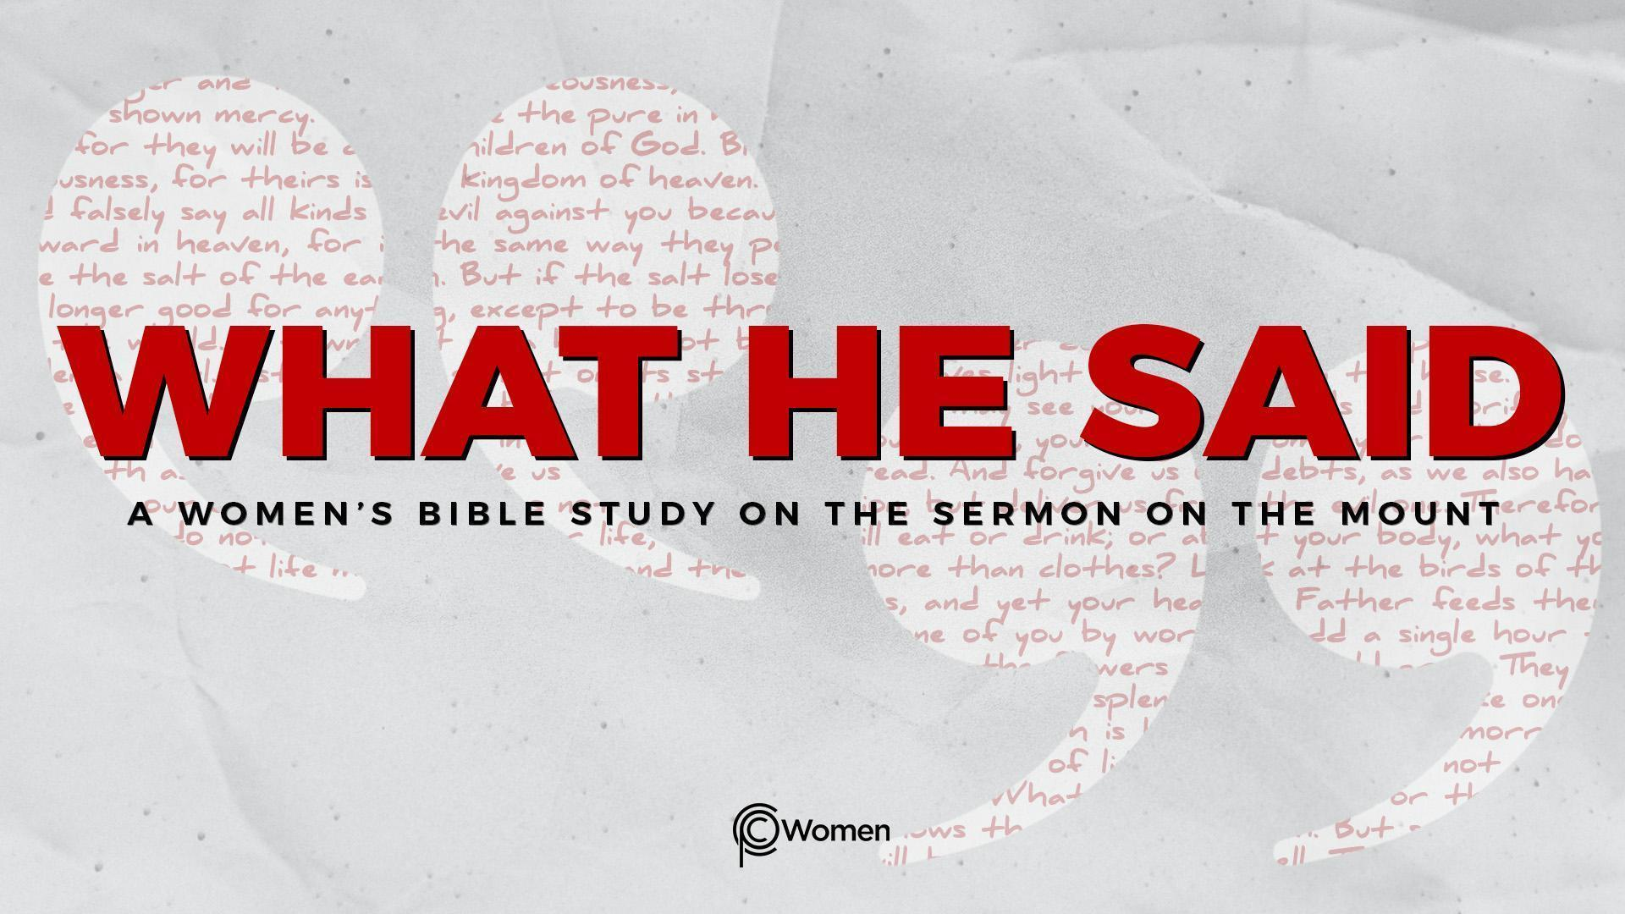
NOTE: Our lesson questions are based on the NIV 2011 edition. Our preference is your first time through the questions, you answer without consulting commentaries - delight in what the Holy Spirit will reveal to you.

Lesson 22
Matthew 7:12-14

1. What truth, verse or insight did you take away from last week’s study of Matthew 7:7-11 and how have you been applying it to your daily life?

2. Pray for God to give you insight into His word as you read this week’s passage, Matthew 7:12-14. Jesus began His teaching by saying He came to “fulfill” the Law and the Prophets (Matthew 5:17) and as He comes to the end of His teaching, He says the Law and the Prophets can be summed up by what is known as “The Golden Rule.” In what context did you first hear The Golden Rule and how has it shaped the way you have treated or responded to other people?

3. a) Considering all that you now know about Jesus’ teaching and His vision of righteousness, how is the Law and the Prophets summed up by, “do to others what you would have them do to you” in V12? Paul writes about this in Romans 13:8-10.

b) What more do you learn about how you are called to treat others from the following:

- Leviticus 19:18

- Matthew 22:36-40

- 1 John 4:19-21

4. How would the world operate differently if all people listened to and followed The Golden Rule? In which of your relationships do you see a need to practice The Golden Rule?

5. Discuss the warning Jesus gives in Matthew 7:13-14, the choice each person must make and how the choice relates to destiny.

6. a) What more do you discover about taking the narrow gate/narrow road from these verses?

- Psalm 1:1-3, 6

- Psalm 16:11

- John 6:66-68

- Revelation 21:3-4

b) What can you expect to find beyond the wide gate according to the verses below?

● Psalm 1:4-6

● Galatians 6:7-8

● 2 Thessalonians 1:8-9
7. In a culture that often follows the crowd along the easier, more inclusive, broad road, how might choosing the harder, less travelled, narrower path lead you to an authentic life of faith and a true sense of peace? Refer to John 16:33, 1 Peter 4:12-13 or another verse that supports your response.

8. Read the Scriptures below. Ultimately, WHO is the narrow gate or the narrow way that leads to eternal life?

- John 10:7-10

- John 14:6

- Acts 4:11-12

9. JESUS SAID: ENTER THE NARROW GATE
Jesus said “Whoever wants to be my disciple must deny themselves and take up their cross and follow me.” Matthew 16:24. He calls us to enter the narrow gate, a path that requires obedience and self-denial. It means dying to sin and living by faith (Galatians 2:20).

a) As you count the cost of being a disciple, what is one specific area of your life—at work, in your home, or in your public or personal interactions—where following Jesus feels harder or more restrictive compared to the broad road of “you do you”?

b) Where is Jesus prompting you to die to sin or self, to set something down or leave something behind, as you follow Him through the narrow gate?

MEMORY VERSE: Jesus answered, “I am the way and the truth and the life. No one comes to the Father except through me.” John 14:6

NAME PRAYER REQUEST

