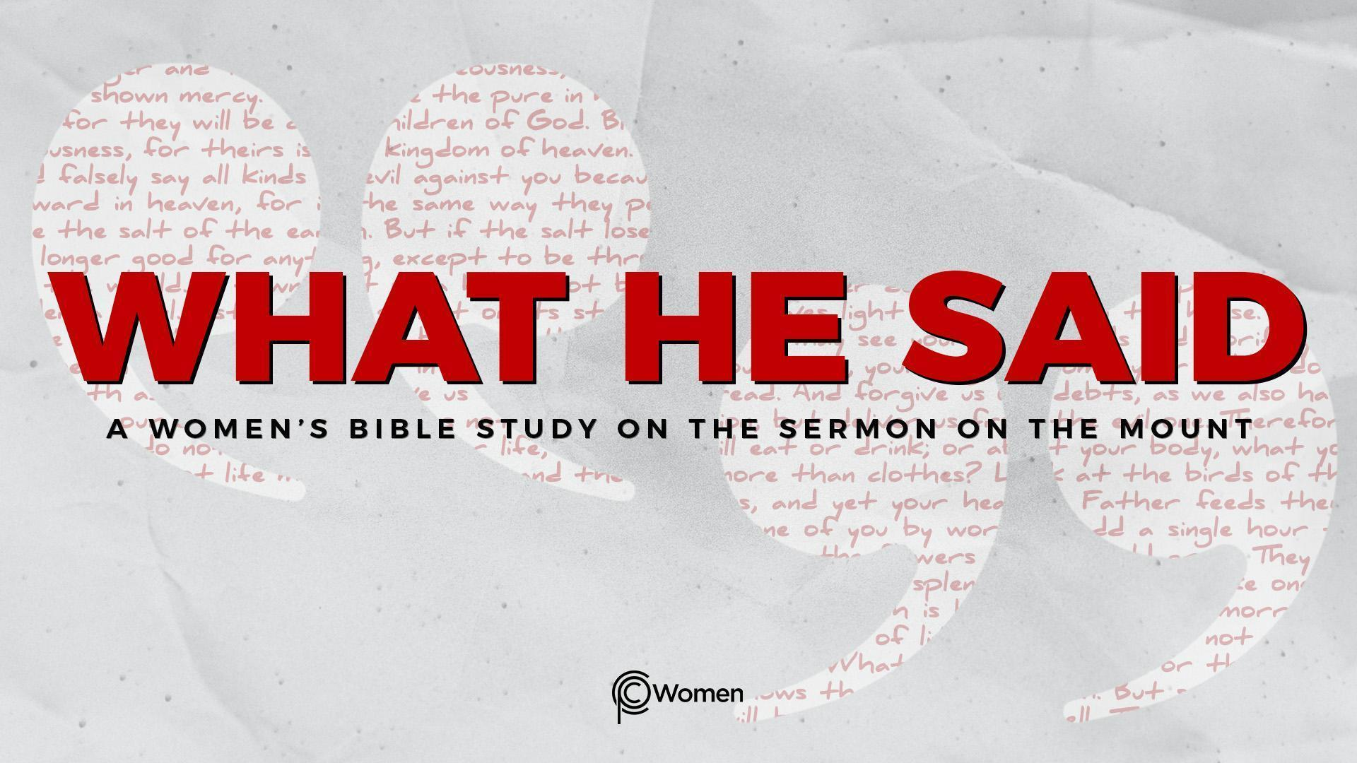
NOTE: Our lesson questions are based on the NIV 2011 edition. Our preference is your first time through the questions, you answer without consulting commentaries - delight in what the Holy Spirit will reveal to you.

Lesson 19
Matthew 6:25-34

1. What surprised you to learn from Lesson 18 and in what ways did a truth, verse or insight provide guidance this week?

2. Pause before you begin and ready your heart to receive wisdom from on high as Jesus turns to the subject of worry. Then read through each verse of Matthew 6:25-34. While some level of concern is appropriate, worry can be negative and is ultimately traced to our view of God. Jesus asks us to train ourselves to consider God’s overabundance of love and generosity obvious in nature. How much more will He provide for your needs. So, what circumstances or things weigh you down to the point of distraction and fear of the future? How do you combat your worry?

3. a) Read the “therefore” at the front of V25 and note how this passage follows from the prior verses contrasting treasures on earth and treasures in heaven. What things does Jesus assume are on the crowd’s list of worries?

b) Jesus asks the first of five questions in this passage. What question does He pose (V25) and what thinking does He expose?

4. a) Despite the fact that Jesus knew real want (Matthew 8:20), what does Jesus call attention to in Matthew 6:26a and how is our heavenly Father portrayed? Read David’s psalm of praise, Psalm 145:15-19, and note how he portrays the bounty of the LORD.

b) When have you experienced the bounty of God? How can that experience renew your thinking in times of want?

5. Rewrite the two important questions Jesus asks in Matthew 6:26b-27 and derive a truth from them about worrying.

6. a) In V28-30, what worry does Jesus turn to with his next question and how does He demonstrate that peace is possible from nature and Scripture?

b) From V30, where do you see the generous nature of God embedded in the question? How does Jesus refer to the person He is addressing and what does that say about how to live without worry? Hebrews 11:6 may provide insight.

7. What do V31-33 disclose about how those with kingdom priorities live? When Jesus says “all these things will be given to you” (V33), is this a promise without any qualifiers? Explain your reasoning.

8. Summarize what Jesus tells the crowd in V34 about a mindset of scarcity for the future. How are the following verses a balm for your worries today?

- Summarize what Jesus says V34:

- 2 Corinthians 12:8-10

- Philippians 4:6-7

- Philippians 4:11-13

- Philippians 4:19

9. JESUS SAID: DO NOT WORRY
Job, about whom the book of Job was written, lost everything – his children, his possessions, his health. He said, “What I feared has come upon me; what I dreaded has happened to me.” Job 3:25. God allowed the things Job worried about, leaving him in turmoil and questioning, until Job repented in His presence and proclaimed to Him, “I know you can do all things; no purpose of yours can be thwarted.” Job 42:2

Recall a time when your worry proved warranted and what you feared came to pass. God did not give you what you thought you needed or gave you something you thought you could not bear. How have you reconciled this with the fact that God can do all things and that no purpose of His can be thwarted? Bring your turmoil and your questions to Him. Allow your group to pray for you and seek the peace of God.

MEMORY VERSE: “Do not be anxious about anything, but in every situation, by prayer and petition, with thanksgiving, present your requests to God. And the peace of God, which transcends all understanding, will guard your hearts and your minds in Christ Jesus.” Philippians 4:6-7

NAME PRAYER REQUEST

