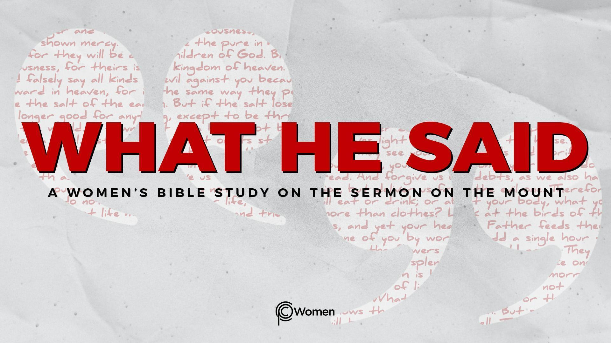
NOTE: Our lesson questions are based on the NIV 2011 edition. Our preference is your first time through the questions, you answer without consulting commentaries - delight in what the Holy Spirit will reveal to you.

Lesson 18
Matthew 6:19-24

1. As you think back to Lesson 17, what truth or insight from Jesus gave you needed perspective on fasting and how have you or will you put it into practice?

2. Pray before you read Matthew 6:19-24 and ask the LORD to show you how to live with kingdom priorities seeing ourselves in relationship to our heavenly Father. In this passage, Jesus focuses on how the disciples relate to material wealth in a time before bank accounts and storage containers. As you think about your priorities, what are the material items you most treasure and why are they of such great value to you? How might it feel if you lost or were unable to access these treasures?

3. a) Jesus contrasts two different kinds of treasures in V19-20. What are the two kinds, how do they differ from one another, and what instruction does Jesus give regarding each kind?

b) Read the following verses and note what you learn about “treasures in heaven:”

- Matthew 19:16, 20-22

- Matthew 25:34-36

- 1 Peter 1:3-4

- Revelation 22:12

4. a) Put Matthew 6:21 into your own words. How have you experienced the truth of this statement by Jesus?

b) Jesus is not making the case for poverty or a life without any possessions. What do you think is the greater lesson He is teaching (V19-21)? Review Paul’s words in 1 Timothy 6:17-19 in your search for similar godly wisdom.

5. Matthew 6:22-23 is a bit cryptic.

a) How is the eye characterized in V22a? What could this infer about the significance of the eye? Note: commentators do not agree.

b) Jesus talks about two different kinds of eyes. From V22b-23a, what is true of healthy eyes as opposed to unhealthy eyes and how might the eyes reflect kingdom priorities? Note: the footnotes in the NIV translation indicate that healthy eyes imply generosity and unhealthy eyes imply stinginess.

c) Comment on how you interpret what Jesus says in V23b and what a person who is stingy conveys about the treasures they are storing up. Proverbs 28:11 speaks to this.

6. a) From Matthew 6:24, describe how a “master” functions and why it is impossible for a person to serve two of them. What are the two masters presented in these verses?

b) CHALLENGE: Read Matthew 22:37-38 and meditate on what Jesus said is the greatest commandment in the Law. Discuss whether you see the love of God as incompatible with the love of money and how the pull of money or material wealth has competed with your desire to love God.

7. JESUS SAID: STORE UP HEAVENLY TREASURES
Heavenly treasures are unseen but they are more real and of greater worth than any worldly treasure. (2 Corinthians 4:18.) So what can we do to obey Jesus and store them up? Could it be this: “Though you have not seen him, you love him; and even though you do not see him now, you believe in him and are filled with an inexpressible and glorious joy, for you are receiving the end result of your faith, the salvation of your souls.” 1 Peter 1:8-9

Ask the Spirit to guide you to fix your eyes not on what is seen but on what is eternal, the unseen. Pour out praise for your faith to believe in Jesus, of greater worth than gold, and for the joy and hope you have in Him.

MEMORY VERSE: “So we fix our eyes not on what is seen, but on what is unseen, since what is seen is temporary, but what is unseen is eternal.” 2 Corinthians 4:18

NAME PRAYER REQUEST

