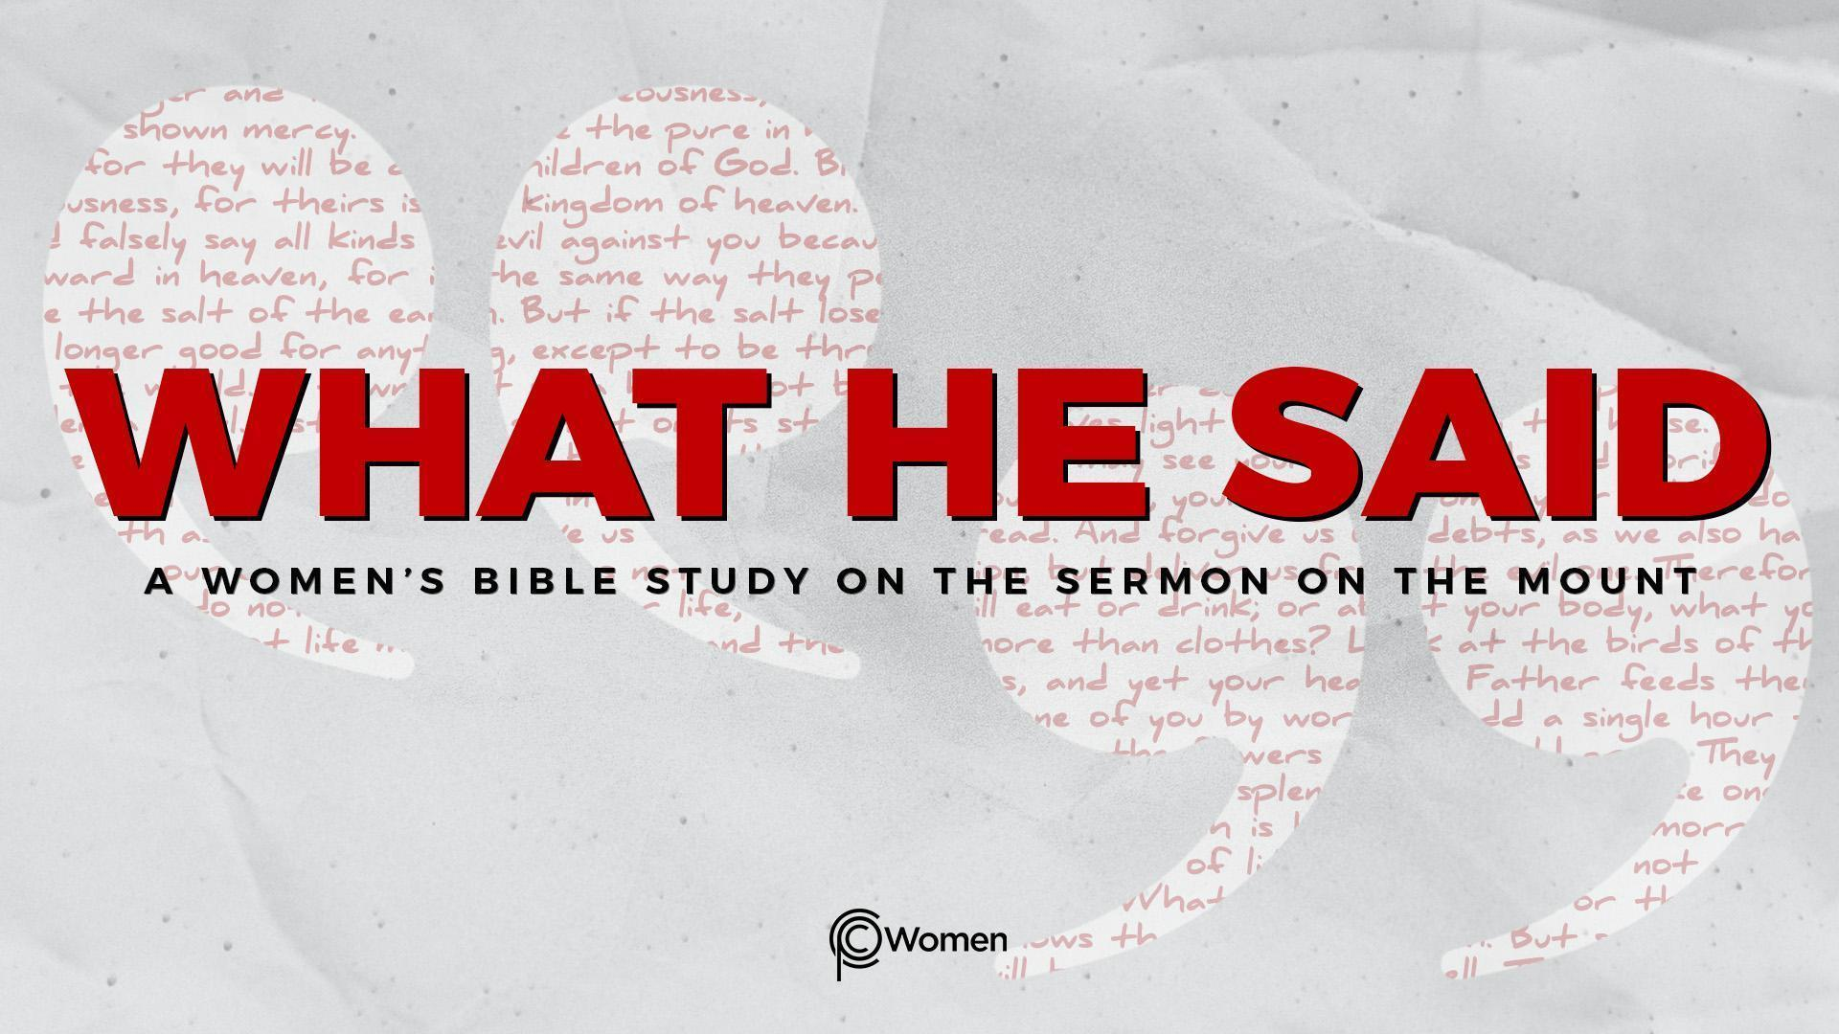
NOTE: Our lesson questions are based on the NIV 2011 edition. Our preference is your first time through the questions, you answer without consulting commentaries - delight in what the Holy Spirit will reveal to you.

Lesson 17
Matthew 6:16-18

1. How did a verse, truth or insight from Lesson 16 adjust your thinking about forgiveness? What difference did this make in your relationships this week?

2. In Matthew 6:16-18, we encounter Jesus’ teaching about fasting that is rewarded by the Father. Pray that God would give you an increased desire to fast discretely. Describe your personal experience with fasting and its significance in your spiritual life.

3. In V16a we are once again warned to avoid acting like hypocrites - those who pretend to be someone they are not or who do the right thing with the wrong motive. What behaviors are we warned against and where have you witnessed or participated in this show of piety?

4. What point do you think Jesus is trying to make in V16b?

5. Which faith practices do you feel most compelled to publicly participate in or to avoid because of your desire for the approval of others? What are the consequences?

6. Rewrite the instructions given in V17 using modern examples for what has been commanded.

7. a) According to V18, why should we keep our fasting secret?

b) Share what you think the godly rewards for fasting promised in V18 could be.

8. Based on what you read in V16-18, what do you believe matters most to God about how we fast and engage in other faith practices?

9. There are many reasons that a person might fast as a practice of faith. Read the following Scripture and make note of who is fasting and why:

- 2 Chronicles 20:2-4
- Ezra 8:21
- Esther 4:14-16
- Isaiah 58:5-7
10. What circumstances are so pivotal or so consequential to you that you might choose to fast and pray in response to them?

11. JESUS SAID: FAST IN SECRET
God’s people have fasted throughout history to humble themselves before Him, seek His guidance and receive His Blessing. Moses was the first to fast, abstaining from food and drink for forty days in order to draw near to God on Mount Sinai (Exodus 34:28). God commanded all to deny themselves (fast) on Yom Kippur, The Day of Atonement (Lev. 23:26-27). Jesus reminds His followers to fast unseen by seeking God’s attention in order to receive His greater reward. Learn how God responded to the examples of fasting in question 9 by reading the rest of the story below. Which of these outcomes do you crave most in your own life and why?

- 2 Chronicles 20:15, 21-22

- Ezra 8:22-23

- Esther 5:1-2, 9:1-2

- Isaiah 58:8-11

MEMORY VERSE: “When you fast, do not look somber as the hypocrites do, for they disfigure their faces to show others they are fasting. Truly I tell you, they have received their reward in full.” Matthew 6:16

NAME PRAYER REQUEST

