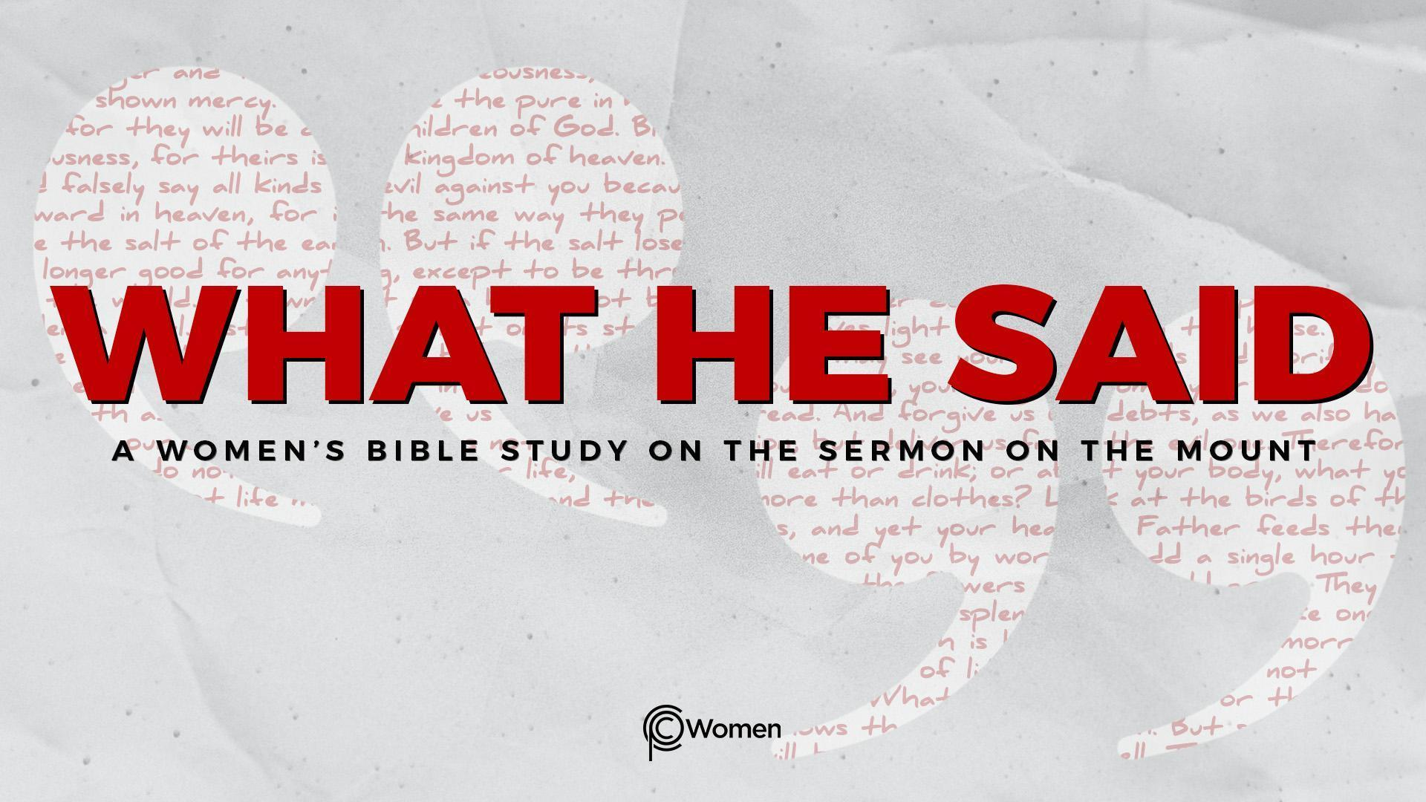
NOTE: Our lesson questions are based on the NIV 2011 edition. Our preference is your first time through the questions, you answer without consulting commentaries - delight in what the Holy Spirit will reveal to you.

Lesson 16
Matthew 6:14-15, 18:23-35

1. Which truth, verse or insight from Lesson 15 was meaningful this week? How did it transform the way you pray?

2. Having finished the Lord’s Prayer, Jesus returns to the topic of forgiveness in Matthew 6:14-15. Before you read these two verses, pray that God would grow you in compassion and mercy by bringing to mind those instances in which you have needed to forgive and to be forgiven. Share a time when you experienced the forgiveness of God or another person. What was the impact of the forgiveness and/or the unforgiveness?

3. a) Use a dictionary to look up the word “forgive.” How is the word defined?

b) Explain how forgiveness might be different from reconciliation.

4. Rewrite the command given by Jesus in V14 as a personal action statement. How does the kingdom view of forgiveness differ from the world’s view?

5. Read the following Scripture and make note of a truth about biblical forgiveness:

- Proverbs 19:11

- Luke 7:44-48

- Luke 17:3-4

- Ephesians 4:32

6. a) Who is responsible for your forgiveness based on V14-15 and what consequences do you face if you do not forgive?

b) How do these verses align with or challenge what you know about the forgiveness Jesus secured for you?

7. a) CHALLENGE: Read Matthew 18:23-35, the parable of the Unmerciful Servant, in which Jesus illustrates kingdom principles of forgiveness. Describe the actions and motivations of the following people, and note your takeaway from the parable.

- King/Master

- Servant #1

- Servant #2

- Takeaway
b) Take a personal inventory of the debt you owe to a holy God. What does it mean to you that Jesus, your Savior and Redeemer, paid that debt with His blood in place of your own and now your sins are forgiven?

8. In what circumstances are you struggling to forgive another for their sins against you? What are the obstacles to your forgiveness? Ask your group to pray that God would help you move toward forgiveness.

9. JESUS SAID: FORGIVE AND CONFESS YOUR UNFORGIVENESS
“Bear with each other and forgive one another if any of you has a grievance against someone. Forgive as the Lord forgave you.” Colossians 3:13. Jesus commands us to forgive because in doing so we reflect the character of our Father and testify to all that we’ve been forgiven because of Jesus’ sacrifice on the cross. But our salvation does not depend on our imperfect forgiveness. When we recognize our unforgiveness, we can confess it and God will forgive us. Use the below scripture as inspiration to write your own declaration of praise to God for all He has forgiven you by grace through faith in Jesus.

- Psalm 103:8-10

- Isaiah 1:18

- Micah 7:18-19

- Luke 23:33-34a

- My Praise

MEMORY VERSE: “Be kind and compassionate to one another, forgiving each other, just as in Christ God forgave you.” Ephesians 4:32

NAME PRAYER REQUEST

