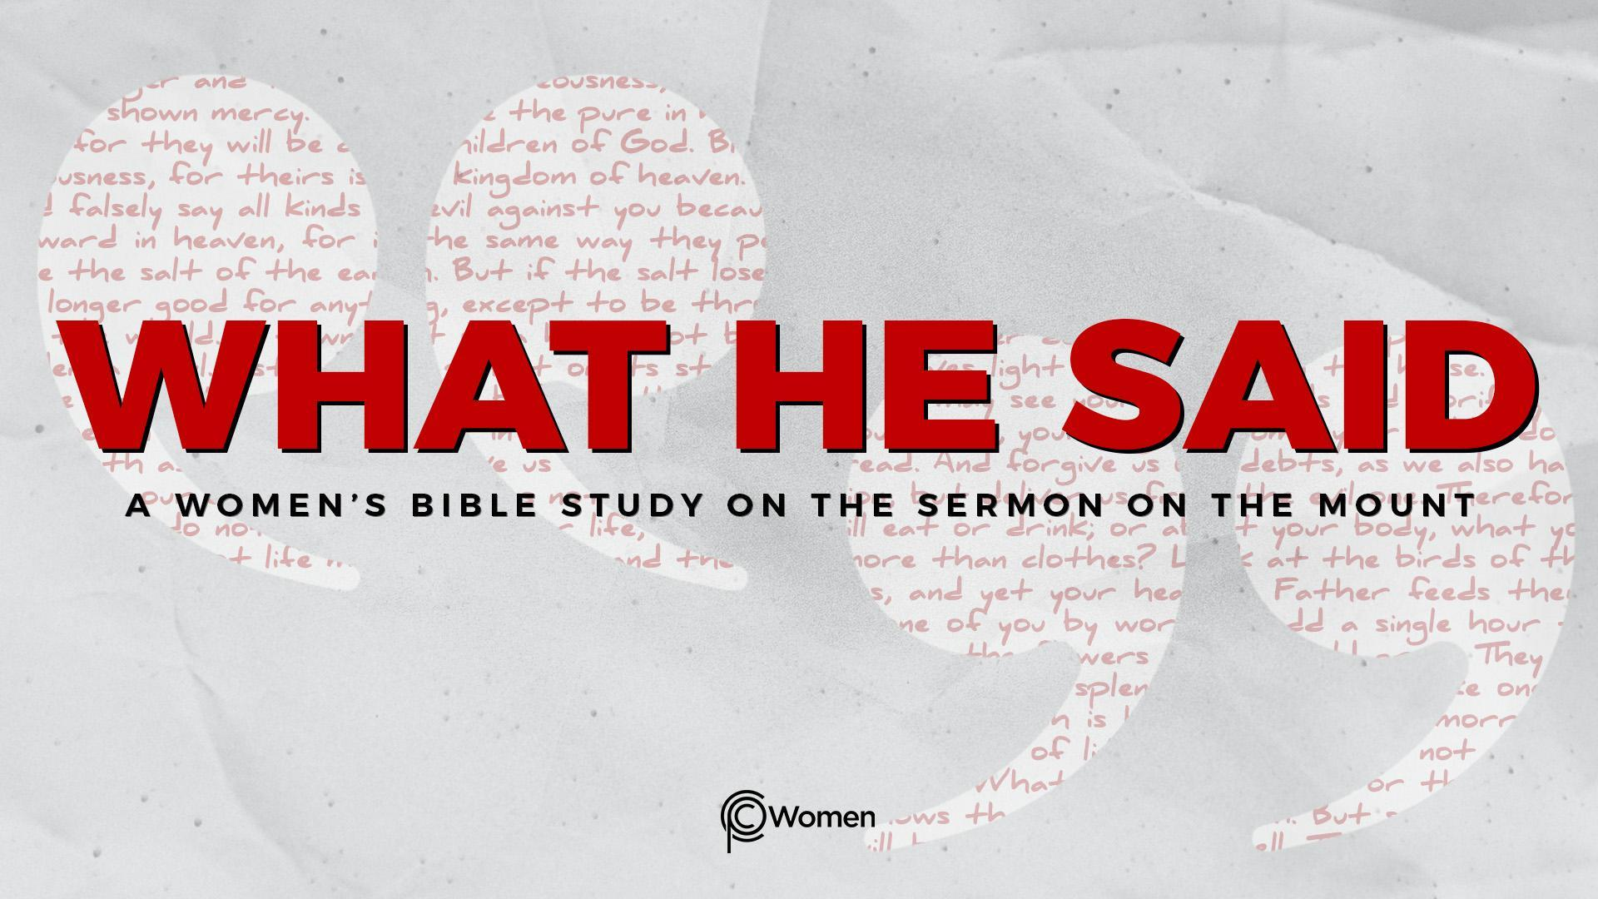
NOTE: Our lesson questions are based on the NIV 2011 edition. Our preference is your first time through the questions, you answer without consulting commentaries - delight in what the Holy Spirit will reveal to you.

Lesson 15
Matthew 6:5-13

1. In what new ways did last week’s lesson inspire you to live and give generously? Share the truth, verse or insight that most encouraged or convicted you to take action.

2. At the very center of the Sermon on the Mount in Matthew 6:5-13, Jesus gives us instructions on Kingdom praying, practiced in secret. He provides a brief model prayer (the Lord’s Prayer) that reflects His teachings, which He lived out perfectly. Ask God to give you a refreshed view and a deeper understanding of the vital role of prayer as you steep in these verses. What is your understanding of the purpose of prayer? What is your expectation of God when you pray?

3. List the stern warning Jesus gives in V5. What is hypocritical about praying as portrayed? Note the Greek word used for hypocrites, hypokritai, speaks of stage actors and others who play roles pretending to be someone they are not.

4. How does Jesus compare prayer that others see with prayer that only the Father sees in V5-6? Where do you see the desire for public recognition or reputation in your experience of prayer?

5. According to V7, describe how the pagans pray. What does Jesus say about the God to whom believers pray in V8 and how does knowing the Father change how you pray?

6. What additional truths about prayer are found in the below verses?

- Psalm 145:18-19

- Romans 8:26

- 1 John 5:14-15

7. Jesus proclaims, “This, then, is how you should pray…” How does Jesus begin the prayer according to Matthew 6:9-10? Based on what Jesus said about the Father in V6 and 8, what is the significance of beginning in this way?

8. What does Jesus tell us to ask for in V11 and what can we learn about how to focus our prayers?

9. Which core value of Kingdom life is at the heart of V12 and how does praying this way hold each of us personally accountable?

10. V13 focuses on protecting the believer from those things that disrupt a right relationship with God. Describe them and the goal of the enemy who seeks to interfere with your life. In what circumstance do you need greater protection from the enemy or temptation?

11. JESUS SAID: PRAY TO YOUR FATHER IN PRIVATE
We live in a world where many equate prayer to positive or wishful thinking. As women who follow Jesus, we know there is nothing of greater value than praying to our Father. We invite Him into our lives and submit to His will through prayer. Jesus reminds us that we don’t gain God’s attention by using persuasive words or winning the favor of others. God loves us. He hears our prayers and knows what we need before we even ask Him. You will find Him when you seek Him with all your heart (Jeremiah 29:12-13).

- Read the below Bible verses and make note of how they further your understanding of prayer.

- Philippians 4:6-7

- Hebrews 4:16

- James 1:5-7

- James 5:16-18

- Reflecting on all you’ve learned from this lesson, write your own timeless truth about prayer and claim it over your life.

MEMORY VERSE: “Your Father knows what you need before you ask Him.”
Matthew 6:8b

NAME PRAYER REQUEST

