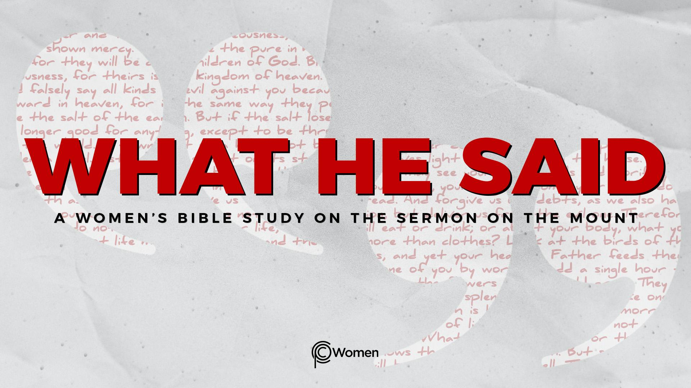
NOTE: Our lesson questions are based on the NIV 2011 edition. Our preference is your first time through the questions, you answer without consulting commentaries - delight in what the Holy Spirit will reveal to you.

Lesson 12
Matthew 5:38-42

1. How did Jesus’ rejection of oaths and vows enlighten you about kingdom values? What truth, verse or insight from Lesson 11 helped you think biblically about something that came up this past week?

2. Seek the truth the Lord wants to communicate as you read through Jesus’ unsettling teaching around the law of retaliation in Matthew 5:38-42. He is illustrating what it looks like when a citizen of the kingdom is personally injured and the humanity of the perpetrator is recognized. Think back to a time when you were wronged, unfairly accused or taken advantage of. What was your response to the wrong and how did it resolve? What was one lesson you learned?

3. In V38, Jesus weighs in on another issue addressed in the Torah. What was previously taught about the bounds of retaliation? Supporting Scripture can be found at Exodus 21:24; Leviticus 24:20; Deuteronomy 19:21. How do you see this law as an attempt to control anger and violence?

4. a) From Matthew 5:39, what is the principle Jesus lays down and what is the first example He gives of a kingdom response? Note: a slap on the cheek is not about physical injury, but about insult (2 Corinthians 11:20).

b) In offering the other cheek, what does the injured party demonstrate about their relationship with God, where their security lies, or what they value?

5. a) What is the second example in Matthew 5:40 and what is unique about it? Note: standard dress in Jesus’ day consisted of an inner and outer garment, with the outer garment doubling as a poor person’s bedding (Exodus 22:25-27).

b) What is the greater significance of giving up a coat or outer garment and how would the distinctives of kingdom living be graphically on display?

6. a) What is Jesus’ third example in Matthew 5:41? Note: under Roman occupation, a Roman soldier had the right to force a civilian to carry a load, with one mile being the legal limit (Matthew 27:32).

b) How would the response to abuse that Jesus advocates upend the power dynamics of the situation and demonstrate kingdom principles?

7. Reframe what Jesus proposes in Matthew 5:42. What do you think Jesus is saying about the importance of being generous beyond what is normal and comfortable?

8. From V39-42, which of the four examples is the toughest for you to see yourself living out and why? What arguments might you make to justify any unwillingness to do what Jesus says? Turn this into a prayer to align your heart with kingdom priorities.

9. JESUS SAID: TURN THE OTHER CHEEK
Paul said, “Do not repay anyone evil for evil. Be careful to do what is right in the eyes of everyone. If it is possible, as far as it depends on you, live at peace with everyone. Do not take revenge, my dear friends, but leave room for God’s wrath, for it is written: “It is mine to avenge; I will repay,” says the Lord.” Romans 12:17-19.
Paul, like Jesus, advocates against vengeance and retaliation on a personal level; instead, followers of Jesus are those who trust in the perfect divine justice of God.

Jesus asks His followers to break the cycle of violence by responding to provocative situations in unexpected ways. The ramifications of living this way are enormous. As you contemplate life in the kingdom of heaven, how do you see yourself fitting in? Where do you see opportunities to show Jesus’ radical love in your relationships? Ask your group to pray for you as you grapple with what Jesus said.

MEMORY VERSE: “But I tell you, do not resist an evil person. If anyone slaps you on the right cheek, turn to them the other cheek also.” Matthew 5:39

NAME PRAYER REQUEST

