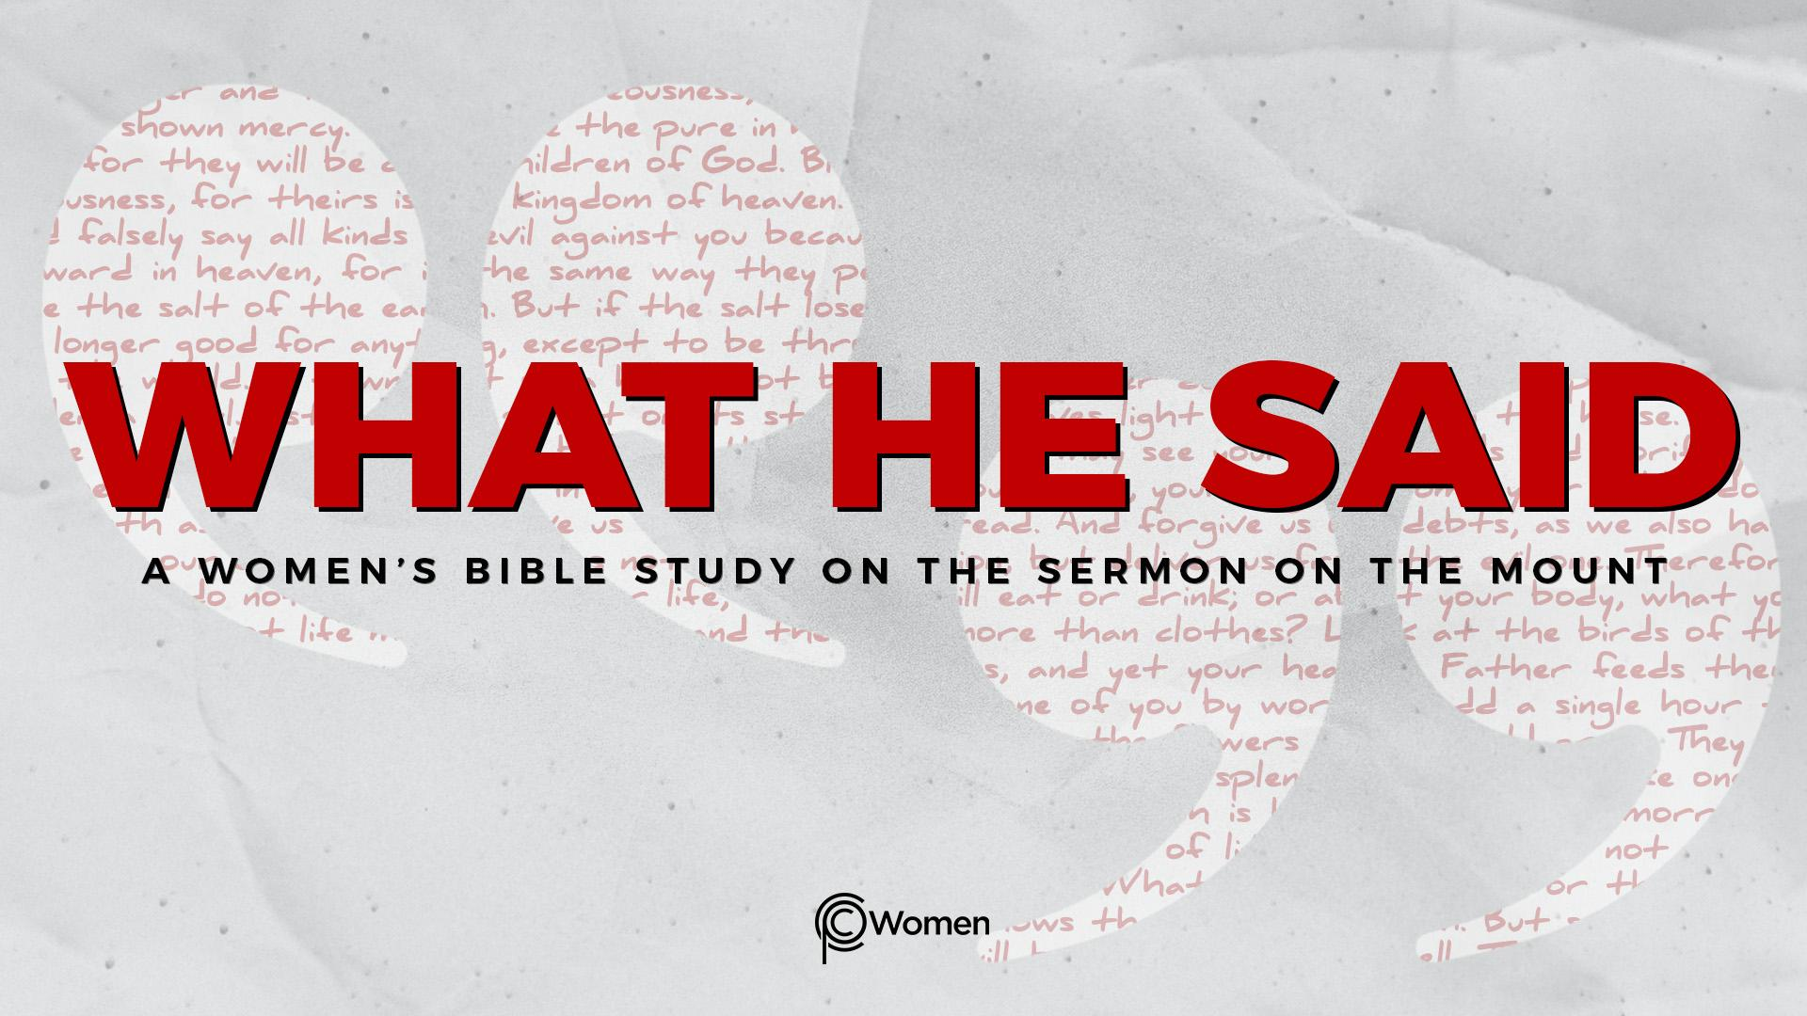
NOTE: Our lesson questions are based on the NIV 2011 edition. Our preference is your first time through the questions, you answer without consulting commentaries - delight in what the Holy Spirit will reveal to you.

Lesson 11
Matthew 5:33-37

1. What did Jesus say about divorce that strengthened your grasp of God’s intention for marriage and how did God use this truth or insight?

2. As you prepare to read Matthew 5:33-37, ask the Holy Spirit to guide you into the truth of kingdom values. Jesus condemns the common practice of using religious sounding language in an effort to induce others to agree or to make a promise seem more weighty. In what circumstances have you made a vow or taken an oath? When has a statement of intention made to you by another person been prefaced with a vow or an oath? Do you ever casually say, “I swear to God…”?

3. Provide the definitions of an oath and a vow. What do they accomplish? How does an oath differ from a vow?

4. a) Jesus again affirms the Law’s authority by summarizing several Scriptures in V33. What does He say had been said long ago about oaths and vows?

b) What do you learn about oaths and vows from the following verses:

- Leviticus 19:11-12

- Numbers 30:2

- Deuteronomy 23:21-23

- Psalm 50:14

5. a) According to Jesus in Matthew 5:34-36, should His followers be swearing or taking oaths? List the four examples Jesus calls out.

b) Why do you think Jesus has a problem with swearing by them?

6. a) How does making an oath or vow in God’s name as a way to guarantee the truthfulness of a promise “profane the name of our God?” (Leviticus 19:12)

b) From each of the verses below, write a truth about the use of the Lord’s name or making a vow to the Lord:

- Exodus 20:7

- Psalm 96:8-9

- Ecclesiastes 5:2, 4-6

- Hebrews 12:28-29
7. How did Jesus conclude His teaching on oaths and vows in Matthew 5:37, later echoed by His half-brother James in James 5:12?

8. In your opinion, what motivates people to make an oath or a vow that Jesus rejects? What is the deeper issue that concerns Jesus?

9. JESUS SAID: SAY WHAT YOU MEAN, MEAN WHAT YOU SAY
King Solomon, a man of great wisdom, once said, “Do not be quick with your mouth, do not be hasty in your heart to utter anything before God. God is in heaven and you are on earth, so let your words be few.” Ecclesiastes 5:2. According to Jesus, in whom are hidden all the treasures of wisdom and knowledge, “all you need to say is simply yes or no.” Matthew 5:37. In plain terms, say what you mean and mean what you say.

In what relationship have you been less than candid about your intentions or made statements to another person in order to achieve a desired outcome? How can speaking the simple truth be the way to love and honor someone instead of being manipulative or invoking the name of God?

MEMORY VERSE: “Above all, my brothers and sisters, do not swear - not by heaven or by earth or by anything else. All you need to say is a simple “Yes” or “No.” Otherwise you will be condemned.” James 5:12

NAME PRAYER REQUEST

