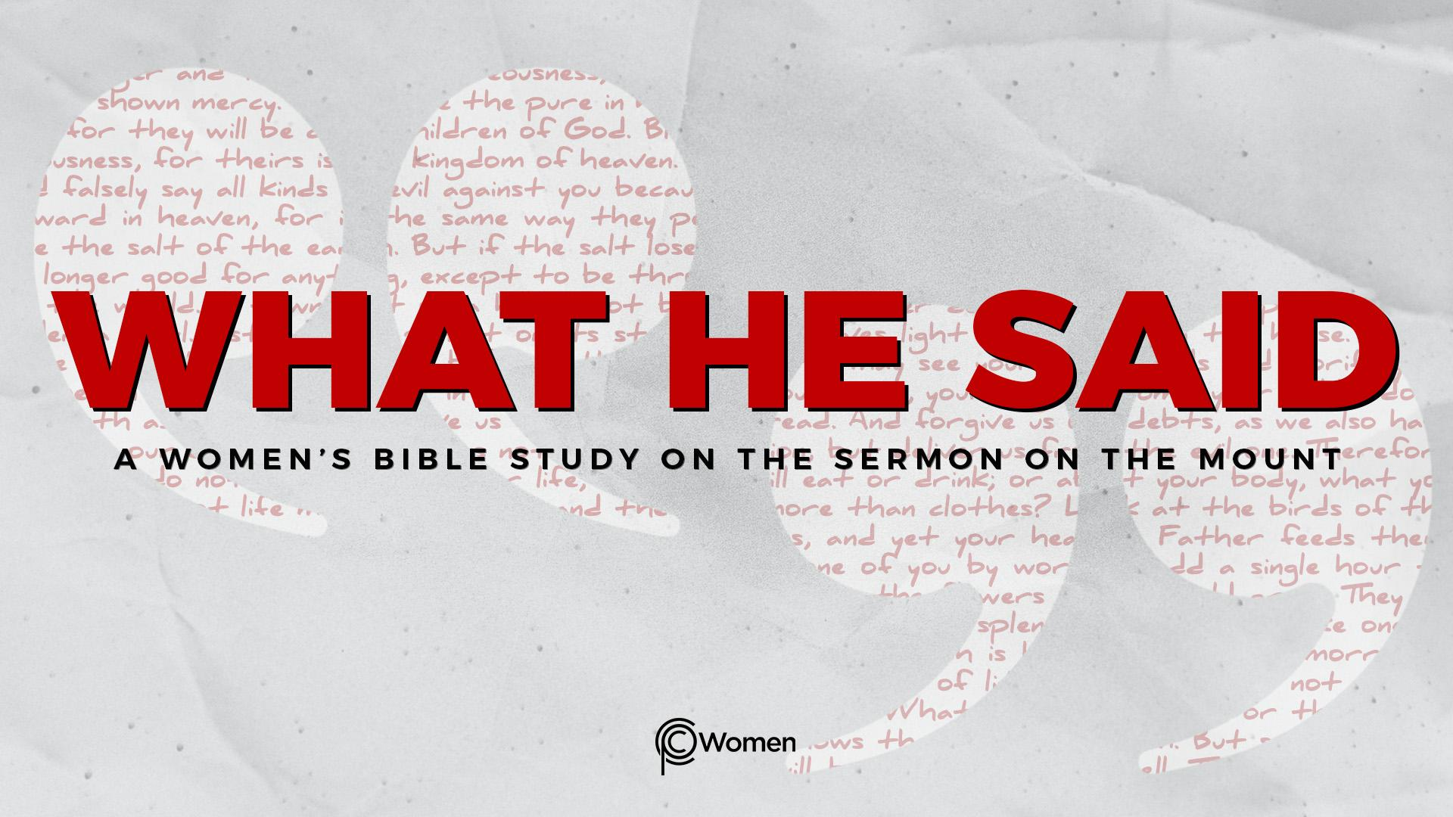
NOTE: Our lesson questions are based on the NIV 2011 edition. Our preference is your first time through the questions, you answer without consulting commentaries - delight in what the Holy Spirit will reveal to you.

Lesson 1
Matthew 4:12-5:2

1. What truth, verse or insight from the Overview of the Sermon on the Mount spoke to you? Describe what’s stirring in your spirit as you anticipate a deeper understanding of Jesus’ words as we dive into What He Said.

2. Read through Matthew 4:12-5:2, asking the Lord to open your eyes and heart to the invitation from Jesus. How and when did you first encounter the words of Jesus, and what were your initial responses to those words?

3. In V12-16, we get a glimpse of where Jesus’ ministry begins. Discuss the connections you make from the prophet Isaiah’s words quoted in V15-16 and the life of Jesus. Refer to John 1:4-5 and 29-31 for more insight.

4. In Matthew 4:17, we learn Jesus’ main message.
- What does it mean to repent and how would you restate Jesus’ message in your own words?

- What do you think the kingdom of heaven is and how might its nearness give rise to Jesus’ call to repentance?

5. The kingdom of heaven is present in and through Jesus and also a future reality.
What insight about the kingdom do you gain from these verses?

- Matthew 6:9-10

- Matthew 13:37-43

- Matthew 18:3-4

- Luke 22:14-18

- Acts 1:6-8

6. Reflect on the Old Testament’s prophetic references to the kingdom of heaven in the passages below:

- Psalm 145:10-13

- Daniel 7:13-14, 27

- Zechariah 14:1, 4, 8-11

7. We witness two sets of brothers meet Jesus near the Sea of Galilee in Matthew 4:18-22.
a) Who are the brothers, what are they doing, and what does Jesus invite them to do instead?

b) What strikes you about their response to Jesus’ invitation?

8. As you read V23-24, note the different aspects of Jesus’ ministry, His authority and His way with people.

9. Picture the large crowds coming from a broad geographic region, following Jesus and His disciples near the Sea of Galilee as we read in Matthew 4:25-5:2. What do you imagine the crowds were seeking from Jesus, and what were you seeking from Jesus when you first encountered Him?

10. JESUS SAID: COME, FOLLOW ME
“From that time on Jesus began to preach “Repent, for the kingdom of heaven has come near.”“ Matthew 4:17. Jesus invites all to repent or turn around and join His kingdom. It’s What He Said, and it’s for you!

Take some time to reflect on His simple (but not necessarily easy), profound, and personal invitation to “Come, follow me,”(V19). Have you made a decision to repent and follow Jesus? How has His message changed you? If you have not yet made that decision, what has held you back or still holds you back from following Him?

MEMORY VERSE: “From that time on Jesus began to preach, ‘Repent, for the kingdom of heaven has come near.’” Matthew 4:17

NAME PRAYER REQUEST

