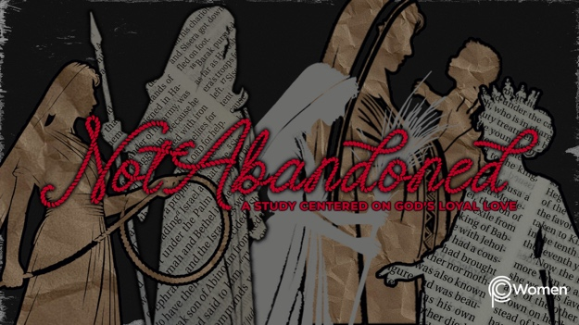

NOTE: Our lesson questions are based on the NIV 2011 edition. Our preference is your first time through the questions, you answer without consulting commentaries - delight in what the Holy Spirit will reveal to you.

Ruth
Lesson 9
Ruth 1:1-5, Judges 21:25

1. What lesson from the life of Deborah or the ultimate defeat of Sisera did you most need, and how has it impacted you this week?

2. Pray that God would help you to see His presence and provision in the life of a Moabite woman named Ruth, an unlikely believer, as you begin her story by reading Ruth 1:1-5. It takes place during the closing days of the judges, when God’s chosen people neglected their commitment to Him by adopting the worship practices of the pagan nations around them. What members of Ruth’s family do we meet and what do we learn about each of them and their circumstances?

3. a) What details are provided in V1a, and what do you think is important for us to know about the attitudes and behaviors common to the Israelites when Ruth’s story takes place? To answer, reference what you’ve learned in our study thus far as well as Judges 2:16-19 and 21:25.

b) Summarize the promises made by God in the verses below and note whether the promise is conditioned on the obedience of Israel.

- Genesis 17:6-10

- Exodus 19:5-6

- Deuteronomy 28:1-6, 15-20

4. Read Deuteronomy 23:3-6. Based Israel’s dealings with the Moabites, why is Moab an odd choice for an Israelite’s new home (Ruth 1:1-2)?

5. Difficult circumstances lead Elimalek to take his family to a new land, leaving their home and everything they’ve known. When have you found yourself in unfamiliar territory? How did it draw your heart closer to God or did your heart pull away from Him?

6. Naomi’s life takes a sad turn in V3. Describe what she faces and what it may have been like for her living in a foreign land?

7. What do we learn about the wives of Naomi’s sons in V4, and what impact would you anticipate these pagan women might have on the family and its obedience to God’s law?

8. a) From Ruth 1:5, what additional tragedy does this family experience and what are the ramifications for these women?

b) Despite their loss, reflect on God’s hesed for this family using the following Scripture passages:

- Deuteronomy 7:6, 9

- Psalm 127:3

- Psalm 145:13-16

- Proverbs 18:22

9. GOD IS: COVENANT KEEPER
At first glance, Ruth’s family appears to be no different than others who were living as they saw fit rather than in obedience to the requirements of the law (Judges 12:25). Without the gift of hindsight, we might even wonder whether or not God would abandon them and the nation of Israel for their disobedience. However, as we’ll soon discover, God is the ultimate Covenant Keeper and there is no limit to His steadfast love.

a) What encouragement can you take from the below passages of Scripture highlighting God as the ultimate Covenant Keeper?

● 2 Samuel 7:11b-13

● Isaiah 11:1-3a, 10

● Jeremiah 31:31-34

● Matthew 1:1-6

● Romans 11:26

- Write a prayer of petition asking God to fulfill one of His promises in your own difficult circumstances or offer a praise for being the object of God’s hesed when you most needed it?

MEMORY VERSE

“Know therefore that the Lord your God is God; He is the faithful God, Keeping His covenant of love to a thousand generations.” Deuteronomy 7:9

NAME PRAYER REQUEST

