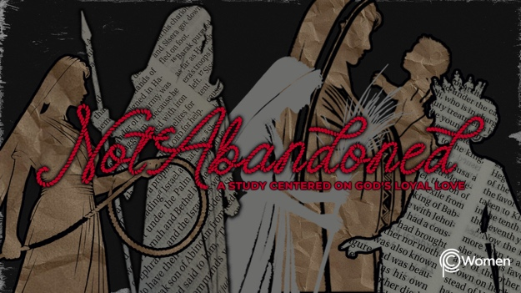

NOTE: Our lesson questions are based on the NIV 2011 edition. Our preference is your first time through the questions, you answer without consulting commentaries - delight in what the Holy Spirit will reveal to you.

Deborah
Lesson 8
Judges 5:1-31

1. What truth, verse or insight from your study of Judges 4:11-24 has been relevant to a battle you are currently fighting? Why did you need to hear this or how did it change your response to an enemy’s tactics?

2. Approach Deborah’s song of deliverance in Judges 5 with prayer, and ask God to open your eyes to what He is saying about the joy and blessing in being a willing instrument used for His purposes. After reading over or listening to these verses several times, what is the mood of this song and what are some of the key phrases?

3. Who is Deborah praising in V1-3, 9? Why do you think Deborah includes the word “willingly” as being praiseworthy?

4. According to V4-5, what natural events are recalled?

5. Describe life under the Canaanite oppression until Deborah arose from V6-8.

6. In V10-18 there is a poetic roll-call of some of the tribes of Israel. List which tribes were helpful and which tribes were not, as the victory is recounted. See Deuteronomy 27:12-13 for tribe names.

7. What strikes you as interesting in the description of the battle against Sisera from V19-23?

8. How is Jael portrayed in V24-27? Note any connection you see between her being called “a tent-dwelling woman” and the method of Sisera’s demise.

9. What nameless woman do you meet in V28-30, and who or what is she waiting for?

10. a) Deborah ends her song with a beautiful sentiment in V31. What does her choice of words demonstrate about her relationship to the Lord and to those who love Him? Share a favorite verse that captures your relationship with the Lord.

- Deborah was a mother in Israel, an unlikely leader, who led Israel to victory in a lopsided battle against Sisera. As you reflect on her courage and her dependence on the Lord, where is God asking you to depend on Him for strength and courage in a seemingly impossible situation?

11. GOD IS: REST FROM ENEMIES
“Wicked people will not oppress them anymore, as they did at the beginning and have done ever since the time I appointed leaders over my people Israel. I will also give you rest from all your enemies.” 2 Samuel 7:10b-11. A promise was made to Israel; the rest promised was to be found in the land already promised. Jesus promised rest to the weary and burdened and that rest was to be found only in Him. Matthew 11:28. Spend some time praying for those who are weary and burdened and who are not yet dwelling in the rest offered by Jesus.

MEMORY VERSE

“So may all your enemies perish, Lord! But may all who love you be like the sun when it rises in its strength.” Judges 5:31

NAME PRAYER REQUEST

