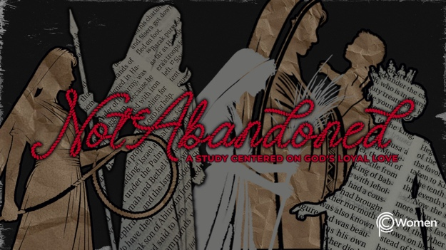

NOTE: Our lesson questions are based on the NIV 2011 edition. Our preference is your first time through the questions, you answer without consulting commentaries - delight in what the Holy Spirit will reveal to you.

Deborah
Lesson 7
Judges 4:11-24

1. Where did you need the Lord’s help this week and what truth or verse from your study of Judges 4:1-10 aligned your thinking with Scripture?

2. Pray that the Spirit would reveal deep truth as you continue reading Judges 4:11-24. Deborah plays a significant role in Israel’s victory as an encourager and a leader, building up the faith of Barak and his men. Identify some of the ways Deborah speaks and acts to encourage the Israelites in their battle.

3. What do you learn about Heber the Kenite, his wife and family from V11,17? Refer also to Judges 1:16. Do you think Heber would be considered friend or foe of the Israelites?

4. Who is Sisera (see Judges 4:2) and how did he respond to news of the movement of Barak in Judges 4:12-13?

5. From V14-17, summarize the events of the battle as recorded.

6. Discuss the exchange of communications between Jael and Sisera in V18-20. How did Jael put Sisera at ease?

7. Read V21-24.
a) What surprise did Jael have for Sisera and later for Barak?

b) What was the fate of Jabin King of Canaan? Review Judges 4:2 as a reminder of the power he once wielded.

8. In your opinion, who is ultimately responsible for Israel's victory and give your reasoning using verses from Judges 4? How does human faithfulness and obedience fit in?

9. a) As you reflect on Israel’s victory, how do you explain Jael’s conduct in light of her husband’s alliance with King Jabin and Sisera?

b) What position would you take if your community (think of your workplace, family, church) becomes corrupt or takes a stand against God as He has revealed Himself in His Word? Would you step up and take action or remain quiet and keep the status quo?

10. GOD IS: VICTOR
The Bible is clear that the Lord and His Son Jesus are the Victors and as believers we have the opportunity to share in that victory. It is also true that the victory we enjoy when we stand for the Lord is His. “But thanks be to God! He gives us the victory through our Lord Jesus Christ.” 1 Corinthians 15:57. Jesus’s victory was on the cross when He defeated Satan and the power of evil. While we do not win every clash with our enemies and many of our struggles are of our own making, one day His victory will be fully realized. Read Isaiah 25:8 and Revelation 21:4.

What strong stand or action is God asking that you take in His name and on His behalf? Exercise discernment and seek courage to fight the Lord’s battles in His strength. Make sure the territory you are fighting for belongs to the Kingdom of God. Pray for God’s victory in the battle He is calling you to fight.

MEMORY VERSE

“But thanks be to God! He gives us the victory through our Lord Jesus Christ.”
1 Corinthians 15:57

NAME PRAYER REQUEST

