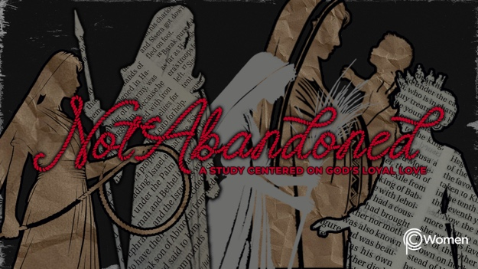

NOTE: Our lesson questions are based on the NIV 2011 edition. Our preference is your first time through the questions, you answer without consulting commentaries - delight in what the Holy Spirit will reveal to you.

Deborah
Lesson 6
Judges 4:1-10

1. How did last week’s lesson about Israel during the time of the judges resonate with you in light of the present time? What truth, verse or insight about the character of God deepened your faith in Him?

2. Prayerfully read through Judges 4:1-10 where we are introduced to Deborah, a judge and a prophet as well as a wife and a mother. She was not of royal descent nor was she famous or married to anyone famous. She simply said yes to the call to lead Israel and was a faithful leader for over forty years during an extremely corrupt and chaotic era. When have you found yourself called to do something you felt unequipped to handle either in your personal or professional life? How might Deborah motivate you to embrace your calling with God confidence?

3. What are some distinctives about Deborah’s role as a prophet from these verses:

● Deuteronomy 18:15-18

● Jeremiah 1:4-7

● 1 Samuel 16:13

4. Describe the Israelites’ situation and how they got there, their oppressors, and where the Israelites turned for help as revealed in Judges 4:1-3. Ehud, the judge prior to Deborah, is the subject of Judges 3:12-30.

5. a) According to Judges 4:4-5, who is Deborah, where did she hold court and how did God use her to help the Israelites?

b) Read Exodus 18:13-16. From this description of Moses in his role as judge, what conclusions can you make about Deborah’s role and standing in the community?

6. The court system of Israel is addressed by Deuteronomy 17:8-13. Summarize how the courts were supposed to work and how they were to influence the lives of the Israelites.

7. Who did Deborah send for and what were the Lord’s instructions to him as recounted by Deborah in Judges 4:6-7?

8. a) From V8-10, what do you observe about Barak and the battle ahead?

b) Barak wanted Deborah with him in battle. How do you view his request to her in V8? Was it a lack of courage or a failure to trust in the Lord on Barak’s part or could he have wanted the presence of God’s spokeswoman to inspire confidence in the troops?

9. Where do you see evidence of Deborah’s courageous faith in Judges 4:1-10?

10. GOD IS: MY HELP
When the Israelites suffered oppression at the hand of their enemies and cried out to the Lord for help, He heard their cry and provided a judge. “The Lord is my helper; I will not be afraid. What can mere mortals do to me?” Hebrews 13:6. This is a declaration of belief in God’s power and provision. God’s people are encouraged to rely on Him to meet all their needs.

Take this opportunity to praise God, your constant source of help, even as you face conflict, and surrender your most urgent needs to Him seeking His assistance and intervention. Pray for someone within your circle of family or friends or your church community, like your pastor, who is on the front lines and longs to experience the Lord as their help.

MEMORY VERSE

“The Lord is my helper; I will not be afraid. What can mere mortals do to me?” Hebrews 13:6

NAME PRAYER REQUEST

