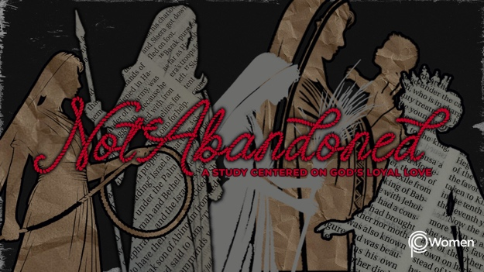

NOTE: Our lesson questions are based on the NIV 2011 edition. Our preference is your first time through the questions, you answer without consulting commentaries - delight in what the Holy Spirit will reveal to you.

Deborah
Lesson 5
Judges 2:1-19, 3:7-11

1. What was one of your takeaways from the life and legacy of Rahab and which truth, verse or insight from last week’s lesson caught your attention?

2. God raised up Deborah, an unlikely leader, to be one of Israel’s twelve judges after the death of Joshua, while Israel was settling the promised land. It was a dark time marked by the Israelites’ repeated cycles of covenant breaking, oppression by their enemies and then crying out to God for help. In response, God raised up judges to fight for the Israelites and save them. Pray for wisdom before you read Joshua 21:43-45 and Joshua 24:14-28, detailing events leading up to the time of the judges. NOTE: Questions 2-4 relate to the historical background of the time of the judges.

Describe where the Israelites were when Joshua’s leadership came to an end and how you see the Lord’s blessing on them in Joshua 21:43-45.

3. a) From Joshua 24:14-15, summarize the instructions given by Joshua to the Israelites.

b) What did the Israelites acknowledge about the Lord in V16-18 and what commitment did they make? See also V21, 24.

4. Note the eternal truths about the Lord in Joshua 24:19-28 from Joshua’s statements to the Israelites. Respond to these truths by asking the Lord to expose the rebellion and sin within you and your ongoing need for God’s rescue and grace.

5. Even though they vowed obedience and service to God only, the Israelites did not completely follow the Lord’s commands to fully eradicate their enemies as they settled the promised land. Now read Judges 2:1-19. According to V1-3, what did the angel of the Lord say to the Israelites and how did they react in V4-5?

6. a) From V6-9, what marked Joshua’s leadership? Have you experienced this kind of spiritual leadership and what was the impact on your life?

b) What did the Israelites do to provoke the Lord’s anger in V10-15 and what do you note about how He expresses His anger?

7. What is the role of the judges according to V16-19 and what are the repeated cycles evident in the Israelites’ choices?

8. Read Judges 3:7-11 where Othniel, the first of the judges, is introduced. How did the Lord respond to Israel at this time? What did Othniel accomplish?

9. GOD IS: SLOW TO ANGER
Because of His hesed, God is “slow to anger” in response to human wickedness, rebellion, and sin (Exodus 34:6). However, if we keep choosing sin, God eventually hands us over to our destructive desires and decisions. But He is patient and He gives us many opportunities to repent and choose His way. This is an expression of His loyal love and justice.

- What are some additional aspects of God’s patience from the following verses:

● Nehemiah 9:26-28

● Jeremiah 25:4-11

● Romans 9:22-24

● 2 Peter 3:8-9

- Reflect on a time you have seen or experienced your need for the patience of God and respond in prayer to our “slow to anger” God.

MEMORY VERSE

“The Lord is not slow in keeping His promise, as some understand slowness. Instead, He is patient with you, not wanting anyone to perish, but everyone to come to repentance.”
2 Peter 3:9

NAME PRAYER REQUEST

