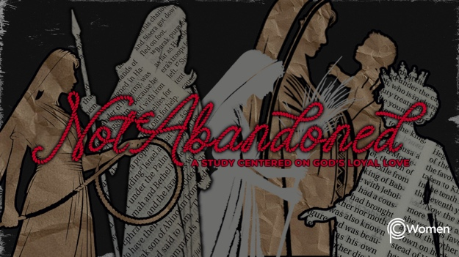

NOTE: Our lesson questions are based on the NIV 2011 edition. Our preference is your first time through the questions, you answer without consulting commentaries - delight in what the Holy Spirit will reveal to you.

Rahab
Lesson 4
Joshua 6

1. How were you emboldened or challenged by Rahab’s faith in Joshua 2 or what truth or insight about the saving power of God gave you needed courage?

2. As you come to Joshua 6, pray that God’s grace would be revealed in the defeat of Jericho and in the salvation of Rahab and her family. Read through the chapter. The Israelites came against Jericho in an unlikely way in the name of the Lord and in obedience. Where do you find the very presence of God in this chapter and how do you think He figures into the Israelites’ victory?

3. According to V1-5, what was the situation in Jericho, and what was the unusual battle plan the Lord advised would deliver the city into the Israelites’ hands?

4. In V6-21, Joshua carries out God’s plan. As the extraordinary events played out, where were Rahab and her family and what might it have been like for them as they watched the Israelites over the course of the seven days?

5. How were Rahab and her family treated and what was their fate according to V22-25?

6. Which verses in Joshua 6:17-25 capture the progression of how Rahab and her family are integrated into the Israelite community? What words or phrases capture your own experience of integration into the community of believers?

7. God gave Rahab a glorious legacy despite an inglorious past. Discover how He used her and reflect on how her life still speaks about faith in action in the following verses:

- Psalm 111:10

- Matthew 1:1, 5:6

- Hebrews 11:31

- James 2:14-17

8. a) Rahab is repeatedly referred to as “the prostitute” in Joshua 6. What new label would you like to give her and why?

b) What past label do you desire to shed and what is one thing you can do to live into your new identity in Christ as healed, holy, redeemed and rescued by the scarlet cord of His blood?

9. a) What do you appreciate about the Lord’s heart as revealed through Rahab’s story and her new legacy? Take some time to thank God for giving us an unlikely heroine like Rahab.

b) Where might God be calling you to obedience and to trust in His ways even when they don’t make sense from conventional wisdom? Ask God to give you courage to move ahead as He directs you.

10. GOD IS: GRACE
Amazing Grace, how sweet the sound that saved a wretch like me! Grace has been defined as “God’s Riches At Christ’s Expense” and also as God’s favor toward the unworthy or undeserving. Grace is a gift of God, unearned (Eph. 2:8-9). It is an extension of His love and mercy, and the essence of the gospel message. By God’s grace, you were forgiven, bought with the blood of Jesus, redeemed from slavery and into freedom. By grace, the legacies of women are still being rewritten. Recount the stories of the women of the New Testament below and note where you see the grace of God doing a work of redemption or healing.

● Luke 7:36-50

● John 4:4-26, 39-42

● Luke 8:2-3, 42b-48

MEMORY VERSE

“But Joshua spared Rahab the prostitute, with her family and all who belonged to her, because she hid the men Joshua had sent as spies to Jericho—and she lives among the Israelites to this day.” Joshua 6:25

NAME PRAYER REQUEST

