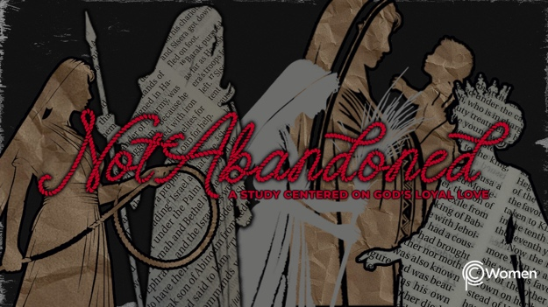

NOTE: Our lesson questions are based on the NIV 2011 edition. Our preference is your first time through the questions, you answer without consulting commentaries - delight in what the Holy Spirit will reveal to you.

Rahab
Lesson 3
Joshua 2

1. What truth, verse or insight from Lesson 2 has been food for thought as this week unfolded and how did it influence your thinking or actions?

2. Ask the Lord to give you wisdom as you read Joshua 2 in which we are introduced to our heroine, a Gentile and a prostitute in Jericho named Rahab. While prostitution was an accepted albeit stigmatized profession in ancient cultures, it was condemned by God’s law. Leviticus 19:24, 20:9. What admirable character traits are exhibited by Rahab and in what ways are your expectations of her colored by her background, past and profession?

- a) According to Joshua 2:1, what was the mission of the spies?

b) Where did they go, and why do you think they went there?

4. What was the king’s message to Rahab and what did Rahab do in defiance of the king to assist the Israelite spies in V2-7?

5. Describe the atmosphere in Jericho based on V8-11 and trace Rahab’s confession of new faith in the God of the Israelites.

6. From V12-14, what oath was made between Rahab and the spies and how did the oath come about? Comment on how God met her plea for kindness or hesed with the spies’ assurance they would treat her with hesed and not abandon her.

7. Give a summary of the escape plan for the spies orchestrated by Rahab in V15-16 and 21b-24.

8. What actions were required of Rahab before the oath would be a binding agreement according to V17-21a? What greater significance/foreshadowing do you see in the scarlet cord? HINT: Think about the thread of redemption from the blood of the Passover lamb (Exodus 12:12-13) to the blood of Jesus (1 Peter 1:18-21).

9. a) What encourages you about Rahab and her faith in the Lord considering her background and the risks she was taking?

b) What opportunities has the Lord given you in spite of or because of your background, your past, or your particular circumstances? How did your background, past or circumstances prepare you for the role you were able to play in furthering God’s plan?

10. GOD IS: THE ONE WHO SAVES
Rahab understood that only God could save her and her family from death. She tied a scarlet cord in the window to mark her household for protection. She simply believed God and acted in faith. The story of Rahab foreshadows a Savior who saves by grace through faith. Find some nuggets of truth about the God Who Saves in the following verses.

● Psalm 68:20

● Isaiah 12:2

● Luke 1:68-75

● Acts 4:12

● 2 Timothy 1:9-10

MEMORY VERSE

“When we heard of it, our hearts melted in fear and everyone’s courage failed because of you, for the Lord your God is God in heaven above and on the earth below.” Joshua 2:11

NAME PRAYER REQUEST

