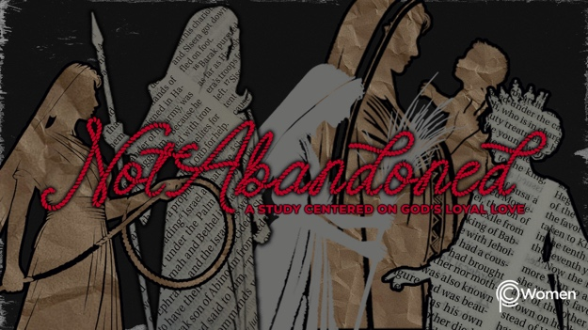

NOTE: Our lesson questions are based on the NIV 2011 edition. Our preference is your first time through the questions, you answer without consulting commentaries - delight in what the Holy Spirit will reveal to you.

Sharing Class
Lesson 25

Sharing Class is a time to look back and celebrate what we’ve learned throughout the year. This lesson is designed to help you in your time of reflection. You might want to refer to your lessons and lecture notes, the “Memory Verses”, or “My Main Thing” document as you answer these questions.

1. From our study of this year, which verse or reflection on who God is did you love or need in this season and why?

2. Where have you seen the scarlet cord of God’s hesed in your story or how has this study deepened your understanding of what it means to know God’s faithful, pursuing, loyal loving kindness?

3. Share how you have seen the Lord answer a personal prayer request this year.

4. What truth or quote from a lecture will you cling to in light of the circumstances you are facing? How has the truth or quote encouraged you or assured you that you are not abandoned?

5. For each of the women we studied, how did she inspire or challenge you?

- Rahab

- Deborah

- Ruth

- Hannah

- Esther

6. What character trait or spiritual practice demonstrated by these beloved women would you like to build into your life? Ask your group to pray for you.

