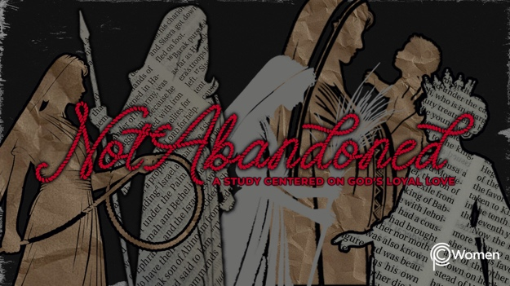

NOTE: Our lesson questions are based on the NIV 2011 edition. Our preference is your first time through the questions, you answer without consulting commentaries - delight in what the Holy Spirit will reveal to you.

Esther
Lesson 24
Esther 9-10

1. As you think back to the lesson on Esther 7-8, how were you enlightened about the unseen hand of God and where did you see Him at work this week?

2. We have come to the final two chapters of Esther. Before you read Esther 9-10, ask God to reveal His deeper truths to you. The narrative that began with the threat of extermination of the Jews becomes a time of thanksgiving and celebration upon their deliverance. “I will praise you, Lord my God, with all my heart; I will glorify your name forever. For great is your “hesed” toward me; you have delivered me from the depths, from the realm of the dead.” Psalm 86:13. When have you witnessed God’s hesed provide deliverance from despair and how willing are you to show that same hesed to others?

3. What happened on “that day” according to Esther 9:1-4, what was supposed to happen that day, and how do you explain the turn of events?

4. a) In V5-10, what did the Jews do to their enemies?

b) In light of what the Jews legally could have done according to Esther 8:11, how did they show restraint in Esther 9:6-10, 15-16?

c) In what areas of your life do you think it would be wise for you to show restraint or self-control? Note any Scriptures that offer Biblical advice in an area that seems out of control.

5. a) Why do you think Esther made additional requests in V11-14 and how did the Jews spend the thirteenth, fourteenth and fifteenth days of the month from V15-19?

b) Haman and his sons were descendants of Agag, king of the Amalekites, Israel’s eternal enemies. How do the verses below help you understand Esther’s harsh treatment of Haman’s sons?

● Exodus 17:8-16

● Deuteronomy 25:17-19

● 1 Samuel 15:1-3, 7-11

6. a) In Esther 9:20-32, Mordecai required the Jews in all provinces to annually observe Purim on the fourteenth and fifteenth days of Adar. What did those days commemorate, how were they to be celebrated and what was the purpose of the holiday?

b) The observance of Purim is an important reminder to the Jews of God’s deliverance. It is easy to forget the hesed God has showered upon us and in our sin, fail to have a heart of gratitude. Examine the customs you have established to make the holidays times in which you remember to thank God. Consider which customs are most meaningful, which you could do differently or which new things you might incorporate to honor God.

7. This historical book ends with a tribute to Mordecai. What are the various aspects of Mordecai’s character referenced in Esther 10:1-3 and which would you like to cultivate in your own life?

8. GOD IS: THE ONE WHO SPEAKS
God is not expressly mentioned in the book of Esther, and yet He is not silent. He speaks through those who do His will and honor Him. God spoke through King Xerxes who was moved to grant Esther’s requests, allowing the Jews to survive. “In the Lord’s hand the king’s heart is a stream of water that He channels toward all who please Him.” Proverbs 21:1. What insights do you find about the God Who Speaks in the following verses:

● Psalms 29:3-4

● Isaiah 55:10-11

● Matthew 4:4

● John 1:1

● Hebrews 1:1-2

MEMORY VERSE

“In the past God spoke to our ancestors through the prophets at many times and in various ways, but in these last days he has spoken to us by his Son, whom he appointed heir of all things, and through whom also he made the universe.” Hebrews 1:1-2

NAME PRAYER REQUEST

