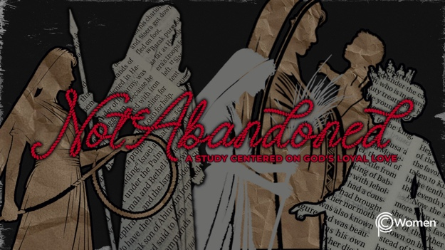

NOTE: Our lesson questions are based on the NIV 2011 edition. Our preference is your first time through the questions, you answer without consulting commentaries - delight in what the Holy Spirit will reveal to you.

Esther
Lesson 23
Esther 7-8

1. What truth, verse or insight from our lesson on Esther 6 has encouraged you this week and when did you find it helpful?

2. Pray that God would open your eyes to see His unseen hand as you read through Esther 7 and 8. In these chapters, what are some surprising reversals, circumstances which were intended for evil but were repurposed by God for His redemptive plan?

3. From Esther 7:1-6, summarize the setting, Esther’s petition in response to the king, and point out the ways she showed humility.

4. Describe the betrayal discovered by the king in V7-8 and how this might have led to his accusation against Haman.

5. What is Haman’s fate according to V9-10?

6. From Esther 8:1-2, what happened to Haman’s wealth and position?

7. Despite the reward and honor at Haman’s defeat, what crisis still loomed in V3-6 and how did Esther approach this dire situation? For insight on royal edicts issued under Medo-Persian law, read Daniel 6:8, 15.

8. Read Esther 8:7-14.

- What did the king propose in response to Esther’s plea and how is his regard for Esther apparent? Refer back to Esther 7:5 also.

b) Who authored the edict, what did it provide, and how did God provide for the Jews without breaking Haman’s prior edict (review Esther 3:10-15)?

9. How was this edict received by the Jews and by people of other nationalities according to Esther 8:15-17?

10. There is a divine reversal of the story’s direction in Esther 7-8. CHALLENGE: Consider the divine reversal represented by the cross of Jesus, which was intended to end His life. Discuss how this is the greatest divine reversal in history.

11. GOD IS: DEFENDER
God is our Defender, our fortress, our rock in whom we can take refuge. David knew this and cried out to Him when being pursued by Saul: “Deliver me from my enemies, O God; be my fortress against those who are attacking me…You are my strength, I watch for you; you, God, are my fortress, my God on whom I can rely.” Psalms 59:1, 9-10.

From what enemy do you need the Lord to deliver you? Cry out to Jesus and ask Him to be your Defender as you struggle against a foe, trusting He will not abandon you. Ask your group to pray for you.

MEMORY VERSE

“Deliver me from my enemies O God; be my fortress against those who are attacking me. You are my strength, I watch for you;” Psalm 59:1, 9a

NAME PRAYER REQUEST

