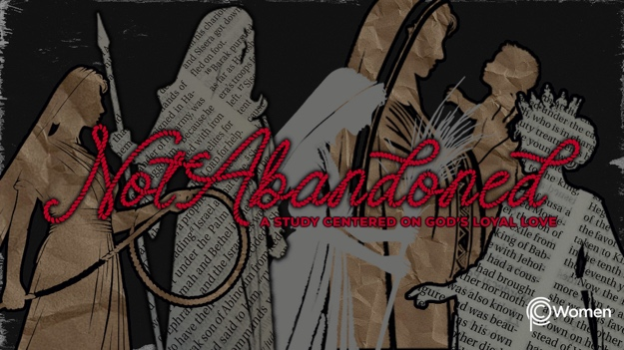

NOTE: Our lesson questions are based on the NIV 2011 edition. Our preference is your first time through the questions, you answer without consulting commentaries - delight in what the Holy Spirit will reveal to you.

Esther
Lesson 22
Esther 6

1. As you reflect back on Esther 5, what truth or insight from the lesson has been food for thought this week and how were you challenged to display the prayer, patience or humility of Esther?

2. Seek the wisdom of the Lord before you read through the turn of events chronicled in Esther 6, showcasing how God changed the course of history in one sleepless night. The king decides to honor Mordecai and then seeks advice from Haman, who has come to discuss Mordecai’s execution. Look back over the first six chapters of Esther and note other examples of God’s unmistakable intervention and providential timing.

3. According to Esther 6:1-3, where do we find the king and what does he discover? Refer back to Esther 2:21-23.

4. a) When have you done the right thing but your accomplishment was forgotten or overlooked? How did you handle it?

b) Allow each of these verses to reframe your Biblical perspective on doing the right thing:

● Galatians 6:9

● Hebrews 6:10

● James 4:6

● 1 Peter 3:8-12

5. How does the king approach his dilemma in Esther 6:4-6 and what great irony do you find in the situation?

6. List each detail of Haman’s recommendation to the king in V7-9.

7. From V10-11, paint the scene in your own words.

8. What was Haman’s state of mind or attitude according to V12? Reference the facts in V4b and 6b in your answer.

9. What words of wisdom does Haman hear in V13-14 and how might this wisdom relate back to God’s original promise to Abram in Genesis 12:3?

10. God often works in our lives through events that seem unexpected and insignificant. Consider how He has directed and guided your life through a chain of events, each by itself seemingly unimportant at the time. Encourage the women in your group with your story.

11. GOD IS: PROVIDER
Jehovah-Jireh is one of God’s names and it means “the Lord will provide.” Genesis 22:14. God provided for Esther and Mordecai and the Jewish people and He has provided for you. In Genesis 22, God provided a sacrifice to save Isaac, foreshadowing the provision of His Son for the salvation of all those who put their faith in Him. Praise Him for the many ways the Lord has provided for you from the following verses:

● Psalm 111:9

● 1 Corinthians 10:13

● 1 Timothy 6:17

● a favorite verse of your own

MEMORY VERSE

“[The Lord] provided redemption for his people; he ordains his covenant forever- holy and awesome is his name.” Psalm 111:9

NAME PRAYER REQUEST

