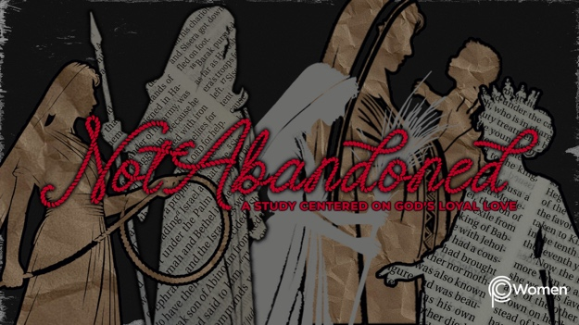

NOTE: Our lesson questions are based on the NIV 2011 edition. Our preference is your first time through the questions, you answer without consulting commentaries - delight in what the Holy Spirit will reveal to you.

Esther
Lesson 21
Esther 5

1. The prior lesson on Esther 3-4 was sobering. How did these Scriptures intersect with the things that are concerning you? What truth, verse or insight has caused you to examine your heart or your actions?

2. Pray for discernment as you read through Esther 5. Haman and Esther stand in stark contrast to one another. How would you characterize who has influenced Esther as compared to who has influence in Haman’s life? It will be helpful to review Esther 4:12-16. Recall the influence of different people for good or for ill in your own life.

3. a) Describe Esther’s approach to the king and her requests of Him from Esther 5:1-8. What did the king’s reception of Esther and his statements demonstrate about his attitude toward her?

b) Why do you think she waited and made the same request twice instead of immediately coming out with her ultimate request?

4. Contrast the fickle emotions experienced by Haman and the steady resolve apparent in Mordecai from V9-10a.

5. As you consider the strength of Esther and Mordecai, steep in these verses about operating in the fear of humans as opposed to having a right fear of God. What truth surfaces from each Scripture?

- Proverbs 29:25

- John 12:42-43

- Acts 5:28-29

- Galatians 1:10-12

6. As you review Esther 5:10b-13:

a) List the reasons for Haman’s boasting.

b) What does he admit in V13?

7. Who is speaking into Haman’s life in V14 and what is their counsel to him?

8. Write a truth about the dangers of pride and arrogance, or about the nature of humanity from Esther 5. Share a supporting Scripture verse if one comes to mind.

9. What do you see as some of the benefits of responding to a trial or dire situation you are facing with prayer, patience and humility?

10. GOD IS: MERCIFUL
God’s mercy is visible through the king’s response to Esther. Our God is “rich in mercy.” Ephesians 2:4. This divine attribute is an extension of His hesed for us. Its foundation is forgiveness. In His tender mercy, God shows us leniency; He does not punish us as our sins deserve. God’s mercy is fully revealed in Jesus: “In his great mercy he has given us new birth into a living hope through the resurrection of Jesus Christ from the dead, and into an inheritance that can never perish, spoil or fade.” 1 Peter 1:3-4a. What more can you learn of His mercy from the Scriptures below? Pray for someone who is in need of mercy and consider whether God might be asking you to show mercy to them

- Exodus 34:6-7

- Micah 6:8

- Matthew 5:7

- Romans 9:14-18

MEMORY VERSE

“He has shown you, O mortal, what is good. And what does the Lord require of you? To act justly and to love mercy and to walk humbly with your God.” Micah 6:8

NAME PRAYER REQUEST

