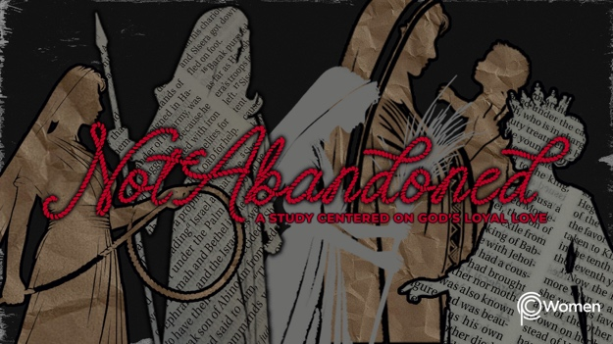

NOTE: Our lesson questions are based on the NIV 2011 edition. Our preference is your first time through the questions, you answer without consulting commentaries - delight in what the Holy Spirit will reveal to you.

Esther
Lesson 20
Esther 3-4

1. As you think back on Esther 2 when Esther was made queen, what truth, verse or insight from the lesson stands out and how does this ancient story relate to you today?

2. This week we are tackling Esther 3-4. Prayerfully read through these two chapters in which you will meet Haman, referred to as “the Agagite, the enemy of the Jews.” Haman puts a diabolical plan into effect while Mordecai and Esther take action against it. When have you seen or read about the course of history changing because someone was willing to stand up at great personal risk?

3. From Esther 3:1-7, how was Haman honored, what conflict arose with Mordecai, and what was Haman’s endgame? NOTE: Scholars believe ~4 years have passed since Esther became queen.

4. How did Haman pitch his plan to King Xerxes and what is notable about Xerxes’ response in V8-11?

5. a) How was Haman’s plan to exterminate the Jews communicated and what are the horrific details in the text of the edict according to V12-15?

b) Haman exemplifies how deceitful and desperately wicked the human heart can be. What do the verses below affirm about our potential for wickedness:

● Psalm 53:1-3

● Proverbs 11:5, 20

● Isaiah 59:2, 6b–9

● Jeremiah 17:9

6. Read Esther 4:1-5 and summarize the great mourning in response to the edict and order of the king.

7. What did Mordecai ask of Esther and what was Esther’s reaction in V6-11?

8. a) Write an important truth from V12-14 arising from Modecai’s words to Esther.

b) We don't always know what purpose God may have for putting us in a certain position or situation. Expand on this by using an example from your own life when God used you in an unexpected way or when you were reluctant to respond to His prompting.

9. Esther asks all the Jews in Susa to fast for her before she will go into the king (V15-17). From the following verses, why might Esther have made this request:

● 2 Samuel 12:16, 22-23

● Ezra 8:21-23

● Nehemiah 9:1-4

● Joel 2:12-14

10. GOD IS: DELIVERER
Read Genesis 12:1-3, in which the Lord made a promise to Abram involving land, a nation, a name and a blessing. Mordecai knew this promise and he knew God is the deliverer who would somehow rescue and preserve the Jews from Haman’s evil plot. God is the deliverer of His people, not because they deserve to be rescued, but as an expression of His mercy and love, His hesed.

Through Jesus, believers are delivered from sin, death and judgment. Sometimes God rescues us from trials and sometimes He walks through the trials with us. Take this time to recall from what Jesus has rescued you and thank Him for His hesed.

MEMORY VERSE

“[Mordecai] sent back this answer: ‘Do not think that because you are in the king’s house you alone of all the Jews will escape. For if you remain silent at this time, relief and deliverance for the Jews will arise from another place, but you and your father’s family will perish. And who knows but that you have come to your royal position for such a time as this?’” Esther 4:13-14

NAME PRAYER REQUEST

