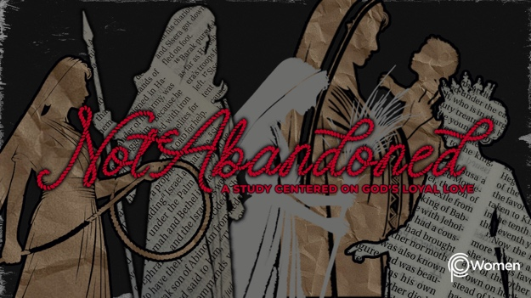

NOTE: Our lesson questions are based on the NIV 2011 edition. Our preference is your first time through the questions, you answer without consulting commentaries - delight in what the Holy Spirit will reveal to you.

Rahab
Lesson 2
Joshua 1

1. What truth, verse or insight regarding the hesed of God did you cling to this week and when did you yearn for or glimpse His unfailing, loyal love?

2. Before we meet Rahab, our unlikely heroine, pray for understanding of the historical context as you read Joshua 1. After God dramatically rescued His people out of slavery in Egypt under Moses, we find the Israelites, now under Joshua’s leadership, on the edge of Canaan, the land God promised to them. What words or phrases are repeated and what jumps out as the main message of this chapter?

3. From Joshua 1:

- What promises does the Lord make and what charge does He give to Joshua in V1-9?

- How are God’s promises reflected in Joshua’s instructions to the people from V10-15?

- According to V16-18, how did the Israelites’ respond?

4. To help us understand this moment in time, let’s look back to God’s covenant with Abraham, then known as Abram, promising him descendants and land as recorded in Genesis 15:1-21. Read through these verses in Genesis and consider the following:

- What is remarkable about the character or personality of Abraham, including his willingness to trust the Lord despite his circumstances?

- Describe the attributes of God that surface as He deals with Abraham.

- What do you find interesting or perplexing about the covenant cutting ceremony pictured in V7-21? What do you think it accomplished?

5. How is your idea of following God expanded by the following verses as you reflect on His instructions to His people?

- Exodus 33:1-2

- Deuteronomy 6:4-9

- Deuteronomy 6:10-12

- Deuteronomy 6:13-15

6. Recall a time the Lord asked you to be strong and courageous in view of unknown circumstances or to trust Him when you felt abandoned or insecure. What did you learn about yourself? What did you learn about God?

7. GOD IS: SOVEREIGN
There is no doubt that the Lord is Sovereign. He has the absolute right to govern His creation and He controls everything with His perfect power and perfect knowledge. Sometimes He chooses not to act or to allow things to happen for reasons of His own. Looking to His sovereignty calms our fears and gives us courage to move forward in our faith.

a) What do the following verses reveal to you about the sovereignty of God?

- Job 42:2

- Isaiah 46:10

- Daniel 4:35

- Colossians 1:16-17

b) Abraham exercised faith in the sovereignty of the Lord as he waited for the fulfillment of the promises (Genesis 15:1-9). Reflect on how you respond in times of waiting or uncertainty, and write a prayer proclaiming your trust in His sovereignty.

MEMORY VERSE

“Have I not commanded you? Be strong and courageous. Do not be afraid; do not be discouraged, for the Lord your God will be with you wherever you go.” Joshua 1:9

NAME PRAYER REQUEST

