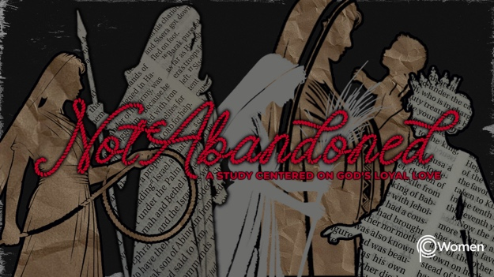

NOTE: Our lesson questions are based on the NIV 2011 edition. Our preference is your first time through the questions, you answer without consulting commentaries - delight in what the Holy Spirit will reveal to you.

Esther
Lesson 19
Esther 2

1. How did God speak to you as you studied Esther 1 and what truth or insight from the passage resonated with you this week?

2. Read through Esther 2 and ask God to reveal Himself to you in the historical narrative. You get to meet Esther, our unlikely queen. On a high level, observe which new characters are introduced and the major twists and turns in these verses? NOTE: Some years have passed between chapters 1 and 2. Commentators say that during this time period King Xerxes waged war against Greece and was disastrously defeated.

3. From V1-4, what was on Xerxes’ mind and what plan did his personal attendants come up with?

4. a) List what you can glean about Mordecai and the kind of person he is from V5-7 and V10-11.

b) Who is Esther from V7-10? How would you characterize her relationship with Mordecai? Do you think she felt abandoned in the king’s harem, why or why not?

5. Explain the process all the young women in the harem went through (V12-14).

6. a) According to V15-18, when it was Esther’s turn to be with the king, how did she prepare, and what were the results?

b) Why do you think Esther won the favor of so many people? See V9, 15, & 17.

7. Describe the plot that was uncovered by Mordecai and how God had strategically placed Mordecai and Esther in V19-23?

8. Reflect on your own life: your opportunities, accomplishments, positions and talents. Prayerfully consider where God has placed you and how He may be using you in light of your unique story for His higher purposes.

9. GOD IS: FAITHFUL
Faithfulness is what we long for in our God. “He is the Rock, his works are perfect,
and all his ways are just. A faithful God who does no wrong, upright and just is he.” Deuteronomy 32:4. Because God is faithful, He is true to Himself and His Word and when He promises something, He will keep that promise. God is also faithful in the relationship He chooses to have with His people.

- Find gems of truth that reflect aspects of God’s faithfulness to you in the following:

● Deuteronomy 7:8-9

● Isaiah 25:1

● Lamentations 3:22-23

● 1 John 1:9

b) Given that the Israelites’ Babylonian exile was a discipline from God, where do you see His faithfulness in Esther 2?

MEMORY VERSE

“Lord, you are my God; I will exalt you and praise your name, for in perfect faithfulness you have done wonderful things, things planned long ago.” Isaiah 25:1

NAME PRAYER REQUEST

