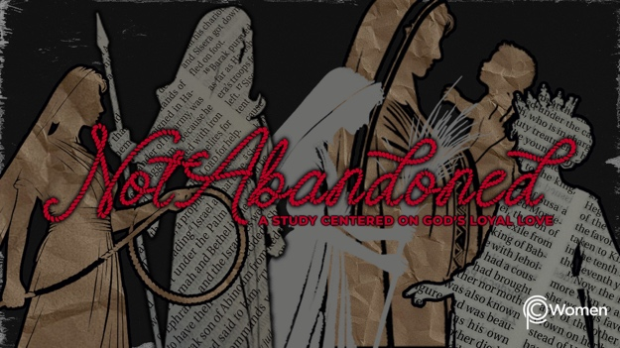

NOTE: Our lesson questions are based on the NIV 2011 edition. Our preference is your first time through the questions, you answer without consulting commentaries - delight in what the Holy Spirit will reveal to you.

Esther
Lesson 18
Esther 1

1. As you think back to the lesson on Hannah’s prayer of praise, what truth, verse or insight gave you fresh insight and how have you seen it apply to the everyday of your life?

2. Read the back story to Israel’s years in Babylon in 2 Chronicles 36:15-20. While some Jews returned after 70 years in exile to rebuild the temple in Jerusalem, many did not. The book of Esther is about a Jewish community remaining in Susa, the capital city of the ancient Persian empire which had conquered the Babyonian empire.

- From 2 Chronicles 36:15-20, how did the Jewish people come to live in Babylon?

- What do you think life might have been like for them in exile? For further insight, review the prophecy of Jeremiah 29:4-10.

3. With that context, prayerfully read all of Esther 1. What do you know about one of the key characters, King Xerxes, from V1-2?

4. Describe the banquets he gave, who he invited and the festivities held as recorded in V3-8.

5. According to V9-12, what did Xerxes ask of his wife, Queen Vashti, and how did she respond? What is your opinion of his ask and of her response?

6. How did Xerxes make his political decisions, as revealed by V13-14?

7. a) What advice was sought by Xerxes and what was the proposed solution from V15-20?

b) Share your thoughts on the soundness of the reasoning of the king’s advisors and of the ripple effects they anticipated throughout the kingdom.

8. From V21-22, how did Xerxes respond to the advice he was given?

9. When you are confronted with a circumstance requiring you to take action, what is your decision-making process? Where do you turn for advice or who do you consult, and why?

10. GOD IS: HOLY

“Who among the gods is like you, Lord? Who is like you— majestic in holiness, awesome in glory, working wonders?” Exodus 15:11. God’s holiness is more than just one of His attributes. It is the totality of His perfection and purity, in stark contrast to king Xerxes! God is other; He exists above and apart from the world He created. His holiness encompasses His power, knowledge, justice, mercy, goodness and love, but also His separation from evil. “And these are but the outer fringe of his works; how faint the whisper we hear of him! Who then can understand the thunder of his power?” Job 26:14.

Although God is not expressly mentioned in the book of Esther, His fingerprints are everywhere. Share a time when you have had a glimpse of God’s Holiness.

MEMORY VERSE

“Who among the gods is like you, Lord? Who is like you - majestic in holiness, awesome in glory, working wonders?” Exodus 15:11

NAME PRAYER REQUEST

