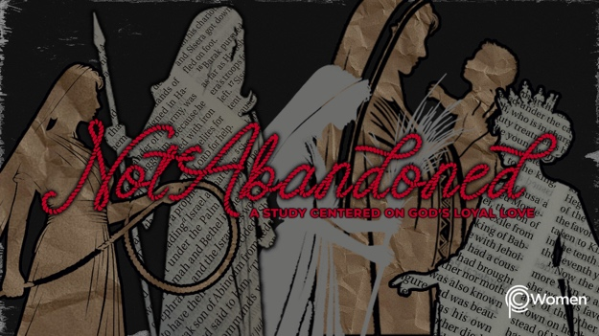

NOTE: Our lesson questions are based on the NIV 2011 edition. Our preference is your first time through the questions, you answer without consulting commentaries - delight in what the Holy Spirit will reveal to you.

Hannah
Lesson 17
1 Samuel 2:1-11

1. What truth or insight has stayed with you from the prior lesson on Hannah and share about a conviction of the Spirit that brought you to your knees this past week?

2. Hannah, our unlikely mother, poured out her great sorrow before the Lord and because of His hesed, He granted her prayer for a son. Prayerfully read Hannah’s beautiful prayer of praise and thanksgiving in 1 Samuel 2:1-11. How would you describe Hannah as you steep in the overflow of her heart? Of which other Biblical figures who sang songs of praise are you reminded?

3. a) From V1-3, how is God portrayed by Hannah?

b) What are Hannah’s verbal and nonverbal responses to all the Lord has done for her?

4. a) List the unexpected reversals you find in V4-5.

b) When have you seen God work a reversal to your benefit or to the benefit of another person?

5. a) In V6-8, which attributes of God are highlighted?

b) Note a truth about God that you really want to remember and why it is meaningful to you at this moment in time.

6. According to the final few verses of Hannah’s praise song, V9-10, the Lord will judge the ends of the earth. Read the following Scriptures and reflect on the hope found in this sobering aspect of God.

- Isaiah 33:22

- Psalm 96:10, 13

- Acts 17:31

- 2 Corinthians 5:10

7. What encourages or convicts you about Hannah’s praise, especially as you consider again the offering she made to the Lord (V11)?

8. God met Hannah in her barrenness which had caused personal anguish as well as being stigmatized by her culture. Recall when Jesus met someone in their personal anguish or cultural stigma and demonstrated His hesed. For example, see Matthew 9:27-33, Mark 5:25-34, Luke 5:12-15; 19:2-9.

9. GOD IS: THE EXALTED ONE, WHO TAKES NOTICE OF THE LOWLY
The Psalmist asks, “Who is like the Lord our God, the One who sits enthroned on high, who stoops down to look on the heavens and the earth?” Psalm 113:5-6. The Lord is exalted in His power and yet He has His eye on those of humble status. Express your own praise in the style of Psalm 113 celebrating the intervention of the God of highest majesty in the ordinary lives of those in need of Him.

MEMORY VERSE

“There is no one holy like the Lord; there is no one besides you; there is no Rock like our God.”
1 Samuel 2:2

NAME PRAYER REQUEST

