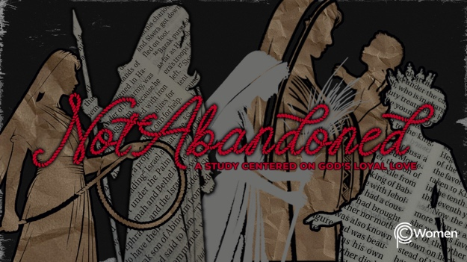

NOTE: Our lesson questions are based on the NIV 2011 edition. Our preference is your first time through the questions, you answer without consulting commentaries - delight in what the Holy Spirit will reveal to you.

Hannah
Lesson 16
1 Samuel 1:19-28; 1 Samuel 2:18-21

1. What truth, verse or insight from last week’s lesson about Hannah and her passionate prayer life was meaningful to you and when did you put it into action?

2. Ask the Lord to open your eyes to see Hannah as He sees her before you read 1 Samuel 1:19-28 and 1 Samuel 2:18-21. God answered her prayer and she was faithful to her vow to Him. When have you experienced answered prayer, either yours or another’s, and how did it impact your faith? In what tangible ways did you express praise for who God is or what He has done?

3. What does the Lord do for Hannah in 1 Samuel 1:19-20, and how does she honor Him?

4. a) Reading V21-23, why does Hannah stay back during the annual trip to sacrifice to the Lord?

b) What do you think it might have been like for Hannah as she pondered keeping her promise to the Lord and leaving her son with Eli the priest, particularly in light of Eli’s poor track record as a father? Refer to 1 Samuel 2:12, 17.

5. Recount what actions Hannah takes and of what she reminds Eli in 1 Samuel 1:24-26.

6. a) From 1 Samuel 1:27-28, what does Hannah acknowledge and how would you describe her spiritual strength?

b) What God-given gift could He be calling you to give back to His service?

7. Read 1 Samuel 2:18-19, 21b about Hannah’s son Samuel. Where do we find Samuel and how has Hannah maintained her connection with him?

- How does Eli bless Elkanah and Hannah from V20-21a and what is the Lord’s response?

9. What are some of the spiritual traits exhibited by Hannah and her family that you admire? With these traits in mind, identify one practical step you could take to prioritize a deeper, more intentional relationship with God.

10. GOD IS: TRUSTWORTHY
Through Hannah’s persistent heartfelt prayers, a child was conceived and Samuel was born. (Read 1 Samuel 3:19-21 and 1 Samuel 7:2-6 for several glimpses into the life of Samuel as he matured.) Because the Lord is worthy of trust, Hannah faithfully surrendered her precious son to His service. “Commit your way to the Lord, trust in Him.” (Psalm 37:5)

Now reflect on the trustworthiness of God in the life of Hannah and Samuel, and in your own life. Consider whether you have been withholding something or someone precious from the Lord for lack of trust and take this time to surrender those precious things to Him. What favorite verse can you claim in this time of surrender?

MEMORY VERSE

“Commit your way to the Lord; trust in Him and He will do this: He will make your righteous reward shine like the dawn, your vindication like the noonday sun.” Psalm 37:5-6

NAME PRAYER REQUEST

