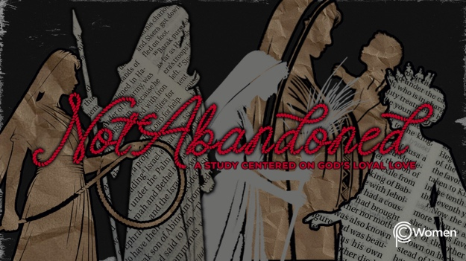

NOTE: Our lesson questions are based on the NIV 2011 edition. Our preference is your first time through the questions, you answer without consulting commentaries - delight in what the Holy Spirit will reveal to you.

Hannah
Lesson 15
1 Samuel 1:1-18

1. As you reflect on the prior lesson about Ruth’s new family and the abundant blessing she experienced, how did her story minister to you and what truth or insight brought you hope?

2. Prayerfully read 1 Samuel 1:1-18, in which we are introduced to a faithful woman named Hannah, living during a dark period of Israel’s history when the people had largely rejected God. Hannah would eventually give birth to Samuel, the last of Israel’s judges and the first of the prophets. What are your first impressions of Hannah’s home life and her prayer life?

3. a) From V1-3, what details do you learn about the lives of Elkanah and Hannah? To understand V3 more fully, read Deuteronomy 16:16.

b) We read in 1 Chronicles 6:22-27 that Elkanah is a Kohathite priest. What roles and unique responsibilities did Elkanah and his priestly (Kohathite) descendants have according to the following verses:

- Numbers 3:27-31

- 1 Chronicles 6:31-33

- Malachi 2:7

4. a) Describe the blessings and the heartache Hannah may have experienced in 1 Samuel 1:4-8. Talk about how Elkanah handled her sadness.

b) When have you wrestled with, or been the object of, jealousy or rivalry, and how did God use the opportunity to transform you?

5. a) Read V9-11. What do you observe about Hannah’s emotions and her prayer to the Lord?

b) Share your thoughts about what Hannah is willing to do in return for answered prayer.

6. a) What wrong assumption does Eli, the priest, make in V12-18, and how does Hannah
explain the true state of her heart?

b) After Hannah corrected Eli, how did he respond to her and what does his response say about him?

7. Find a truth about God or about the power of prayer in these Scriptures and allow them to prompt you to cry out to Him:

- Psalm 145:18-19

- Romans 8:26

- 1 Thessalonians 5:16-18

- 1 Peter 3:12

8. GOD IS: PEACE
Paul spoke of the peace of God, one which transcends all understanding and will guard our hearts and minds in Christ Jesus. (Philippians 4:7). Jesus told us, “Peace I leave with you, my peace I give you. I do not give as the world gives. Do not let your hearts be troubled and do not be afraid.” John 14:27. Peace is more than lack of conflict; it is completeness, soundness, welfare.

In what ways do you identify with Hannah in the anguish and grief that robbed her of peace? When have you felt abandoned by God because of unmet longings? Maybe you have been too weak to pray or unable to find the words. Let the Spirit guide you in prayer, inviting God and His peace into the situation.

MEMORY VERSE

“In the same way, the Spirit helps us in our weakness. We do not know what we ought to pray for but the Spirit himself intercedes for us through wordless groans.” Romans 8:26

NAME PRAYER REQUEST

