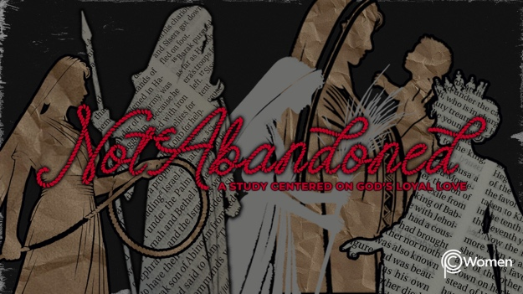

NOTE: Our lesson questions are based on the NIV 2011 edition. Our preference is your first time through the questions, you answer without consulting commentaries - delight in what the Holy Spirit will reveal to you.

Ruth
Lesson 14
Ruth 4:13-22

1. What truth or insight from last week’s lesson highlighting God as our Redeemer gave you renewed your thinking in a hard chapter or deepened your appreciation of the freedom Jesus purchased for you?

2. Before you read the conclusion of the story in Ruth 4:13-22, pray that God would open your eyes to see all that He has abundantly restored to Ruth and Naomi. Explain who you see as the hero of this story.

3. Ruth’s choice to follow her mother-in-law brought her to Bethlehem as a foreigner and a widow without family or any means of provision. Describe the ways God has transformed her life from V13.

4. a) From V14-15 how do the women acknowledge the greatness of the Lord in Naomi’s life?

b) It is fitting to praise God and speak a blessing. Make this praise / blessing into your own:

Praise be to the Lord, who this day has ______________________________________________

May the Lord bless __________________________________________________________________

5. Re-read Ruth 1:1-5 together with 4:13-17. God’s abundant provision is dramatically apparent from these verses. Contrast these two chapters of Naomi’s story. Note where you see God’s hesed or other attributes at work. If needed, review Lesson 1 for a refresh on God’s hesed.

6. Some falsely believe that followers of God have been promised only health, wealth and prosperity. How do the lives of Ruth and Naomi correct this thinking and how would you more accurately state the truth about God’s love and provision for His followers?

7. CHALLENGE: In V17, why do you think the women say Naomi has a son? Look back to Ruth 1:5 and 4:5 for help with your answer.

8. Naomi and Ruth are two very different women with a shared story. Which of these women do you most relate to and why?

9. a) Compare Ruth 4:18-22 with Matthew 1:1-6, 16, 20-21. What amazes you about God and those He chooses to include in His plan for salvation?

b) How does God’s use of the ordinary lives of unlikely believers convict you or strengthen your understanding of God’s grace in including any of us in His salvation story?

10. GOD IS: ABUNDANCE
Jesus declares, “The thief comes only to steal and kill and destroy; I have come that they may have life, and have it to the full.” (John 10:10) Our God is a God of abundance. He calls each of us to deny ourselves and follow Him, so that we can live abundantly in Him. Ruth was a foreigner and widow who was once far from God, but her willingness to trust in Him and live as He commands led her to not only gain abundant earthly provision but an eternal role in His Kingdom.

Let the below Scriptures coach you on what it means to live the abundant life promised to those who love and follow God. Where are you experiencing emptiness, longing to be filled with God’s abundance?

- Psalm 37:3-4

- Psalm 86:5

- Luke 12:22-24, 31

- 2 Corinthians 9:8

MEMORY VERSE

“And God is able to bless you abundantly, so that in all things at all times, having all that
you need, you will abound in every good work.” 2 Corinthians 9:8

NAME PRAYER REQUEST

