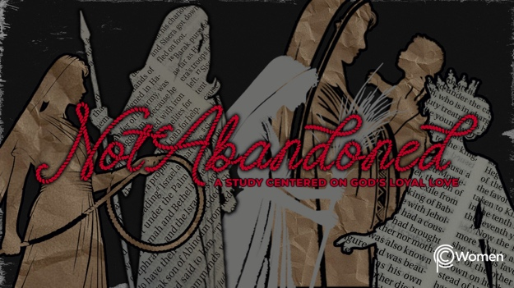

NOTE: Our lesson questions are based on the NIV 2011 edition. Our preference is your first time through the questions, you answer without consulting commentaries - delight in what the Holy Spirit will reveal to you.

Ruth
Lesson 13
Ruth 4:1-12

1. How did the truths from the previous lesson, seeing God as our Protector, encourage you to pray differently or invite God into your circumstances in new ways?

2. In Ruth 4:1-12 we witness Boaz secure the redemption of Ruth with love, honor and a commitment to acting as God commands. Pray that God would reveal how His indisputable power can redeem or reclaim for His purposes even the most difficult of circumstances as you read these verses. Make a list of some of the circumstances in Ruth and Naomi’s life that you hope will improve because of Boaz’s actions as guardian-redeemer.

3. From V1-2, who is involved in the encounter and where did it take place?
NOTE: a city gate was a place where counsel was given and rulers would meet; this is also where elders of the community would examine evidence and make judgments. For example, see Deuteronomy 25:5-9.

4. How does Boaz begin the conversation with the nearer kinsman in Ruth 4:3, and why do you think he takes this approach?

5. a) How does Boaz outline the course of action before them and what is the nearer kinsman’s initial response in V4?

b) Use a dictionary to explain what it means to redeem something or someone.

6. a) According to V5-8, what does the redemption of Naomi’s land include and how does this affect the nearer kinsman’s answer and actions?

b) Why do you think the nearer kinsman declined his right to redeem the property?

7. Rewrite Boaz’s announcement in V9-10 from Ruth’s perspective, claiming each promise over her life. What aspects of God’s hesed are on full display?

8. What blessings are imparted by the witnesses at the gate in V11-12?

9. What current circumstance are you desperate for God to redeem or reclaim for His purposes? Pour out your heart in a prayer.

10. GOD IS: REDEEMER
Boaz’s love and redemption of Ruth are a silhouette, or foreshadow, of God’s hesed expressed in the ultimate redemption through Jesus’s life, death and resurrection. While God redeems lives here on earth, His greatest gift is found in the eternal redemption of His people. As John 3:16 declares, “For God so loved the world that he gave his one and only Son, that whoever believes in him shall not perish but have eternal life.”

For each Scripture below, write a timeless truth about God’s role as Redeemer.

● Psalm 130:7-8

● Isaiah 43:1-4

● Colossians 1:13-14

● 1 Peter 1:18-19

MEMORY VERSE

“For he has rescued us from the dominion of darkness and brought us into the kingdom of the Son he loves, in whom we have redemption, the forgiveness of sins.” Colossians 1:13-14

NAME PRAYER REQUEST

