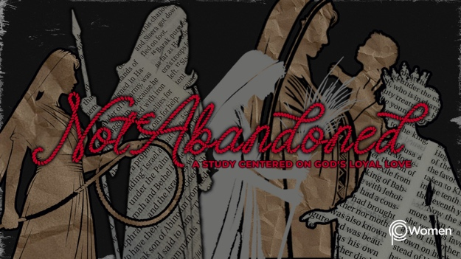

NOTE: Our lesson questions are based on the NIV 2011 edition. Our preference is your first time through the questions, you answer without consulting commentaries - delight in what the Holy Spirit will reveal to you.

Ruth
Lesson 12
Ruth 3

1. How were you challenged to extend the kindness of God to others this week as you reflected on all that God did for Ruth by Boaz’s hand? Confess a time you were tempted to justify an unkind word or deed.

2. Ask God for a deeper understanding of the challenges Ruth faces as a widow in Bethlehem as you read Ruth 3. How do you see God’s protective presence at work in Ruth’s life here and in the earlier chapters of her story?

3. What does Naomi say she wants for Ruth in V1? What concerns do you think she has for Ruth?

4. Outline Naomi’s instructions to Ruth in V2-4. How would you characterize the way Naomi is instructing Ruth to approach Boaz? Recall the role of a guardian-redeemer in Leviticus 25:25, 5, 49.

5. How does Ruth receive Naomi’s instructions in V5-6? When in your own life have you hesitated to follow the guidance of the Lord or of godly people?

6. Describe the scene in V7-9, giving mention to the beauty you see in this pivotal moment.

7. a) How does Boaz respond to Ruth’s request and what reasons does he give in V10-11?

b) Boaz commends the virtues of Ruth’s character. What are some of the hallmarks of good character from the following verses?

● 1 Samuel 16:7

● Proverbs 31:10

● Colossians 3:12-14

● James 1:2-4
c) Pray and ask God to be your coauthor as you write a sentence candidly describing facets of your own character. What godly character trait do you most want to cultivate in yourself?

8. What additional facts do you learn in Ruth 3:12-14 and how do Boaz’s plans give you insight into his character?

9. Read V15-18. How does Boaz continue to show generosity toward Ruth? What do you think a union between Ruth and Boaz would mean for Naomi?

10. GOD IS: PROTECTOR
The road that brought Ruth to this place in her life has been difficult, but God has been her protector. While once Ruth did not know God’s love and forgiveness, she now walks with Him. When Ruth and Naomi couldn’t provide for themselves, God ensured their protection through a law written before they walked the earth. God now extends His protection in the form of a guardian-redeemer of noble character and abundant means.

Psalm 91 is often called the psalm of protection and speaks of finding refuge and security in God’s shadow. Meditate on Psalm 91 and let it lead you into prayer seeking God’s protection in your life or in the life of a loved one.

MEMORY VERSE

“Whoever dwells in the shelter of the Most High will rest in the shadow of the Almighty. I will say of the Lord, ‘He is my refuge and my fortress, my God, in whom I trust.” Psalm 91:1-2

NAME PRAYER REQUEST

