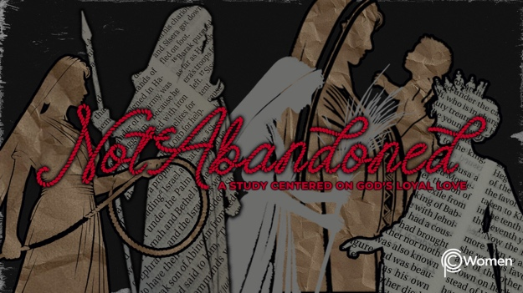

NOTE: Our lesson questions are based on the NIV 2011 edition. Our preference is your first time through the questions, you answer without consulting commentaries - delight in what the Holy Spirit will reveal to you.

Ruth
Lesson 11
Ruth 2

1. How did God’s open invitation to return to Him in Lesson 10 inspire you to pray for a loved one in new ways this week?

2. Pray that God would give you eyes to see Him at work in the everyday lives of His people before you read Ruth 2, where Ruth meets Boaz while gleaning in a grain field she later learns he owns. As it turns out, the course of her life is forever changed. How has an unexpected divine meeting changed the course of your life or when has God brought a person into your path who He used in unexpected ways?

3. a) Who is Boaz according to Ruth 2:1-3? For more on Boaz’s ancestry, see Matthew 1:5.

b) Ruth gathers grain in Boaz’s fields to provide for herself and Naomi. Read Leviticus 19:9-10 and explain the law that makes this possible. What does the law reveal about God’s heart?

4. How is Ruth described in Ruth 2:4-7 and what new insights do you gain into her temperament?

5. Recount the kindness Boaz extends to Ruth in V8-9. How does it compare to the requirements of the Levitical law?

6. Boaz explains the reason for his kindness to Ruth in V10-13. What does he know about Ruth and how do you imagine his words are received by her?

7. a) From V14-16, how does Boaz lavishly meet Ruth’s and Naomi’s needs?

b) Boaz’s treatment of Ruth mirrors God’s own generosity. Summarize God’s abundant provision and hesed in the following scriptures:

- Exodus 16:3-18

- 2 Kings 4:1-7

- Matthew 14:15-21

- John 2:1-10

8. Look back to Ruth 1:20-21; what change do you witness in Naomi in Ruth 2:17-20a? When have you experienced the Lord’s generosity and kindness and what impact did it have on you?

9. How is your understanding of all that Boaz is able to provide for Ruth expanded in V20b-23? What particular role does Boaz have? Read Leviticus 25:25, 35, 49 to further understand the obligations of a guardian-redeemer to a relative in serious difficulty.

10. GOD IS: KIND
God’s kindness knows no limitations. We experience it in the incomparable act of Jesus, who willingly took our place on the cross so that we would be set free from the penalty of our sin. “But when the kindness and love of our Savior appeared, He saved us, not because of righteous things we had done but because of His mercy.” Titus 3:4-5a. God’s kindness towards those who love Him is experienced not just through His direct actions, but also through the words and deeds of those who follow Him and who keep His commands, as we see in Boaz’s kindness toward Ruth.

Let the below Scripture provoke you to pray, thanking God’s for His kindness and the kindness you’ve experienced through those who love and follow Him.

- Micah 6:8

- Galatians 5:22-24

- Ephesians 4:32

MEMORY VERSE

“May the Lord repay you for what you have done. May you be richly rewarded by the Lord, the God of Israel, under whose wings you have come to take refuge.” Ruth 2:12

NAME PRAYER REQUEST

