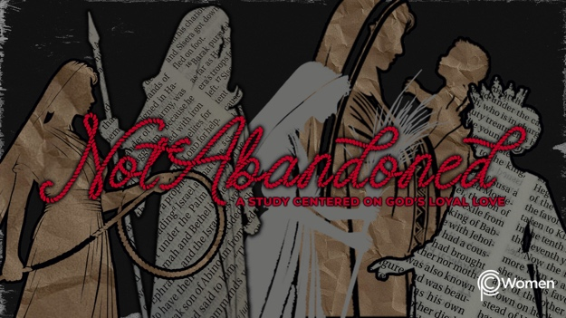

NOTE: Our lesson questions are based on the NIV 2011 edition. Our preference is your first time through the questions, you answer without consulting commentaries - delight in what the Holy Spirit will reveal to you.

Ruth
Lesson 10
Ruth 1:6-22

1. How did last week’s lesson highlighting God as the loyal Covenant Keeper encourage you or shape your prayer life this week?

2. Ruth 1:6-22 features a flurry of activity and emotion as Ruth the Moabite, her sister-in-law Orpah and her mother-in-law Naomi confront the decision of whether or not to return to Bethlehem. Pray for wisdom to recognize the significance of the choices presented. Make note of the decisions made by each woman.

3. In V6-7, what important news does Naomi receive and how does she respond? Why do you think she chose to do this?

4. Read V8-10, noting the Hebrew word for kindness is hesed. Describe the exchange between Naomi and her two daughters-in-law. What do we learn about Ruth and Orpah and their relationship with Naomi from these verses?

5. a) Naomi continues to urge Ruth and Orpah to return to Moab in V11-13. List the reasons she provides and comment on why they would be important considerations.

b) What did Naomi conclude according to V13b? How does her conclusion resonate with you?

6. How do Orpah and Ruth’s responses to Naomi differ and what is Orpah returning to according to V14-15?

7. Ruth the Moabite, a widow herself and a stranger to Bethlehem, makes a powerful declaration in V16-18. Summarize her statement and note any other biblical displays of faith and loyalty they call to mind.

8. How are the women welcomed in V19 and why do you think the townspeople might struggle to recognize Naomi?

9. How does Naomi express feelings of abandonment by God in V20-21? What is her view of herself and her circumstances? NOTE: Naomi means “pleasantness”.

10. V22 marks Naomi’s return to Bethlehem and to God’s chosen people. Describe a time in your life when you experienced a need to return to God in order to be filled. What weighed on your heart as you made the choice to return?

11. GOD IS: AN INVITATION TO RETURN
Set against the backdrop of the time of the Judges when so many had turned away from God, the word return appears fifteen times in the book of Ruth. God invites us to return to Him and receive His blessing. It is an invitation extended to those who have known God, but also to the most unlikely of believers, like Ruth the Moabite.

Reflect on God’s open invitation to return to Him in the below Scriptures and write down the name of someone placed on your heart who needs to return to the loving arms of our merciful God.

● Isaiah 55:6-7

● Joel 2:12-13

● Matthew 18:12-13

● Luke 15:11-32

MEMORY VERSE

“But Ruth replied, “Don’t urge me to leave you or to turn back from you. Where you go I will go, and where you stay I will stay. Your people will be my people and your God my God.“ Ruth 1:16

NAME PRAYER REQUEST

