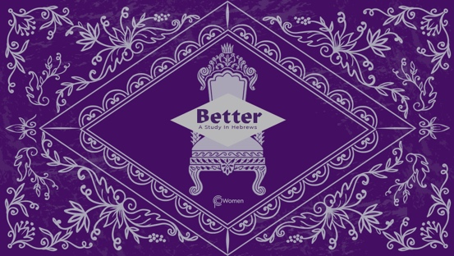

NOTE: Our lesson questions are based on the NIV 2011 edition. Our preference is your first time through the questions, you answer without consulting commentaries - delight in what the Holy Spirit will reveal to you.

LESSON 20
HEBREWS 11:20-31

- How did your study of the faithful in Hebrews 11:8-19 and their longing for a better country transform your mindset on your journey this week?

2. Pray for God's leading as the Holy Spirit speaks to you as you read Hebrews 11:20-31. Revisit the definition of faith in V1. What main themes do you see woven throughout the examples of faith noted in this passage?

3. Isaac, Jacob and Joseph, listed in Hebrews 11:20-22, are important patriarchs in the history of the Jewish people.

- Read Genesis 27:1-40. What surprises you about Isaac’s faith being affirmed by God in Hebrews, given what you know of his story?

- Read Jacob’s blessing to Joseph’s sons (his grandsons) in Genesis 48:8-20. (NOTE: Jacob is also known by the name Israel). What elements of Jacob’s trust in God do you detect in the blessing Jacob gives?

- Joseph speaks to his brothers in Genesis 50:24-25. Summarize the instructions given by him as he is dying, highlighting the elements of his confident faith.

4. Skim Exodus 1:22-2:20 for the backstory of Moses’ parents. Reading Hebrews 11:23 what did Moses’ parents risk by keeping their baby hidden and what is commendable about their faith?

- a) Soak in Hebrews 11:24-28. Why was choosing to be mistreated along with the people of God a choice that reflected Moses’ great faith? What reward is of greater value than the treasures of Egypt?

- In what ways are you challenged to choose discomfort or mistreatment, as you identify with Jesus and His followers? How will you ask your group to pray for you? See Matthew 16:24-27, 1 Peter 1:6-9 for encouragement.

6. Note God’s instructions and promises to the Israelites as they’re brought through the Red Sea in Exodus 14:5-31 (referenced in Hebrews 11:29). What did God’s promise and display of power do to their faith?

7. Read Hebrews 11:30 with Joshua 5:13-6:16, 20. How would God’s instructions to Joshua and Israel’s army test their faith at Jericho?

8. Read Hebrews 11:31 with Joshua 6:17, 22-25 and James 2:25. What is Rahab’s story and how was she rewarded for her “baby faith” in action?

9. CONSIDER JESUS: THE BETTER REWARD

According to Hebrews 11:26, Moses regarded disgrace for the sake of Jesus as of greater value than material treasures because he was looking ahead to his better reward. Although Moses suffered, he was faithful to God and confident in the promise of the coming Messiah. Jesus is the better reward, the One to whom Moses and the patriarchs looked. As you meditate on the passages below, take an inventory of any momentary, lesser rewards you are holding on to and pray about treasuring the better reward, Jesus.

- Matthew 5:11-12

- Romans 8:18

- 2 Corinthians 4:16-18

- Colossians 3:23-24

MEMORY VERSE

“For our light and momentary troubles are achieving for us an eternal glory that far outweighs them all. So we fix our eyes not on what is seen, but on what is unseen, since what is seen is temporary, but what is unseen is eternal.” 2 Corinthians 4:17-18

NAME PRAYER REQUEST

