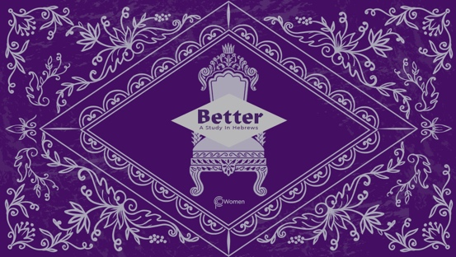

NOTE: Our lesson questions are based on the NIV 2011 edition. Our preference is your first time through the questions, you answer without consulting commentaries - delight in what the Holy Spirit will reveal to you.

LESSON 16
HEBREWS 10:1-18

- As you reflect on Hebrews 9:11-28, what aspect of Christ’s work most stands out to you, and how did your reverence of God’s holiness deepen?

2. Slowly read Hebrews 10:1-18 with a posture of prayer, asking the Lord to bring the text to life in your heart. This passage continues to explore the inadequacy of the old covenant’s sacrificial system. As you consider different cultures and time periods, why do you think people are drawn toward religions with rituals and external practices as a way to alleviate guilt?

3. a) According to V1-4, what are the limitations of the law and its ceremonial
requirements under the old covenant?

b) What, then, was God’s objective behind the sacrificial system, particularly in light of its repetitive nature?

4. a) In V5-10, the author quotes a song of King David (Psalm 40:6-8), and applies David’s words to Jesus the Messiah. How does Jesus’ sacrifice please God and what does that mean for you and me?

b) God’s will is discussed in Hebrews 10:7, 9-10. How do the following verses confirm that Jesus came to do the will of God?

- Luke 22:39-42

- John 6:37-40

- Galatians 1:3-4

5. Read Hebrews 10:11-13.
a) Note the differences you find between the sacrifices of “every priest” and that of “this priest” Jesus.

b) Why does the difference in posture of the priests matter (standing vs. sitting) in regard to their respective ministries? See John 19:28-30.

6. What are the realities of life in Christ according to Hebrews 10:14? How do you see this lived out by those who trust in Jesus?

7. According to V15-18, about what does the Holy Spirit testify and what is the ultimate truth about forgiveness?

8. In what ways do you seek to make yourself more acceptable to God through “sacrifices and offerings,” or external practices? How has this study clarified for you that there is nothing that can be done to free you from sin and guilt beyond what Jesus did once for all?

10. CONSIDER JESUS: THE BETTER SACRIFICE

Jesus willingly and perfectly submitted to the will of the Father as our once for all sacrifice, securing for us eternal salvation. This posture of surrender and obedience is the sacrifice of worship God desires from all His children. Reflect on the verses below to consider what God desires from you beyond compliance with external ritual.

- Psalm 51:16-17

- Isaiah 6:1-7

- Jeremiah 7:22-23

- Micah 6:6-8

MEMORY VERSE

“For by one sacrifice He has made perfect forever those who are being made holy.”
Hebrews 10:14

NAME PRAYER REQUEST

