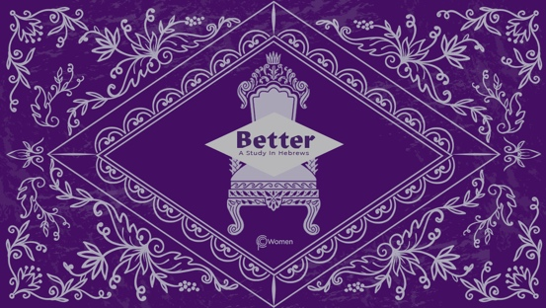

NOTE: Our lesson questions are based on the NIV 2011 edition. Our preference is your first time through the questions, you answer without consulting commentaries - delight in what the Holy Spirit will reveal to you.

LESSON 15
HEBREWS 9:11-28

- What insight about old covenant worship practices from Hebrews 9:1-10 gave you a different appreciation this week, as one living under the new covenant?

2. Pray for the Spirit to give you understanding, then read Hebrews 9:11-28 comparing the cleansing blood of Jesus with the blood of bulls and goats. Make note of repeated words and phrases and of contrasts you see in the text and of any questions that arise.

3. From V11-12, what are some of the ways that Jesus’ priestly work was different from the priestly work under the old covenant and what was He able to accomplish?

4. Carefully read V13-14.
a) How is the blood of Jesus Christ more effective than the blood of animals?

b) According to the author, from what are we cleansed by the blood of Christ, and for what purpose? What do you think it could look like for you personally to live out that purpose? NOTE: A better translation of “acts that lead to death” is “works or deeds that do not save”

5. Explain in your own words how Jesus’ acts as mediator and as ransom as reflected in V15. Refer to dictionary definitions of the terms as well as John 8:34, and 1 Timothy 2:5-6a to help with your answer.

6. In Hebrews 9:16-21, what aspect of a last will and testament is highlighted by analogy, and how does the author connect it to the essential element of the first covenant?

7. Describe how God fulfills the requirement of the law under the new covenant and addresses the problem of sin in V22. Find inspiration from John 1:29 and 1 Peter 1:18-20.

8. Write a truth about the one-time work of Christ that stands out to you from Hebrews 9:23-26. NOTE: A truth is a statement about God or humanity that applies at all times, for all people, everywhere.

9. Read V27-28.
a) What do these verses say about the difference between Christ’s first and second coming?

b) Assess your own eagerness for Christ’s return. How does the expectation of His coming transform the way you live today?

10. CONSIDER JESUS: THE BETTER CLEANSING

The law requires that nearly everything be cleansed with blood. Without the shedding of blood, there is no forgiveness. Through the blood of Jesus, we are offered eternal redemption and a clear conscience through His forgiveness of sins. Yet we sometimes live with ongoing guilt and self-condemnation. For what sins do you continue to feel burdened by guilt and need to remember Christ’s perfect and thorough cleansing (V14)? Repent and receive the forgiveness secured by His blood.

MEMORY VERSE

“So Christ was sacrificed once to take away the sins of many; and He will appear a second time, not to bear sin, but to bring salvation to those who are waiting for Him.” Hebrews 9:28

NAME PRAYER REQUEST

