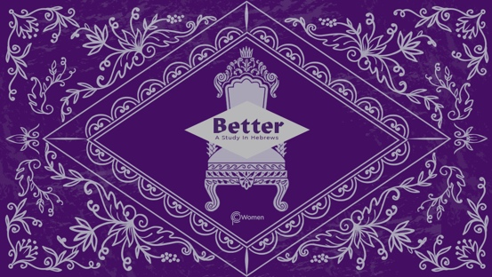

NOTE: Our lesson questions are based on the NIV 2011 edition. Our preference is your first time through the questions, you answer without consulting commentaries - delight in what the Holy Spirit will reveal to you.

LESSON 14
HEBREWS 9:1-10

- Which one of the covenant blessings from your study of Hebrews 8 reassured you this week, and how did it influence your decisions or actions?

2. In this lesson we will steep in Hebrews 9:1-10, where the author discusses worship under the old covenant, including the layout of the tabernacle and the regulations given by God. Ask the Lord to help you see the beauty and greater purpose in these regulations before you read the passage. What are some attitudes that you or others have towards the detailed rules and regulations of the old covenant?

3. During the time of Moses, the tabernacle was the earthly sanctuary, a portable place of worship, where God would meet with His priests. From V1-2, what items were located in the first room, the Holy Place? Read Exodus 25:23-40 and Leviticus 24:5-6 and find one interesting detail about each item.

4. a) For each of the items associated with the Most Holy Place and the ark of the covenant referenced in Hebrews 9:3-5, review the accompanying passages and comment on the item’s meaning to the Israelites.

- Altar of incense (Exodus 30:7-8; Psalm 141:2)

- Jar of manna (Exodus 16:2-5, 31-35)

- Aaron’s staff (Numbers 17:1-11)

- Tablets of the covenant (Deuteronomy 9:10-11)

b) The ark of the covenant is the centerpiece of the tabernacle. According to Exodus 25:17-22, Leviticus 16:2, and Numbers 7:89, why is it so significant?

c) In Hebrews 8:5, the author refers to the tabernacle as “a copy and shadow of what is in heaven.” What aspect of its lavish furnishings has heightened your awareness of God’s holiness, and what it means to approach Him in reverence?

5. a) From Hebrews 9:6-7, how does the ministry in the inner room, the Most Holy Place, differ from the ministry in the outer room, the Holy Place?

b) The requirements of the day referred to in V7 are detailed by the Lord in Leviticus 16. Review these verses and remark on what God requires of Aaron, the high priest.

- Leviticus 16:3-4

- Leviticus 16:6

- Leviticus 16:15-16

- Leviticus 16:20-22

- Leviticus 16:29-31

6. Hebrews 9:8-9 confirms the earthly tabernacle illustrated the incompleteness of the old covenant sacrificial system. Put these verses into your own words.

7. What do you think is meant by the “present time” as opposed to the “time of the new order,” as stated in V9-10?

8. We are not separated from God by a curtain, but by our sin. How did Jesus remove that barrier and open the way to God? For insight, see Matthew 27:50-51, Romans 5:1-2a and Hebrews 6:19-20.

9. CONSIDER JESUS: THE BETTER WAY

An understanding of old covenant worship regulations opens our eyes to the marvelous work of Christ and the better way of the new covenant. Contemplate John 14:6 in which Jesus said “I am the way and the truth and the life. No one comes to the Father except through me.” Bring your thoughts before the Father in a prayer of gratitude, thanking Him for providing Jesus, the only way to come to Him.

MEMORY VERSE
“Therefore, there is now no condemnation for those who are in Christ Jesus.” Romans 8:1

NAME PRAYER REQUEST

