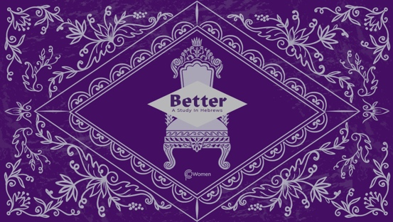

NOTE: Our lesson questions are based on the NIV 2011 edition. Our preference is your first time through the questions, you answer without consulting commentaries - delight in what the Holy Spirit will reveal to you.

LESSON 13
HEBREWS 8

- In this past week, how did the reality of Jesus as the better priest and the better king comfort or convict you from Hebrews 7? What new insight from your study challenged you?

2. Our passage this week continues to exalt the high priest Jesus and the new covenant He inaugurates. After praying and reading Hebrews 8:1-13, look up the word “covenant” in a dictionary and write a definition that fits the context of the passage.

3. V1-2 affirms that we have “such a high priest” referring back to Hebrews 7:23-28. What is true about our high priest Jesus’ posture, location, and action?

4. a) Read Hebrews 8:3-5. Describe the work and the sanctuary to which the high priests were appointed, including how the sanctuary relates to heaven. Refer to Exodus 25:8-9 to give you additional insight.

b) What do you think led to first century believers being tempted to settle for a “copy and shadow” rather than the true sanctuary of Jesus. When do you fall into the same temptation? See Colossians 2:16-17 also.

5. a) According to Hebrews 8:6, compare the ministry of Jesus under the new covenant with the ministry of other high priests under the old covenant.

b) NOTE: The old covenant was a conditional arrangement made by God with the nation of Israel, requiring obedience to God’s laws in return for His protection and blessing. Skim Exodus 19:3-6 and Exodus 24:3-8 to better understand the old covenant. What do you observe about its purpose, terms, and manner of confirmation.

6. According to Hebrews 8:7-9, in what ways was the old covenant insufficient or ineffective? Refer to Hebrews 7:18-19 and Romans 8:3.

7. a) In Hebrews 8:8-13, the author quotes Jeremiah 31:31-34. What does this reveal about God or the Bible, given Jeremiah was first written many centuries before Jesus was born?

b) What are the better promises of the new covenant based on the following verses from Hebrews 8?

- V10

- V11

- V12

8. From Hebrews 8, where do you see God’s tenderness and firmness exemplified in His treatment of His people? How have you experienced His tenderness or His firmness?

9. CONSIDER JESUS: THE MEDIATOR OF A BETTER COVENANT

Jesus is the mediator of a better covenant, established on better promises and is able to save completely those who come to God through Him. During the Last Supper, Jesus took the cup and spoke of His sacrificial death, saying, “This cup is the new covenant in my blood, which is poured out for you.” Luke 22:20. Spend time meditating on each of the blessings of the new covenant in Hebrews 8 and how they are made available to us in Christ. Which one is most precious to you today and why?

MEMORY VERSE
“I will put my laws in their minds and write them on their hearts. I will be their God and they will be my people.” Hebrews 8:10b

NAME PRAYER REQUEST

