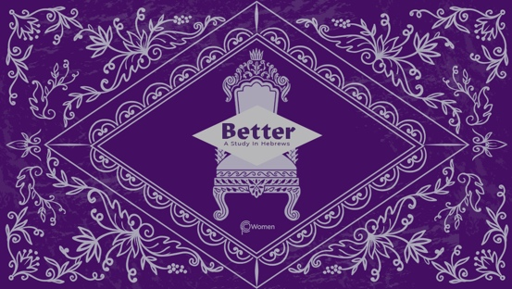

NOTE: Our lesson questions are based on the NIV 2011 edition. Our preference is your first time through the questions, you answer without consulting commentaries - delight in what the Holy Spirit will reveal to you.

LESSON 12
HEBREWS 7

- What truth, verse or insight from the lesson on Hebrews 6:13-20 spoke to you personally and in what ways did it work to give you fresh hope?

2. Seek God’s guidance as you read Hebrews 7, written to Jewish believers who had historically trusted in the Levitical priesthood and the Law. Jesus was neither from the priestly tribe of Levi nor the family of Aaron and some were struggling to see Jesus as superior to Levitical priests. What are some of the modern intellectual stumbling blocks or obstacles to trusting in Jesus as Messiah?

3. From Hebrews 5:6, 10 and 6:20, we learned that Jesus was designated high priest in the order of Melchizedek. What do you discover about Melchizedek, his meeting with Abraham, his origin and the titles he held in Hebrews 7:1-3? For more background, read Genesis 14:11-20. NOTE: Abram is later named Abraham by God.

4. What was the significance of Melchizedek in relation to Abraham from Hebrews 7:4-10 and how was this significance acknowledged?

5. What important question is posed in V11 and what is the underlying assumption about the priesthood?

6. Levitical priests descended from the family of Aaron. As you review V12-16, how did the priesthood change with the designation of Jesus as high priest?

7. Read V17-22, which quotes Psalm 110:4. Why did the law regarding the priesthood, which is holy and good, have to be set aside and how was what took its place better? How does it pierce your heart to see the eternal plan of God in these Scriptures?

8. a) From Hebrews 7:23-28, contrast other high priests and their sacrifice with the better qualities of Jesus and His sacrifice.

b) How does the fact that our high priest Jesus is able to “save completely” and “always lives to intercede” (V25) bring you confidence, comfort or encouragement?

NOTE: Hebrews 7 focuses on Jesus’ appointment by God to the priesthood in the order of Melchizedek, whose name means King of Righteousness and King of Peace.

9. Jesus is our King of Righteousness. How do you get a fuller picture from the verses below:

- Jeremiah 23:5-6

- Romans 3:21-22a

- 2 Corinthians 5:21

- 1 Peter 3:18

10. Jesus is our King of Peace. What further insights do you find in the following:

- Isaiah 53:5

- Romans 5:1

- Ephesians 2:14-17

- Colossians 1:19-20

11. CONSIDER JESUS: THE BETTER KING

But about the Son God says, “Your throne, O God, will last for ever and ever; a scepter of justice will be the scepter of your kingdom.” Hebrews 1:8a. Jesus is our King of Righteousness and our King of Peace forever. As you reflect on the supremacy of King Jesus from the verses in questions 9 and 10 above, consider how Jesus is the better King, truly meeting your deepest needs. In what ways is your trust in King Jesus made visible in your actions or attitudes?

MEMORY VERSE
“But because Jesus lives forever, He has a permanent priesthood. Therefore He is able to save completely those who come to God through Him, because He always lives to intercede for them.” Hebrews 7:24-25

NAME PRAYER REQUEST

