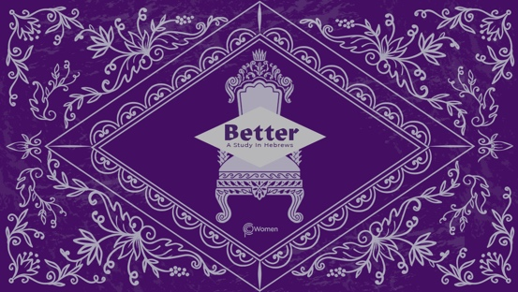

NOTE: Our lesson questions are based on the NIV 2011 edition. Our preference is your first time through the questions, you answer without consulting commentaries - delight in what the Holy Spirit will reveal to you.

LESSON 11
HEBREWS 6:13-20

- Which verse, insight or teaching from your study of Hebrews 5:11-6:12 encouraged or motivated you toward maturity or convicted you of lack of diligence?

2. Prior to reading Hebrews 6:13-20, pray that the Lord may give you the Spirit of wisdom and revelation, so that you may know Him better. This passage focuses on the life of Abraham and offers hope to those struggling with hopelessness and doubt. In what situations do you tend to become doubtful in your faith or feel hopeless? What are the negative things you say to yourself during these times?

3. What is unusual in how God made His promise to Abraham in V13?

4. a) According to V14-15, what was God’s promise to Abraham and how did Abraham respond?

b) What are some of the ways God’s promise to Abraham was fulfilled from the following verses?

  - Genesis 21:1-3, 5

  - 1 Kings 4:20

  - Matthew 1:1-16

  - Galatians 3:6-9

5. How does Abraham inspire you to wait patiently to inherit the certainty of what God has promised? How do you personally maintain an attitude of hope?

6. What is accomplished by an oath and what did God convey by His oath from Hebrews 6:16-17?

7. Who did God seek to encourage with His promise and oath according to V18 and what does this mean for you?

8. a) From V19-20, describe the hope we have and how that hope depends on Jesus.

b) These verses refer to “the inner sanctuary behind the curtain.” Read Exodus 26:30-34. Where was the curtain hanging, what purpose did it serve, and what was kept behind it?

9. What happened to the curtain at the moment Jesus was crucified according to Matthew 27:50-51, and how does this demonstrate the significance of what his death accomplished? Review John 14:6 and look ahead to Hebrews 10:19-20.

10. CONSIDER JESUS: THE BETTER HOPE

Jesus offers hope to the heirs of the blessing promised to Abraham. If you belong to Jesus, then you are Abraham’s seed by faith, and heirs according to the promise as we read in Galatians 3:29. The author of Hebrews encourages his readers to flee to take hold of the hope set before them. “We have this hope as an anchor for the soul, firm and secure.” Hebrews 6:19.

Reflect on your hope as a Christian and how an anchor illustrates that hope. Upon what other anchors have you attempted to secure your hope? Surrender any lesser hope as you approach the throne of grace with confidence that God always keeps His promises.

MEMORY VERSE
“We have this hope as an anchor for the soul, firm and secure. It enters the inner sanctuary behind the curtain, where our forerunner, Jesus, has entered on our behalf.” Hebrews 6:19-20a

NAME PRAYER REQUEST

